Hospice Scheduling and Route-Planning System

AQA A Level Computer Science (7517)

NEA

2022/3

Contents

Analysis 5

Background and Problem Specification 5

Background and Primary Stakeholder 5

The Problem and the Benefits of a Computerised Solution 5

Research 6

Stakeholder Interview 6

Existing Similar Solutions 8

Technical Analysis and Prototyping 10

Scheduling Algorithm 10

Optimisation Algorithm 10

Features of Proposed Solution 16

Initial concept of solution 16

Limitations 16

Requirements 17

Hardware and software 17

User requirements 17

Computational Methods Used/A Level Standard 17

SMART Objectives 18

Documented Design 22

High Level Overview 22

OOP Model 24

Overall Overview 24

IDInterface 26

NurseObject 26

EndUserAccount and AdminAccount 28

PatientObject 30

Location and AdjMatrix 32

ScheduleAlg and OptAlg 35

Comparator Classes 36

DBaseConnection 37

DataStructures 38

Database Design 40

Human-Computer Interaction 43

Login page 43

Admin landing page 44

Admin view page 45

Admin edit page 47

End User landing page 50

End User routes page 51

Security 52

Scheduling Algorithm 52

Optimisation Algorithm (Dijkstra’s Shortest Path Algorithm) 57

Technical Solution 67

Program Listing 67

Overview 67

Objectives 68

A Level Standard 70

Code that implements more complex objectives 71

Maintaining the program’s current state 71

Main algorithms 78

Updating the database while the application is running 103

Testing 108

Test Plan 108

Evaluation 115

Objectives 115

Third Party Feedback 117

Overall Effectiveness of the Solution and Possible Improvements / Extensions 117

Appendices 118

Appendix A: Program Code 118

main\java\com\algorithms\FormattingMethods 118

main\java\com\algorithms\ViewRouteMethods 125

main\java\com\guiLayout\ProtoApplication 129

main\java\com\guiLayout\LoginController 132

main\java\com\guiLayout\endUser\EULandingController 135

main\java\com\guiLayout\endUser\EURoutesController 138

main\java\com\guiLayout\admin\AdminLandingController 141

main\java\com\guiLayout\admin\AdminEditController 143

main\java\com\guiLayout\admin\AdminViewController 164

main\java\com\oopModel\IDInterface 168

main\java\com\oopModel\NurseObject 169

main\java\com\oopModel\PatientObject 173

main\java\com\oopModel\account\EndUserAccount 176

main\java\com\oopModel\account\AdminAccount 179

main\java\com\oopModel\algs\OptAlg 180

main\java\com\oopModel\algs\ScheduleAlg 188

main\java\com\oopModel\comparator\LocationComparator 192

main\java\com\oopModel\comparator\NurseComparator 193

main\java\com\oopModel\comparator\PatientComparator 194

main\java\com\oopModel\matrix\AdjMatrix 195

main\java\com\oopModel\matrix\Location 199

main\java\com\oopModel\storage\DataStructures 204

main\java\com\oopModel\storage\DBaseConnection 216

main\resources\com.guiLayout\adminEdit.fxml 220

main\resources\com.guiLayout\adminLanding.fxml 224

main\resources\com.guiLayout\adminView.fxml 225

main\resources\com.guiLayout\endUserLanding.fxml 227

main\resources\com.guiLayout\endUserRoutes.fxml 230

main\resources\com.guiLayout\loginPage.fxml 232

Appendix B: Bibliography 234

# Analysis

## Background and Problem Specification

### Background and Primary Stakeholder

The primary stakeholder for this project is a local Hospice charity with a workforce of nurses that work to serve patients in the community at their home address rather than on the Hospice site itself.

During the working week (five days, Monday to Friday), each nurse that is working on that day is allocated a series of patients to visit on their shift. Currently, the visits to patients are scheduled in order of priority and where possible as close to the last patient in order to minimise travel time and distance between each visit.

### The Problem and the Benefits of a Computerised Solution

The Hospice allocates shifts manually in their administration (admin) team, which is time consuming and does not always result in routes being as efficient as they could. This leads to additional cost to the charity in fuel and workforce time.

Based on discussions with the Stakeholder, the use of computers to develop a system that performs this shift scheduling and route optimisation automatically would also enable the charity to minimise the number of admin staff. This would be beneficial as major donors review staff breakdowns when considering whether to donate to a charity, and as a result, a smaller number of admin staff would demonstrate that more of the donor’s money is going directly towards making a difference and helping people instead of being spent on organisation.

An additional benefit of a computerised solution that could optimise routes would be to minimise travel time between appointments which would lead to nurses being able to see more patients and also reduce fuel costs.

The problem would therefore be suited to a computerised solution in order to maximise time and cost efficiency across admin staff and nurses, making the most of the Hospice’s finite resources by utilising the speed and processing power of a computerised automatic solution.

## Research

### Stakeholder Interview

**Questions**

The main questions to the potential user:

1. What are the essential, must-have elements of the solution in your job role?
2. What would be the non-essential or nice-to-have elements of the solution to help you in your day-to-day work?
3. What level of IT experience do you have?
4. How many users would the system need to have?

Questions one and two determine which features each user needs to be part of the solution. The questions also identify any other features which the users would prefer to be incorporated into the system which are less of a priority.

Questions three and four identify the number and types of users in terms of IT experience that the system may have. This will help to determine how complex a solution can be developed and how it must be designed to respond to the expected number of users.

**Responses**

Q1:

Any solution will need to be time-saving and simple to use for all users and will also need to be able to hold data securely. It needs to be able to manage large amounts of data and should provide nurses with the most time-efficient routes between patients’ homes during their shifts in order to improve efficiency and reduce travel costs.

Q2:

The solution should enable admin users to input details about patients, their priority and whether they require extended visits. The solution should also be able to pull across an overview of the patient’s medical history from SystmOne (a database that holds medical records), for nurses to view.

Q3:

In terms of IT experience, the users can be split into two categories:

* Admin
* Nurses (who are defined as End Users)

Admin users will be responsible for inputting and maintaining data and will have good IT skills and a reasonable experience of interacting with intuitive, menu-driven databases.

They will also have more time for training, as overseeing route and shift planning will be the bulk of their role.

Nurses will need to access their work schedules and routes. They may have IT experience so will need the solution to be intuitive and very simple to use with minimal training.

Q4:

There will be less than five admin users for inputting/maintaining data and 25+ nurses viewing data output.

**Interview Summary and Analysis**

The answer to Q1 about must-have requirements demonstrates the need for a system-based solution that holds nurse and patient data securely. It should also provide an automatic process for allocating nurses to patients based on their shift pattern and patient location. This will save time from the current manual allocation and reduce travel time and costs.

In order for the system to hold data securely, access should be via unique account logins with secure passwords, which ensures personal nurse and patient data is kept safely.

The response to Q2 about nice to have requirements indicates that admin users should be able to input additional information about patients including the length of visit (if additional time is needed), and how the visit should be prioritised. This means that it would be ideal for the solution’s scheduling algorithm to be able to deal with and respond to multiple constraints, and it would also be helpful if the system were able to pull an overview of a patient’s medical history from SystmOne.

Both answers to Q3 and Q4 regarding IT experience and number of users, demonstrate the need for stakeholders to be able to log into individual accounts which have different levels of access rights depending on the stakeholder’s role.

Admin stakeholder accounts will be for inputting data, so need to be able to add and modify patient and nurse data. They will also be used for adding and removing nurse accounts.   
  
End User accounts for nurses will have fewer permissions and will only be able to view the shifts and routes for the individual user the account is set up for. The user interface for nurse accounts will be simpler than that of admin accounts as nurses may have limited IT experience.

### Existing Similar Solutions

As part of the development of the solution, background research has been done to determine whether there are existing solutions for either the entire problem or for aspects of it. This is to gain an understanding of the advantages and drawbacks of existing systems in order to develop the most comprehensive solution for the stakeholder.

A number of solutions have therefore been investigated and these are detailed below.

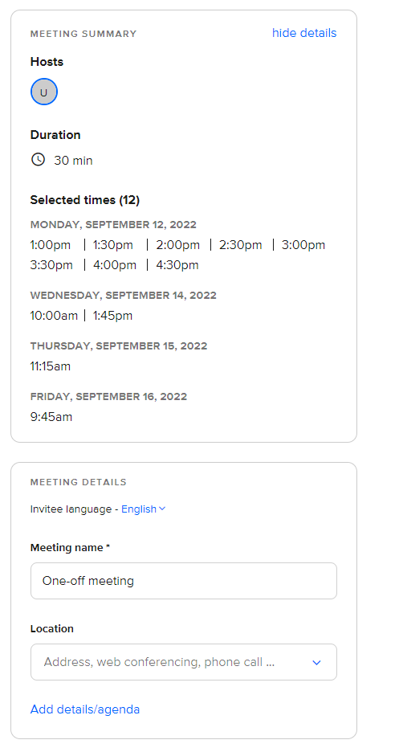**Scheduling software: Calendly**

Calendly is free scheduling software enabling users to create and organise meetings of different lengths at selected times. When meetings are created, users also have the option to add extra information, such as agendas, other general details and a location.

Users can then view these meetings on a calendar (below); the software also prevents users from holding meetings at times which lead to conflicts or are outside working hours.

Elements of the software, such as the ability for the user to view their scheduled meetings for the week in a calendar format, could be useful for the solution, as well as the ability to input working hours, which resulted in times outside those hours being greyed out on the calendar.

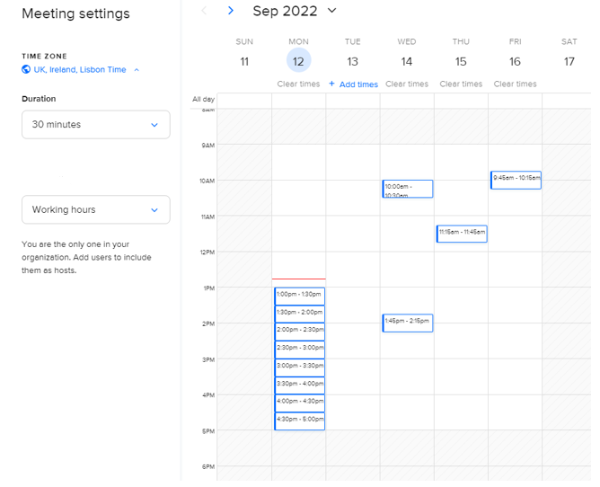However, a key limitation of the software is that scheduling must be done manually which makes it unsuitable as a solution to the stakeholder problem.

**Workforce rostering software: Totalmobile Organise**

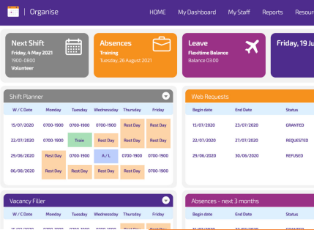Organise is workforce rostering software that enables workers to view their shifts during the working week by month, as well as their next shift’s date, time and description clearly. Workers can also add and view upcoming leave and absences directly from the home page.

Some of the software’s other capabilities involve sickness and absence management and timesheet functionality. Elements, such as the user-friendly interface and the ability for staff to log in and immediately view their shifts and leave clearly, could be useful if incorporated into the solution.

**Route-planning/optimisation software: Circuit**

Circuit is route-planning software which enables courier drivers to enter destinations along a route, and then automatically optimises the route in order to improve time-efficiency and reduce travel costs.

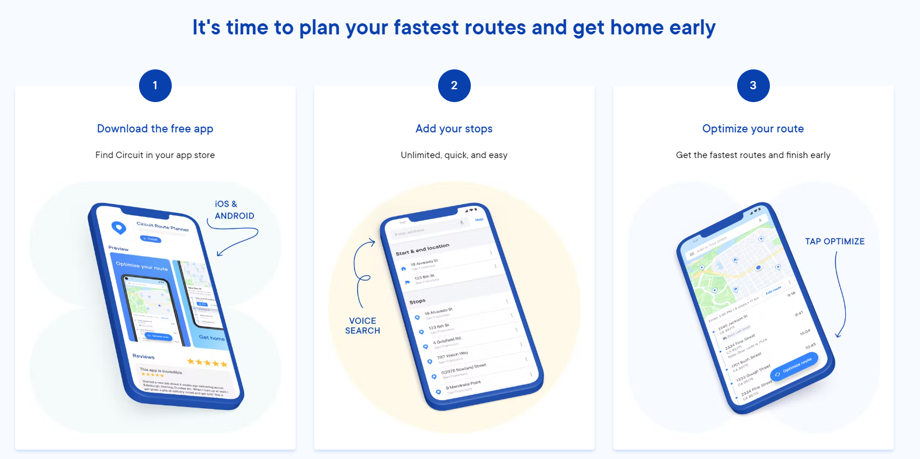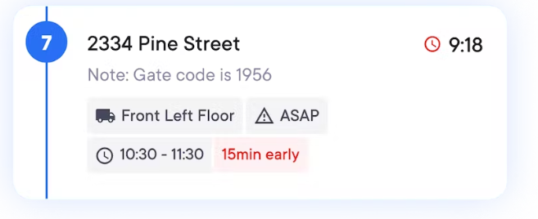The software’s simple interface and the way that it organises stops so that couriers can see the stop number, time and any extra details of information could be useful for the solution. Being easily able to view each visit (in a similar format to the image on the right), displaying the patient’s address and the visit duration for example, would be practical for nurses with minimal IT experience.

**Summary of Similar Solution Research**

In summary, the existing solutions reviewed provide some useful elements, such as a clear user interface and the ability for end users to immediately view their scheduled shifts once logged in, to include in a solution for the stakeholder. None however provide the full functionality that is required in the must-have needs.

## Technical Analysis and Prototyping

As part of the development of solution, analysis and prototyping of the main scheduling and optimisation algorithms has been carried out. This analysis is explained below.

### Scheduling Algorithm

In a solution for the stakeholder, an algorithm would be required to schedule visits to patients over a five-day working week. This algorithm would gather data on nurse working patterns (on which days they work). It would then gather data on patients to visit, grouping them by priority level (highest priority first) and whether they require a longer visit time.

Next, the algorithm would assign patients (by priority level) to each nurse for each day the nurse works. This would then produce the shifts for each nurse on each day that they worked.

### Optimisation Algorithm

In a solution, once patients had been assigned to nurses’ shifts, the individual patient locations could then be input into an optimisation algorithm. This location information would be used to reorganise patient visits so that the travelling distance between each one was as efficient as possible. However, the patients would still be ordered by priority first, then distance.

This algorithm would therefore need to maintain a weighted graph of patient locations, and use graph traversal to determine the most efficient routes between them. Graph traversal algorithms such as Dijkstra’s shortest path algorithm could therefore be used to optimise routes within the system.

Dijkstra’s shortest path algorithm finds the shortest route between an initial node and all of the other nodes in a weighted graph. It would be suited for this solution as routes would need to be optimised by starting from an initial node (the last patient visited), then finding the closest patient of the highest priority to visit next, in order to create the most efficient route. This algorithm would also be better suited for the solution for the stakeholder than others, such as Johnson’s algorithm or the Bellman-Ford algorithm, due to its speed in processing graphs with many connections[1].

**Graph Prototype**

The optimisation algorithm in the solution for the stakeholder would require a graph to be implemented in order to keep track of patients’ locations and the relative distances between them.

As part of research, a class to implement an adjacency matrix in order to represent a graph has been prototyped, explained and tested below. It contains functionality to create a graph of *n* nodes, then update, modify and delete the vertices and weights between those nodes.

Adjacency matrix class:

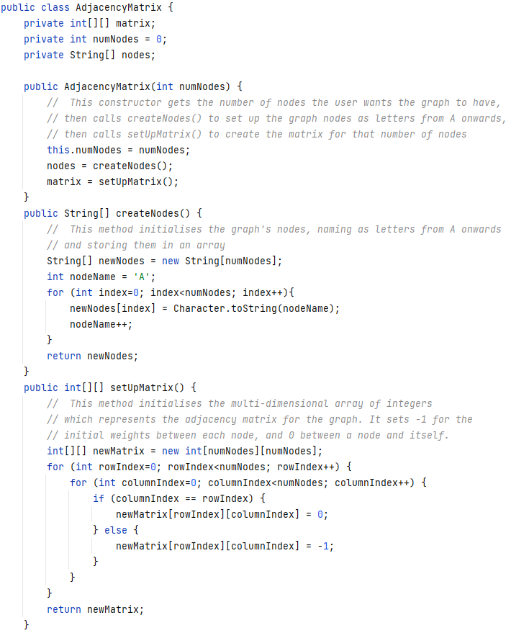

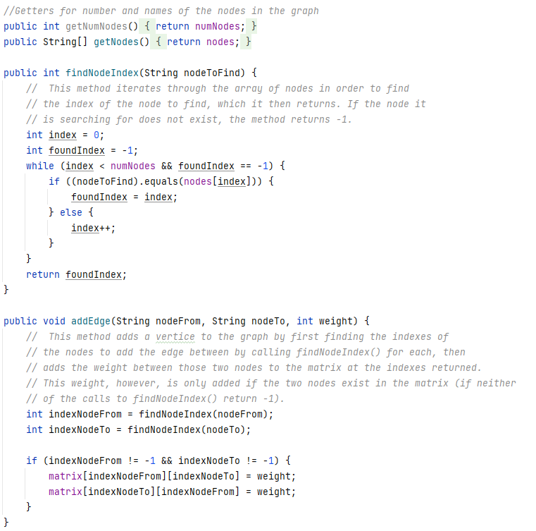

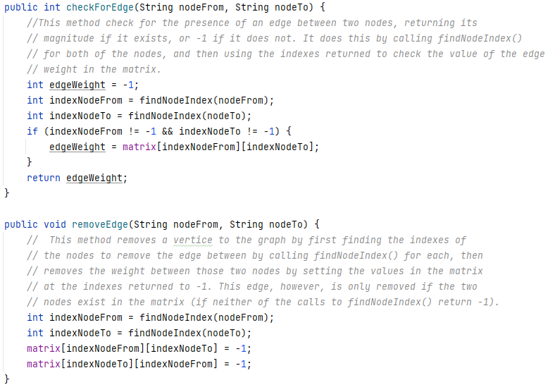

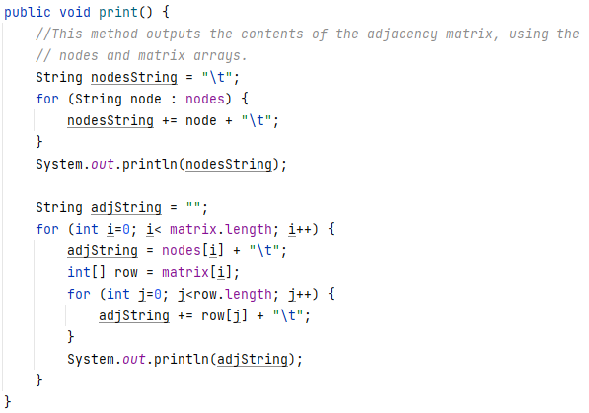

An example of testing for this class is shown below. In the test, an instance representing a graph of four nodes is instantiated, then several edges are added and removed from the graph, while their presence and the value of their weights are queried and the results output.

Code used to test class:

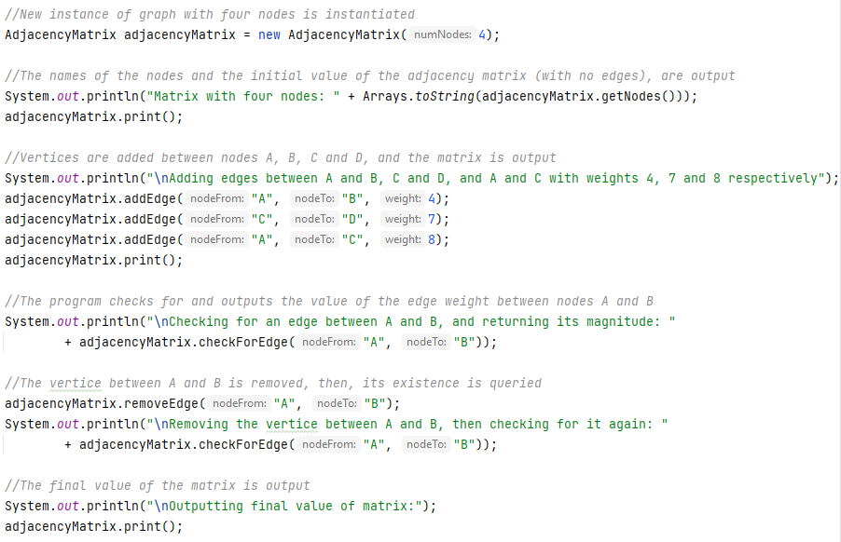

Output when test code is run:

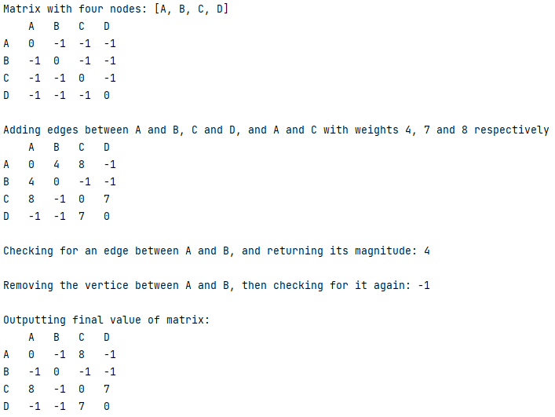

## Features of Proposed Solution

### Initial concept of solution

Based on the stakeholder interviews and the additional research conducted, an initial concept for the solution would be to design a system that is capable of storing nurse and patient data which can then be manipulated to produce schedules for each nurse and an optimised route per schedule.

There will be two user types for the system – admin and end user (nurse). Admin users will be responsible for managing the input and maintenance of nurse and patient data into the system all of which be stored persistently. This data for nurses will include names and working pattern information. For patients, this data will include names, locations, priority level and whether they require a longer appointment.

Admin users will also be able to create, amend and delete both admin and end user accounts and change account passwords. They will also be able to view all routes that have been generated by the system for each nurse.

Nurses will only access the system to view their shift details – i.e. which patients to visit, for how long per patient (appointment length), and the route plan. This will be based on a five-day working week.

All access to the system will be via secure login (username and password required) which will take each user to their own, relevant landing page, based on their account type.

**User Response**

The stakeholder response is that the initial concept seems good, though they have highlighted the importance of keeping the interface simple and easy to load for nurses as they would have limited technical knowledge and would also be time-pressured.

### Limitations

The main limitation of the software is its inability to respond and adapt to live changes, such as nurses being absent due to sickness or patients cancelling visits, as the five-day period goes on. The solution would only be capable of making a plan of routes and shifts for the next five days. This will not be part of the solution as it is out of scope for the project.

Another limitation would be that the system does not implement actual mapping software such as Google Maps which provides live traffic data. Travel time efficiency will therefore be impacted; however the solution does provide efficient routes based on distance.

In terms of the nice to have requirement of connecting to SystmOne which was identified in the stakeholder interviews – as this will be a link into a highly secure national patient record system containing sensitive information, this is out of scope.

## Requirements

### Hardware and software

* A computer powerful enough to run the system
* Mac, Linux or Windows operating system to run the Java program
* Java compiler, to translate the Java which the program is written in, so that the program can run
* MySQL Server to hold database
* JavaFX library which will be used to create the user interface

### User requirements

**Design**

* Simple, intuitive interface for end user accounts as the users have little technical experience
* Clearly laid out shifts and routes for nurses to view quickly and easily

**Functionality**

* Secure username and password log ins in order to maintain security and protect nurse and patient data
* Admin accounts for input and maintenance of data and management of accounts and viewing all route data for all nurses
* Simple end user accounts for nurses to access their shifts and routes
* Scheduling to assign patients to nurse shifts in order of priority and by length of visit
* Route optimisation for each shift in order to save time and reduce travel costs
* Persistent storage of nurse, patient, account, shift and route data

### Computational Methods Used/A Level Standard

In order to be of A Level standard, the solution will implement the following technical skills (from the example technical skills table provided by the exam board):

* Complex user-defined algorithms:
  + Automatic scheduling algorithm to assign patients to shifts which can respond to constraints such as whether patients require longer visit times or nurse working patterns
  + Route optimisation algorithm to make the route for each nurse’s shift as efficient as possible
* Graph traversal to perform route optimisation
* Queue operations and maintenance to perform scheduling
* Hashing to store account passwords securely
* Complex user-defined use of object-oriented programming (OOP), using a model which implements an interface, inheritance, composition and aggregation, where objects are dynamically generated by the user’s interaction with the system
* Use of a data model made up of several interlinked tables in a database to store data persistently
* Use and maintenance of dictionaries and multi-dimensional arrays

## SMART Objectives

|  |  |  |  |  |  |
| --- | --- | --- | --- | --- | --- |
| Area | ID | Relies on | Requirement | Justification | Deliverables |
| [0] Secure Login and User Accounts | 1.01 | 1.23, 1.24 | The system should have unique logins and passwords for individual users | Access to the system must be secure in order to keep nurse and patient data safe. | A login page when the system is opened, so users must enter the correct login details to access the system. |
|  | 1.02 | 1.01, 1.02.1 – 1.02.4 | Admin users should have accounts with greater access rights | Admin users must be able to control and manipulate the data within the system so that shifts and routes can be calculated correctly. | An edit page for inputting and amending data within the system (which is then saved to the database), and a page for viewing the routes of all nurses. Each of which can be accessed when an admin user logs in. |
|  | 1.02.1 | 1.02.2 – 1.02.31 | Admin users should be able to modify data about or to add and remove nurses and patients | Admin users must be able to input and amend data within the system. | An edit page which allows admin users to modify data about nurses and patients. |
|  | 1.02.2 | 1.25 | Admin users should be able to add, delete and amend patient address areas (Locations), and their relative distances | Admin users must be able to input and amend data within the system. | An edit page which allows admin users to modify location data. |
|  | 1.02.3 | 1.02.31 | Admin users should be able to add and remove other Admin or End User accounts | Admin users must be able to input and amend data within the system. | An edit page which allows admin users to modify data about Admin and End User accounts. |
|  | 1.02.31 | 1.23, 1.24 | Admin users should be able to reset the passwords of other Admin and End User accounts | Admin users must be able to input and amend data within the system, as well as being able to recover accounts by resetting passwords if End Users forget them. | An edit page which allows admin users to modify data about Admin and End User accounts. |
|  | 1.02.4 | 1.22, 1.31, 1.41 | Admin user should be able to view the routes of all nurses in the system | Admin users should be able to view the data stored in the system, and the output from the scheduling and optimisation algorithms. | A viewing page which allows admin users to view the routes of every existing nurse. |
|  | 1.03 | 1.01, 1.03.1, 1.03.2 | Nurses should have access to simpler accounts with fewer access rights | Nurses will have limited IT knowledge, and only need to view their individual shifts and routes, so should have access to accounts with fewer access rights. | A page for viewing shifts and a page for viewing routes, each of which can be accessed when a nurse logs into their End User account. |
|  | 1.03.1 | 1.22 | Nurses should be able to view their shifts over a five-day period | Nurses must be able to view each of their shifts. | A viewing page to display each nurse’s individual shifts over the five-day working week. |
|  | 1.03.2 | 1.22 | Nurses should be able to the view the optimised route for each of their shifts | Nurses must be able to view the optimised routes for each of their shifts. | A viewing page to display each of a nurse’s optimised routes for each of their shifts. |
| [1] User Interface | 1.11 | 1.03.1, 1.22 | Shifts for nurses should be presented in a clear, simple format | Nurses will have limited IT experience, and may be accessing their shift details under time pressure, so shift information must be displayed in a clear, easily-understandable format. | Shifts for nurses displayed in a simple table format, which is easy to access once they have logged in. |
|  | 1.12 | 1.03.2, 1.22 | Routes for each shift should be presented in a clear way, and should be easy to navigate to | Nurses will have limited IT experience, and may be accessing their shift details under time pressure, so routes must be displayed in a simple format, in a place that is easy to navigate to. | Routes for each shift displayed in a simple table which can easily be navigated to once a nurse has logged into their account. |
| [2] Database | 1.21 | 1.21.1 – 1.21.2 | Data for each patient should be stored persistently | Patient data must be stored persistently so that it can be accessed conveniently for processing or viewing. | Persistent storage of patient data in a database. |
|  | 1.21.1 |  | The system should store the name and address of each patient | The name and address of each patient should be stored so that nurses can view where their appointments are and who they are visiting. | Persistent storage of each patient’s name, the first line of their address. |
|  | 1.21.2 |  | The system should store the priority level of each patient, and whether they require an extended visit time | Patient priority levels and extended visit time details must be stored so that they can be utilised to schedule and optimise shifts and routes correctly and in the proper order. | Persistent storage of each patient’s priority level, and whether they require a longer appointment time. |
|  | 1.22 | 1.22.1 | Data for each nurse should be stored persistently | Nurse data must be stored persistently so that it can be accessed conveniently for processing or viewing. | Persistent storage of nurse data within the database. |
|  | 1.22.1 |  | The system should store the working patterns; the details of each 12 hour shift; and corresponding routes for each nurse | Nurse working pattern data must be stored persistently so that it can be used for scheduling shifts. Details of routes and shifts should be stored persistently so that each nurse’s individual ones can be quickly displayed for viewing. | Persistent storage of each nurse’s shifts and routes, as well as their individual working patterns. |
|  | 1.23 |  | The username and password for each Admin account should be stored securely and persistently | The username and password for each Admin account should be stored persistently to enable admin users to log in to the system when it is opened. Password details should also be stored securely to prevent unauthorised access to the system. | Persistent storage of the usernames and encrypted passwords for each Admin account in the database. |
|  | 1.24 |  | The username and password for each End User account should be stored securely and persistently | This data should be stored persistently to enable nurses to log into their accounts when they open the system. Passwords should also be stored securely to keep nurse and patient data safe by preventing unauthorised users from accessing the system. | Persistent storage of the usernames and encrypted passwords for each End User account in the database. |
|  | 1.25 |  | Data for locations of patient addresses and their relative distances should be stored persistently | Location data should be stored persistently so that it can be quickly accessed for route optimisation. | Persistent storage of the location of each patient’s address, and the relative distances between these locations in the database. |
| [3] Scheduling | 1.31 | 1.02.1, 1.21 – 1.22.1, 1.31.1 | The system should organise visits to patients over a five-day period | Scheduling should organise patients into shifts for each nurse over the five-day working week as that is when the stakeholder needs nurses to make visits. | A scheduling algorithm that assigns patients to each nurse’s shifts over the five-day working week. |
|  | 1.31.1 | 1.21.2 | The system should schedule higher priority patients first | Higher priority patients must be assigned to shifts first in order to maximise the chances of them receiving a visit during the week. | A scheduling algorithm that prioritises assigning higher priority patients to nurses’ shifts first. |
| [4] Route Optimisation | 1.41 | 1.02.2, 1.02.3, 1.21 – 1.22.1, 1.25, 1.31, 1.41.1 | The system should determine the most efficient route between patients for each shift of each nurse | Efficient routes between patients should be created in order to minimise travel time for nurses and fuel costs. | An optimisation algorithm to determine the most efficient route between the locations of each patient, for each of every nurse’s shifts. |
|  | 1.41.1 | 1.21.2 | The system should prioritise patient priority over minimising travel distance when creating optimised routes | It is important to the stakeholder that the patients on each shift are still visited in order of priority, even if that means that the route could otherwise be more efficient in terms of travel distance. | An optimisation algorithm which attempts to produce the shortest (distance) routes possible, while still visiting patients in order of priority. |

# Documented Design

## High Level Overview

The system will be an application where users can log in securely with a username and password to either view or amend data about accounts, patients, location, nurses, routes and shifts. It is represented by the structure diagram below.

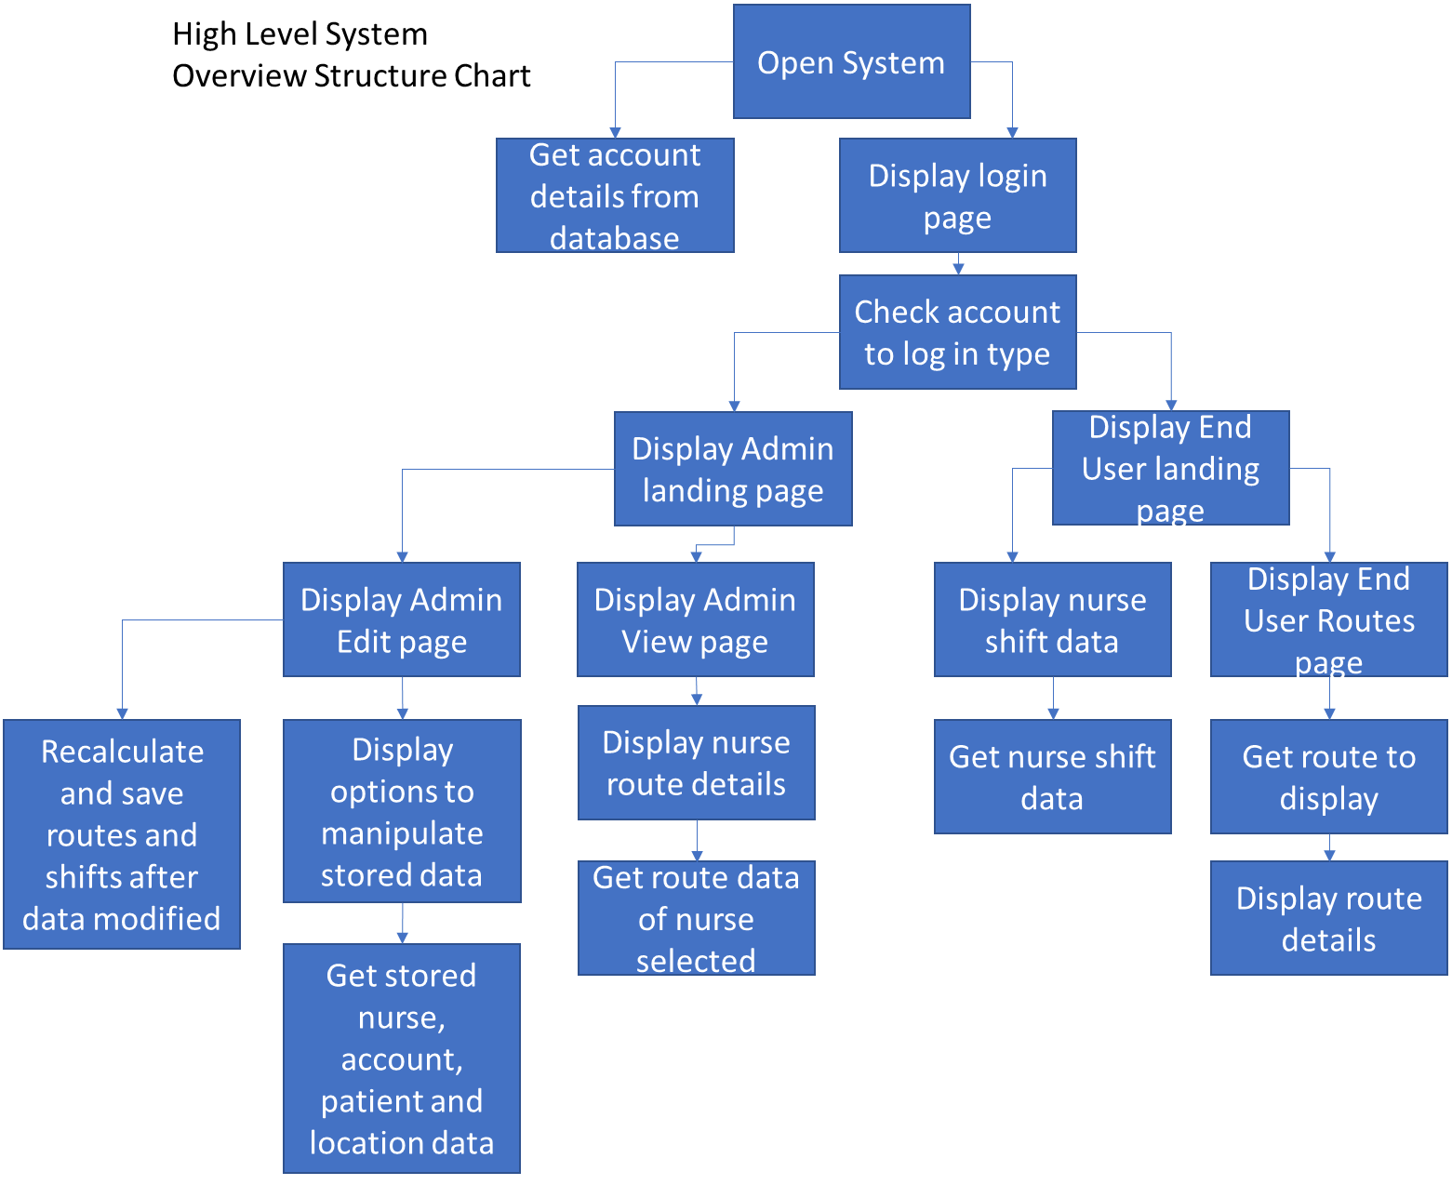

When a user opens the application, a log in page will be displayed where the user can enter their account username and password to sign in. Once logged in, the user will be directed to their relevant landing page, depending on their account type (Admin or End User).

Nurses, who have End User accounts, will be directed to the End User landing page, where the user’s shifts over the five-day working week will be displayed in a simple, table format (therefore implementing objective 1.03.1). On this page, there will then also be the option to navigate to the End User routes page, where the user can select each of their shifts in order to view the corresponding route (meeting objective 1.03.2).

Admin users logging into Admin accounts will be directed to the Admin landing page, where they will have the option to navigate to either the Admin view or Admin edit page.

The Admin view page will allow the user to select an existing nurse, then view each of their routes (therefore implementing objective 1.02.4).

Whereas, the Admin edit page will allow the user to select whether they wish to manipulate admin, nurse, patient or location data. Then, it will enable the user to search for, amend or delete existing data of the type selected, or add new data. All of the changes to data on this page will be saved to the database and stored persistently - therefore implementing objectives 1.02.1 – 1.02.31 and 1.21 – 1.25 – and once changes are made to this data, shifts and routes will be recalculated and saved.

On each page (except the login page), the user will be given the option to log out of their account, which would therefore direct them back to the login page. Users would also be able to navigate back and forth between the different pages that their account type provides access to.

## OOP Model

### Overall Overview

A UML diagram of the model’s overall structure is shown below. These classes enable patient, location, account, nurse, route and shift data to be manipulated by the user, therefore enabling objectives 1.02.1 – 1.02.31 to be met. Instances of these classes also enable the scheduling, optimisation and viewing of routes and shifts (meeting objectives 1.02.4, 1.03.1, 1.03.1 and 1.31 – 1.41.1).

**Overall UML diagram of system’s OOP model**

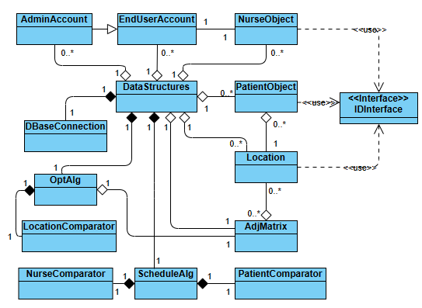

In the model above, the class DataStructures links most classes together as an instance of the class will be used to maintain the program’s state, and will be passed between the controllers of each page in the UI (which control the page’s functionality).

Objects will be instantiated from the classes shown in the model using data fetched from the database, and from user input. Any changes to existing objects or creations of new instances by the user will also be saved to the database as well. All queries to the database will be made through calling the methods of an instance of the class DBaseConnection.

Below is a list of the rest of the classes (and interface), shown in the diagram above, and their uses. This is then followed by more detailed explanations of the attributes and methods of each.

* IDInterface
  + Interface used for generating unique IDs for each instance of NurseObject, PatientObject and Location.
* NurseObject
  + Represents each nurse and holds their data (including their routes and shifts).
* EndUserAccount
  + Represents and holds the details of each nurse’s End-User account.
* AdminAccount
  + Represents and holds the details of each admin user’s Admin account.
* PatientObject
  + Represents each patient and holds their data.
* Location
  + Represents each patient location and holds its data.
* AdjMatrix
  + Used to represent a graph of patients’ Locations as an adjacency matrix.
* ScheduleAlg
  + Used to perform the scheduling of patients and nurses.
* OptAlg
  + Used to optimise each nurses’ shifts.
* PatientComparator, NurseComparator and LocationComparator
  + These comparator classes are used to sort their corresponding object types (PatientObjects, NurseObjects or Locations), when they are added to arrays or priority queues and a specific order must be maintained.

### IDInterface

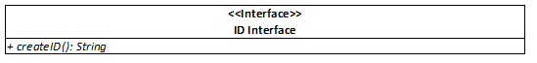

This interface (shown above), contains the abstract method createID(), which is used in PatientObject, NurseObject and Location to create unique ten letter IDs to identify each individual instance. These IDs are also used as primary keys when data is stored in the database.

### NurseObject



The UML diagram of the NurseObject class above contains attributes which allow each of its instances to hold an individual nurse’s data.

**Key Attributes**

The boolean array workPattern stores the details of a nurse’s working pattern over the five-day working week, with each boolean within the array representing whether or not the nurse works on that day (Monday – Friday).

The multi-dimensional arrays shifts[][] and orderedShifts[][] are used to store the shifts of a nurse over the five-day working week, with each array within them representing the shift for a day.

These two attributes each contain five arrays of 24 strings, as each 12-hour shift (from 07:00 to 19:00), is split into 30 minute segments represented by each index value. This means that, when patients are assigned to a shift, their unique IDs (created using IDInterface), are stored in the array for either three or four consecutive index values, representing an appointment for that patient that is either 90 minutes or two hours long if they require a longer appointment time. This would then be followed by “BREAK” in the next index value to allow the nurse 30 minutes between each visit to allow time for travel and a break.

The attribute shifts[][] is used to store the nurse’s shift when it is created by the scheduling algorithm. This information is then utilised by the route optimisation algorithm to create a new, optimised shift which is more efficient and is stored by the attribute orderedShifts[][].

The integer shiftsFilled is an attribute which counts the number of shifts which are not available to fill, including days on which the nurse does not work. It is used in the scheduling algorithm to keep track of how many shifts each nurse has available to fill.

Also, once the optimisation algorithm has run, the attribute routes[] is used to store the optimised routes for each day. Each String within the array stores several 10 letter location IDs (again created for instances of Location using IDInterface), which represent the route between locations to reach each appointment. The IDs for the locations for each appointment in routes[] are also followed by “BREAK”, in order to signify that the appointment location has been reached.

**Key Methods**

When an object is instantiated from the class, one of the three constructors is called. The first, which takes the fewest arguments is used to create an instance from user input so calls the method createID(), which creates a unique nurseID for the new nurse. Whereas the second two constructors are used when objects are instantiated using data stored in the database, so do not call this method.

If the first or the third constructor are used to instantiate the object (meaning that the nurse it represents currently does not have any routes or shifts), the method assembleBaseShiftsRoutes() is called. This method instantiates shifts, routes and orderedShifts, setting the values of the strings in each to be “BREAK” on index values which correspond with days that the nurse does not work.

### EndUserAccount and AdminAccount



**EndUserAccount**



The classes EndUserAccount and AdminAccount (shown by the UML above), are used to represent the Admin and End-User accounts of administrators and nurses. These classes have an is-a relationship as AdminAccount inherits from EndUserAccount. EndUserAccount is also associated with NurseObject, as each nurse stored in the system is represented by one of each of these classes, both with matching IDs.

**Key Attributes**

Instances of the account classes store a username for each user (for example, the username for admin user John Smith would be JohnSmith), which is used to log into the system alongside the passwordHash. This attribute stores the hashed version of the corresponding user’s password in order to hold it securely while still enabling it to be used to authenticate the user when they attempt to log in.

The attribute salt, represented by an array of bytes and unique to each individual account, is also held by instances of the classes in order to further improve security.

Unlike the superclass EndUserAccount, AdminAccount has the attribute name, so that the identity of each admin user can be held. This is not necessary for EndUserAccount as each instance will have a corresponding instance of NurseObject (with the same ID), where the name of the nurse is stored.

**Key Methods**

These classes have two constructors, one with fewer arguments to instantiate objects from user input, and one with more arguments to create instances from data stored in the database.

The constructor for user input takes the arguments name and password, first calling the method generateUsername(name) and storing the result in username. Then, the constructor calls the method generateSalt() in order to create a unique array for the account’s salt. Next, the method createHash() is called twice, once to create a hash of the password entered to store in passwordHash, and once to create a hash of the name associated with the instance in order to create a unique account ID (stored in the attribute accountID).

The final method in the class (other than its getters and setters), is the method compareToPassword(), which is used when the user attempts to log in to create a hashed version of the password entered by the user, which is then compared to the attribute passwordHash in order to authenticate them.

### PatientObject

The UML diagram of the PatientObject above represents how patient data will be stored while the program is running, with each instance of this class representing an individual patient. This class also has a weak has-a relationship with Location (aggregation), so that each patient can be linked to their location for route optimisation.

**Key Attributes**

This class contains attributes used for scheduling and route optimisation such as pLevel, an integer representing the patients’ priority level, and extendedVisit, a boolean representing whether a patient requires an extended visit time. Both of these attributes are used to calculate the patient’s overall priority level, which is held in the attribute overallPLevel.

In order to store patient priority, all patients are categorised into different levels of priority (from one to three where one is the highest), by admin users before their details are entered into the system. This priority level is used to determine the urgency with which a patient requires an appointment, so is used to assign patients with higher priority to nurses’ shifts first.

This attribute and extendedVisit are then used to calculate the patient’s overallPLevel attribute (which is an integer from one to six), where patients who require longer visit times are prioritised above others of the same priority level as these longer visits are harder to fit into shifts.

Each instance of PatientObject also holds the first address line of the current patient, which is then displayed for nurses to view, as well as the patient’s location (represented by an instance of the Location class).

**Key Methods**

This class has two constructors, one for instantiation with user input and one for instantiation with data from the database. Both call the method setUpObject(), which sets the values of each of the class’s attributes (apart from patientID), calling the method calcOverallPLevel() to initialise overallPLevel.

When instantiated from user input, the method createID() (from IDInterface) is also called to create the corresponding patient’s unique, 10 character ID.

### Location and AdjMatrix

The UML diagrams of the AdjMatrix and Location classes below represent how patient locations (the areas in which patients live), are held and how they are utilised to create an adjacency matrix representing a weighted graph which implements instances of Location as nodes and uses the relative distances between them for edge weights. Implementing this graph with these classes then enables graph traversal to be used to optimise routes.

**Location**

KeyAttributes

The class Location’s main attributes are adjacencies and adjWeights, two parallel arrays which contain a list of an instance’s adjacent locations (in the form of their unique IDs which have been created using IDInterface), and the weights between those adjacencies and the instance itself.

This class also contains the attributes distance, route and initialNode, each of which are used in the implementation of Dijkstra’s algorithm during route optimisation. The attribute distance is used to track the instance’s distance from the initial node in the graph, while route is updated to maintain the route from the initial node to that instance until it can be transferred become part of the routes attribute for a route in an instance of NurseObject. Also, the boolean initialNode is used to determine whether optimisation starts from a specific instance of Location or not.

KeyMethods

This class again has two constructors, for instantiation either from user input or database data. Both constructors call the method setupLocation(), which initialises the attributes: name, adjacencies, adjWeights and numAdj. It also calls determineInitialNode(), which checks whether the instance’s name is “Hospice”, meaning that it represents the initial node that each nurse starts from for each shift. If this is true, initialNode is set to true, distance is set to 0 and route is set to the unique locationID of the instance. Otherwise, initialNode is false, distance is 999 and route becomes an empty string.

This class also contains several methods for manipulatnig an instance’s adjacencies, for example, addAdjacency(), removeAdjacency() or changeWeight().

**AdjMatrix**

KeyAttributes

In this class, the adjacency matrix is represented by a 2D array of integers and an array of Locations (named nodes), to establish which rows and columns in the matrix represent which locations.

KeyMethods

The class AdjMatrix has a single constructor, which calls the method constructMatrix() in order to initialise the matrix attribute using the nodes array.

Then, once the object has been initialised, the graph it represents can be manipulated using methods such as addEdge(), removeNode() or getEdgeWeight().

The method getInitialNode() returns the initial “Hospice” node stored in the graph, and is used alongside resetAllNodeDistancesRoutes(), which calls the method determineInitialNode() for each Location node to reset distances and routes to their initial values, in order to perform route optimisation.

### ScheduleAlg and OptAlg

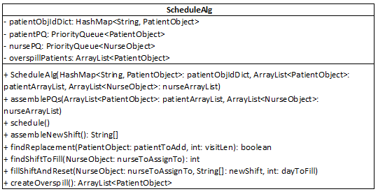

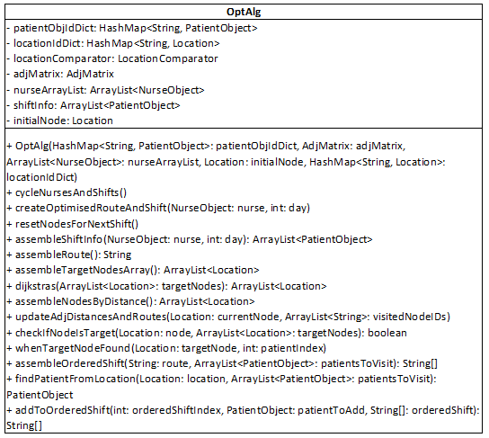

These two classes are used to implement the scheduling and route optimisation algorithms, as is shown in the UML diagrams above. Both classes are linked to DataStructures by composition, as instances are only instantiated when the DataStructures method calculateShiftsAndRoute() is called.

In ScheduleAlg, the constructor calls the method assemblePQs() to initialise the priority queues used for scheduling, then the method schedule() can be called to start the scheduling process.

In OptAlg, the method cycleNurseAndShifts(), which cycles through and optimises all of the shifts of each nurse can be called to start route optimisation.

The methods of each class which actually perform the scheduling and optimisation algorithms are explained and shown in pseudocode in the Scheduling Algorithm and Optimisation Algorithm sections (starting page 52).

### Comparator Classes

The classes LocationComparator, NurseComparator and PatientComparator[2] each have a single method called compare(), which compares a specific attribute of two objects, returning 1, -1 or 0. These classes are each used to sort lists or priority queues of either Locations, PatientObjects or NurseObjects during scheduling or route optimisation by either distance, overall priority or shift availability respectively.

### DBaseConnection

An instance of the class represented by the UML diagram above is instantiated as an attribute in the DataStructures class in order to make queries to the database.

**Key Attributes**

The three constants DBASE_ADDRESS, DBASE_USERID and DBASE_PWORD are used throughout this class to connect to the database.

**Key Methods**

The method connectToDBase(), which returns Statement, is used throughout the system to make SELECT queries to the database.

Other methods in this class used to make queries are updateRecord(), insertRecord(), insertNotAllColumns() and deleteRecord(), each of which construct either an UPDATE, INSERT or DELETE SQL query in the form of a string, then using it as an argument to call the method queryDBase(), which then connects to the database (using the method connectToDbase()), and queries it.

### DataStructures

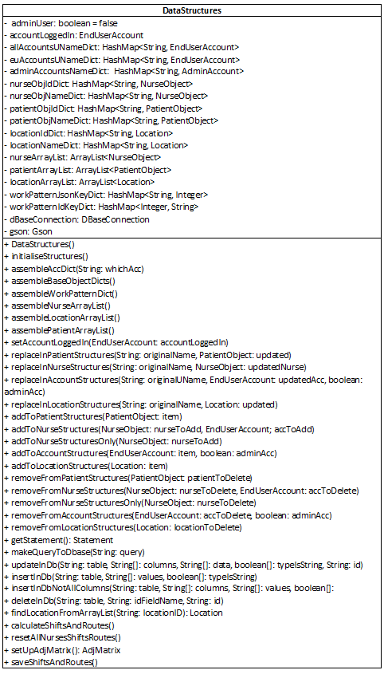

The UML diagram above represents the class DataStructures. This class is used to maintain the program’s state while the system is running, and also to fetch and format data from the database into objects.

**Key Attributes**

The main attributes of this class include accountLoggedIn (an instance of EndUserAccount), which stores the account object of the user currently logged in. This is used alongside the boolean adminUser to determine which individual user is logged in and what type of account they are using.

This class also stores ArrayLists of NurseObjects, PatientObjects and Locations, which are instantiated using the attribute dBaseConnection (an instance of DBaseConnection), to fetch the relevant data from the database. These attributes are then used to create dictionaries of these classes which are used to hold all existing nurses, locations and patients so that they can easily be looked up, using either their names or unique IDs.

The class also contains dictionaries of accounts, used for logging in and for holding all existing Admin and End User accounts.

**Key Methods**

Key methods within this class include initialiseStructures() which, depending on the account type logged in calls specific methods to initialise the dictionaries and ArrayList attributes of the class using data from the database (the methods which this method can call each begin with “assemble”).

While the system is running, these structures are maintained using the methods beginning with either “add”, “replace”, or “remove”, which are called when an admin user amends account, nurse, patient or location data.

The data in the database is also kept up to date using the methods updateInDb(), insertInDb(), insertInDbNotAllColumns() and deleteInDb(), each of which call the method for the corresponding SQL query in the attribute dBaseConnection.

This class also instantiates instances of OptAlg and ScheduleAlg in order to perform scheduling and route optimisation in the method calculateShiftsAndRoutes(), which calls resetAllNurseShiftsRoutes() (a method which resets all nurses’ shifts and routes before they are calculated again), before it begins the scheduling and route optimisation processes).

Once scheduling and route optimisation are complete, the new shifts and routes are then saved to the database using the method saveShiftsAndRoutes().

## Database Design

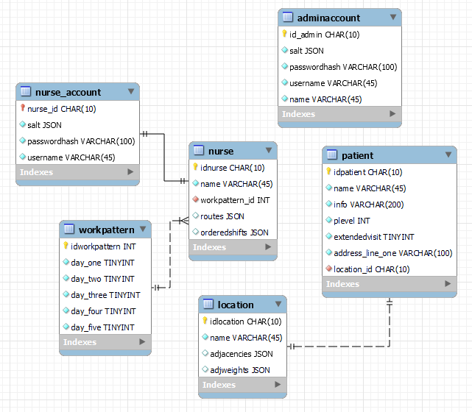

**Database ERD Diagram**

Data for patients, nurses, locations and accounts will be stored persistently in the structure of the entity-relationship diagram above in order to implement objectives 1.21 to 1.25.

**Storing Patient and Location Data**

Patient and location data are stored as is shown above, with the unique IDs created by IDInterface used to represent the primary keys in each of both of their tables. In order to create the OOP association link between the two types of data, a one-to-one relationship has been created between the tables with the foreign key location_id in the patient table referencing the primary key idlocation.

For each location (represented in the system by an instance of the Location class), both of its adjacencies and adjWeights attributes have been stored as JSON fields due to the number of each location’s adjacencies not being consistent for every location.

**Storing Nurse Data**

Data about nurses will be stored in the table nurse, using their unique nurseIDs (created by the NurseObject class) as primary keys.

The working patterns of nurse are stored in the database as a reference to a record from the table workpattern (containing fields representing each day of the working week), using the foreign key workpattern_id. This has been implemented in this way as the relationship between nurses and working patterns is many-to-one, meaning that it is more efficient to store working patterns in a separate table, therefore avoiding data redundancy.

Similar to working patterns, both routes and orderedShifts are attributes of NurseObject that are implemented as arrays and must be stored in the database. However, each route and orderedShift is unique to the nurse it is for (so has a one-to-one relationship), meaning that it is much simpler to parse these arrays into JSON and store them as a single field each in the database, instead of creating another table for routes and two extra tables for orderedShifts (due to orderedShifts being a 2D array, which would result in the need to implement a link entity to represent a many-to-many relationship).

Due to the IDs of EndUserAccount and NurseObject matching when they are used to represent the same nurse, data for End-User accounts (which is stored in the table nurse_account) has a foreign primary key, linked to the primary key of the nurse table, to represent the account’s ID. This is implemented in this way as nurses (represented as instances of NurseObject and records in the nurse table), must exist before End-User accounts (represented as instances of EndUserAccount and records in the nurse_account table).

**Storing Account Data**

In order to store data about Admin and End-User accounts, the tables adminaccount and nurse_account have been implemented. As explained above, nurse_account is linked to nurse, whereas adminaccount is not linked to any other table.

Both of these tables store a unique ID, a username and a hashed version of the password (in order to meet objectives 1.23 and 1.24). They also store a salt, represented as an array of bytes when the program is running, which is unique to each record. As a result, each salt has a one-to-one relationship with each account, so salts have been stored as JSON.

**Queries**

Queries to the database will be made through an instance of DataStructures calling the methods of an instance of DBConnection while the program is running. Details of which types of queries will be made and where, including examples, are detailed below.

SELECT

SELECT queries for fetching data from the database will be made when the user opens the application, and when the user logs in.

When the user opens the system, an instance of DataStructures is instantiated and queries made to the database to fetch the details of each account (which, once fetched, are formatted into instances of EndUserAccount and AdminAccount to authenticate the user when they attempt to log in). An example query for this process would be *“ SELECT id_admin, salt, passwordhash, username, name FROM adminaccount”*.

SELECT queries are then again made when the user successfully logs in, in order to fetch nurse, patient and location data for admin users to amend or for nurses to view their shifts and routes. The queries made for getting nurse data from the database to format into instances of NurseObject would be : *“SELECT idnurse, name, workpattern_id, routes, orderedshifts FROM nurse”*.

The workpattern_id fetched from this query would then be used to look up the corresponding working pattern from the dictionary workPatternIdKeyDict (an attribute of DataStructures), which would have been created using the query: *“SELECT idworkpattern, day_one, day_two, day_three, day_four, day_five FROM workpattern"*.

SELECT queries are also made when nurses are deleted from the system as workpattern records are linked to nurse records through a one-to-many relationship. As a result, to maintain data integrity and prevent data redundancy, the system must check that the work pattern used by the nurse is not used by another if it is to be deleted. As a result, the following query would need to be made, using the workpattern_id from the nurse record (represented in the query by workPatternID): *“SELECT idnurse FROM nurse, workpattern WHERE nurse.workpattern_id = workpattern.idworkpattern AND workpattern.idworkpattern = workPatternID”*.

INSERT, UPDATE and DELETE

When admin users input, amend and remove nurse, account and patient data from the database, queries using UPDATE, INSERT and DELETE would be used. Some example queries are listed below.

* *“UPDATE patient SET name = ‘John Smith’, extendedVisit = TRUE WHERE idpatient = ‘null4ec8jd’”*
  + This query would set the extendedVisit to true and name to John Smith in the record in the patient table had null4ec8jd stored in the idpatient field.
* *“INSERT INTO location (idlocation, name) VALUES (‘nulldc7e70”, “locationA”)”*
  + This query would create a new record nulldc7e70 in the location table with name locationA.
* *“DELETE FROM adminaccount WHERE id_admin = ‘null0a1eaa’”*
  + This query would delete the record with id_admin null0a1eaa in the adminaccount table.

## Human-Computer Interaction

The user interface (UI) will consist of six individual pages which the user can navigate through using the mouse and enter data into using the keyboard. The functionality of each individual page (called a Scene in JavaFX), is controlled by its own controller. Each page is detailed below with screenshots and an explanation of the controller methods which implement the Scene’s functionality.

Please note that each scene (except the login page), contains a label called currentAccount, a “Logout” button, and also may contain a “Back” button at the top of the window (if it is not a landing page). These objects perform the same functions on each page, which are detailed below.

The label currentAccount displays the username of the account currently logged in. The “Logout” button, if clicked, calls the method openLoginScene() which directs the user back to the login page and logs them out of the system. The “Back” button returns the user to their relevant landing page (either calling openAdminLandingScene() and returning an admin user to the Admin landing page, or calling openEULandingScene() and returning a nurse user to the End User landing page).

Also, an instance of the class DataStructures (instantiated when the application is first opened), which contains all nurse, patient, account and location data is also automatically passed between each controller - using the JavaFX methods getUserData() and setUserData() – so that the program’s state can be maintained and any changes saved to the database.

### Login page

When the user first opens the system, they will be able to view a login page as is shown below:

Label here is updated to display an error message if the username entered does not exist, the password entered is incorrect, or if either field has been left blank.

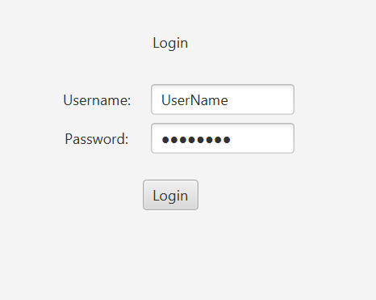

On this page, in order to meet objective 1.01, admin users or nurses will be able to log into either an Admin or End-User account respectively, by entering their unique username and password into the relevant fields (as is shown above).

When this page opens, a new instance of DataStructures is created, and the details of all the existing accounts in the database are fetched and used to instantiate either an instance of AdminAccount or EndUserAccount to represent each one. These objects are then stored in an account dictionary (allAccountsUNameDict), with the account username as the key for each.

Once the user has entered their details, they can click the login button, which will call the method attemptLogin(). This method looks up the username entered in allAccountsUNameDict. If a corresponding account exists, the password entered is then hashed and compared with that account’s stored hashed password. If the two passwords match, the relevant landing page is opened based on the type of account (Admin or End User), which the user is logging into.

### Admin landing page

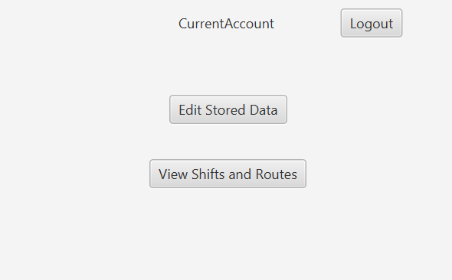If the user logs into an Admin account, the landing page below will open.

Once this window has opened, the user can click either of the three buttons.

Clicking the “Edit Stored Data” button calls the openAdminEditScene() method which directs the user to the Admin edit page, whereas clicking on the “View Shifts and Routes” button calls the openAdminViewScene() method that directs the user to the Admin view page.

### Admin view page

The page shown below implements objective 1.02.4, enabling an admin user to view all nurses optimised routes.

The error label here is updated to contain “No shift and route scheduled for *(day selected)*” if the user selects a day on which the nurse selected either does not work or does not have a shift.

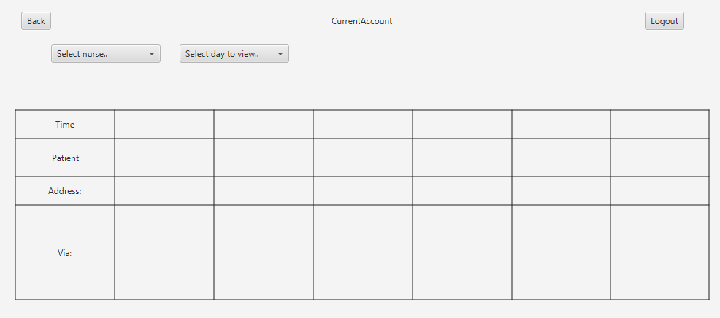

As is shown in the screenshot above, the user can use the “Select nurse..” comboBox (named nurseComboBox), to choose a nurse from a list of all existing nurses’ names in order to view their routes, using the mouse. The user is then able to click on a day (from Monday to Friday) to view the route for that nurse on a specific day, from the dropdown menu displayed by the “Select day to view..” comboBox (named dayComboBox).

When a day is selected, the method viewRouteDay() is called. This method first clears the text displayed by the error label (shown in the screenshot), then clears the grid of information (apart from the labels in the far-left column), by calling the method clearGrid(). This information is represented by a 2D ArrayList of labels (named routeLabels), with one in each segment of the grid between columns two to seven.

Next, using the instance of DataStructures, the method looks up the corresponding NurseObject instance in a dictionary of all existing nurses (nurseObjNameDict), using the name selected from nurseComboBox as a key. Once the corresponding value is found, the day selected from dayComboBox is converted into an index value (from 0 to 4). This value is then used to find the route to display by finding the value at the day index in the NurseObject routes[] attribute.

Once the corresponding route is found, if it is null (meaning that the nurse does not have a shift on that day), or is equal to “BREAK” (meaning that the nurse has a day off on that day), then the message “No shift and route scheduled for *(day selected)*” is displayed on the label above.

Otherwise, the method fillGridPane() is called, which in turn calls the method assembleRouteLabelContents(). This method returns a 2D array of Strings, with each array within the data structure representing a row of the grid. The code in fillGridPane() then iterates through this array, populating the text for each route label, and therefore the grid, row by row with the information below.

* Row One
  + Each column contains the start time of the appointment.
* Row Two
  + Each column contains the name of the patient being visited, as well as any information about the appointment which the nurse needs to know.
* Row Three
  + Each column contains the first address line of the patient, followed by the name of their location.
* Row Four
  + Each column the route the nurse should travel via to reach the appointment (shown as a list of location names).

### Admin edit page

A screenshot of this page is shown below. The Admin edit page implements the objectives 1.02.1 – 1.02.31 as it allows admin users to edit all patient, nurse, account and location data stored in within the system.

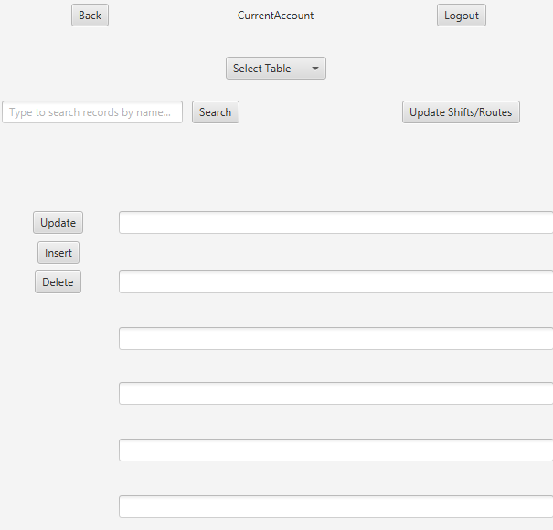

The status label here updates to display error messages when data is input incorrectly.

**Selecting which type of data to edit**

When this page of the UI opens, admin users are able to select the type of data they wish to edit from the “Select Table” comboBox (named tableComboBox). Users can select either Admin, Nurse, Location or Patient, which cause the method onTableToEditUpdate() to be called. This method calls clearCurrentRecordData() (which clears the TextFields shown), and updateLabelNames(), which resets and then updates the names of the labels above each text field, so that the user knows where to enter input. The text which the labels are changed to is shown below.

* If Location is selected the labels above the first two fields are set to:
  + "Name"
  + "Adjacent locations and distances (in format: ‘Name: distance(km), Name: distance, ...’)"
* If Admin is selected the labels above the first three fields are set to:
  + "Name"
  + "Set new password”
  + “Confirm new password”
* If Nurse is selected the labels above the first four fields are set to:
  + "Name"
  + “Days off (in format: ‘Mon, Wed, Thu, …’)”
  + "Set new password"
  + “Confirm password”
* If Patient is selected the labels above each of the six fields are set to:
  + "Name"
  + "Information"
  + “Priority level (1-3)”
  + “Requires extended visit (Y/N)”
  + “Address line one”
  + “Location name”

**Amending, adding or removing data**

Once the user has selected the data to edit from tableComboBox, they can either start entering data to insert new data, or search for existing data to modify or delete.

Adding new data

If the user decides to enter data directly into the TextFields and press the “Insert” button, which will validate the data based on which type of data is being edited and construct a new instance of a class based on that data. Then, the system will either add the object to its corresponding structures in the instance of DataStructures and insert it into the database, or, the status label will be set to display the appropriate error message if the data has been entered incorrectly.

Searching for data and amending or removing it

If the user wishes to amend or delete existing data, they can type the name of a location, account holder, patient or nurse into the “Type to search records by name..” TextField (named recordSearchTextField), and click the Search button to call the method onRecordSearch().

This method calls clearCurrentRecordData() to clear the TextFields of data, then looks up the corresponding object in one of DataStructures’ dictionaries of the corresponding type, which uses the object’s name for as a key (for example, locationNameDict). If an object is found, its details are displayed in the corresponding TextFields, otherwise the status label is updated to display an error message.

Once an object has been found and displayed, the user can then either update the TextFields’ contents and press the “Update” button, or can press the “Delete” button.

Pressing the “Delete” button calls the delete method for the corresponding datatype (e.g. deletAdmin()). This method validates the data to ensure it can be deleted safely, then calls a method in DataStructures to remove the object from the attributes of its corresponding type within DataStructures. Then, a method is called to delete its corresponding record from the database. If the data cannot be deleted safely, for example, if a user tried to delete a location that was linked to existing patients, the status label would be updated to display the relevant error message instead.

Pressing the “Update” button would validate the data in the TextFields, then either display the appropriate error message if the data was incorrect or call the update method for the corresponding data type. If the update method was called, it would update the original versions of the data, currently stored in the attributes of the instance of DataStructures. Next, it would update the corresponding record in the database.

Updating all shifts and routes

Once the user makes a change to the program’s state by pressing either of the “Insert”, “Update”, or “Delete” buttons, the “Back” and “Logout” buttons would be disabled. This would prevent the user from navigating off the page until they had pressed the “Update all Shifts and Routes” button, which would update all shifts and routes and enable the “Back” and “Logout” buttons.

Pressing this button would call the method updateAllShiftsAndRoutes(), which would call the DataStructures methods calculateShiftsAndRoute(), then saveShiftsAndRoutes(). This would update each nurse’s shifts and routes, therefore adjusting for the admin user’s changes, and save these new shifts and routes to the database.

### End User landing page

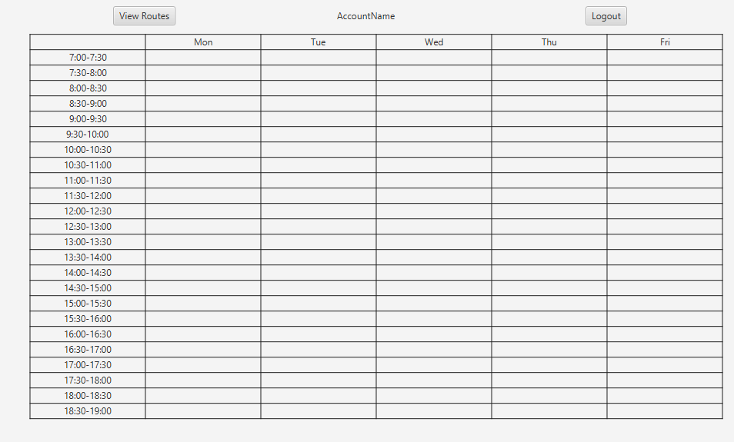The End User landing page, a screenshot of which is shown below, implements objectives 1.03.1 and 1.11, therefore enabling nurses to view their shifts over the working week.

When this window is displayed, the accountID of the accountLoggedIn attribute of the DataStructures instance is used to find the NurseObject instance which represents the nurse logged in by searching the nurseObjIdDict dictionary(another attribute of DataStructures), with the accountID.

Once the corresponding instance of NurseObject has been found, the method displayShifts() is called. This method gets each of the nurse’s orderedShifts for each day of the working week, populating the gridPane shown in the screenshot column by column, with patient names in the row which corresponds to their appointment time for the shift that they have been assigned to. If the nurse does not have a shift or does not work on some of the days, their corresponding columns are left blank.

If the user wishes to view the route for one of their shifts, clicking the “View Routes” button at the top left of the page will call the method openEURouteScene() which directs the user to the End User Routes page.

### End User routes page

The End User routes page (as is shown in the screenshot below), implements objectives 1.03.2 and 1.12 as it enables nurses to view each of their optimised shifts in a clear, simple format.

The error label here is updated to contain “No shift and route scheduled for *(day selected)*” if the user selects a day on which the nurse selected either does not work or does not have a shift.

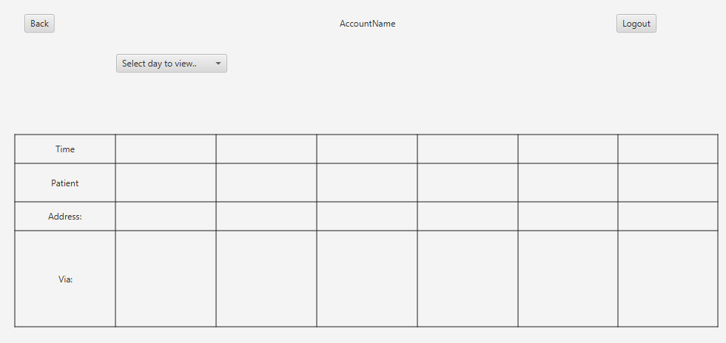

Routes are displayed for the End User logged in using the same methods as the Admin routes page to prevent the duplication of code. The only difference between the functionality of the two pages is that on the End User routes page, the nurse logged in can only view their own routes. Whereas, on the Admin routes page, the admin user can view the routes of any existing nurse using nurseComboBox which is not implemented on the End User routes page.

## Security

In order to meet objectives 1.23 and 1.24 and to keep nurse and patient data secure, users must log into their individual accounts to access the system. In order to store passwords securely, the result of them being hashed with a randomly generated salt is stored in the database instead[3]. Therefore, when the user tries to log in, the same process is applied to the password they enter, which is then compared with the stored value to authenticate the user.

The salt is implemented using the SecureRandom library, and the SHA-256 hashing algorithm (used for hashing), is implemented with the MessageDigest library class.

## Scheduling Algorithm

In order to schedule visits efficiently and automatically, the scheduling algorithm will utilise priority queues to group patients in order of priority level (and whether they have other requirements, such as extended visit times), and also to group nurses in terms of work patterns and availability, therefore meeting objectives 1.31 and 1.31.1

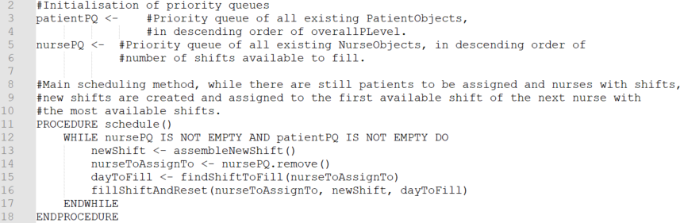The algorithm will then assign patients to nurses in shifts over the five-day period by assembling new shifts and using the method setShift() to set the first available array in the NurseObject attribute shifts equal to the new shift created. This algorithm is shown and explained below.

In the code above, the priority queues of patients and nurses are created, which store patients in order of overall priority level descending and nurses in order of the number of their shifts that are available to fill descending, through the use of the Comparator class in Java[4]. The scheduling process also begins once the method schedule() is called. In this method, while there are still patients to assign to shifts and nurses to be allocated shifts, new shifts are created with the assembleNewShift() method, then assigned to the nurse at the front of nursePQ (and therefore with the most shifts available to fill) with the method fillShiftAndReset(). The corresponding index number of the day to 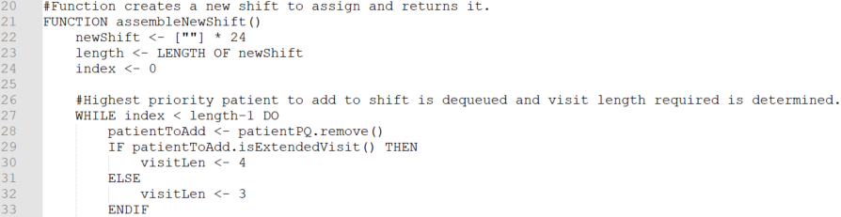assign the shift to is found and fetched with the method findShiftToFill().

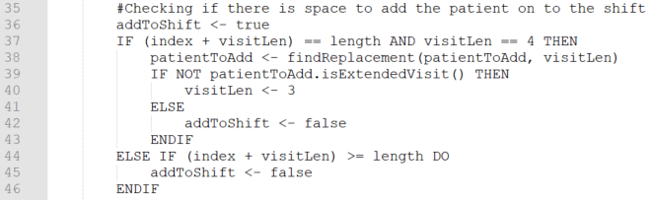In this pseudocode, once schedule() has called the function assembleNewShift(), a new and empty shift (newShift), is initialised and a loop begins that will iterate until the shift has been filled with patients. During this loop, the highest priority patient is dequeued from patientPQ and their required visit length is used to determine the number of time slots (index values), on the shift which their appointment will take up, and visitLen is set equal to this number.

Next, the pseudocode above checks that the shift still has the capacity to add this patient’s appointment using the boolean addToShift, which is initially set to true. If (index + visitLen) exceeds the length of the shift, the shift therefore does not have the capacity to add the patient on, so addToShift is set to false.

If (index + visitLen) is equal to the length of the shift and visitLen is equal to four (meaning that the current patient to add to the shift requires an extended visit), the method findReplacement() is called. This method attempts to find and return a patient from patientPQ that does not need an extended visit and therefore can be added to the end of the shift. If one does not exist, it returns the current patient and addToShift is set to false.

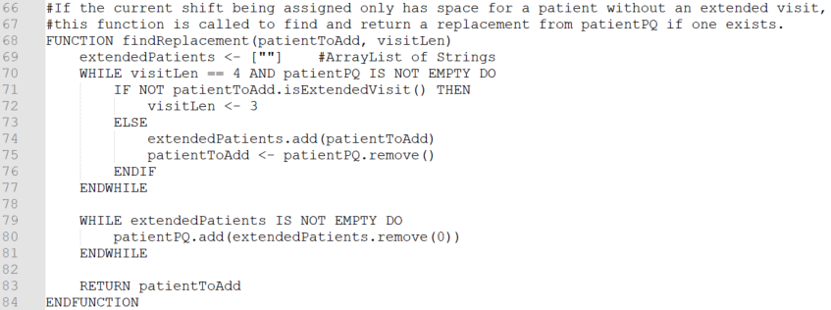

This pseudocode shows the findReplacement() function, which dequeues patients from patientPQ until it either finds one who does not require an extended visit (which it sets patientToAdd to), or until the priority queue is empty. While this is happening, dequeued patients who require extended visits are added to the ArrayList extendedPatients, where they can be temporarily held until the process has finished and they can be returned to patientPQ again.

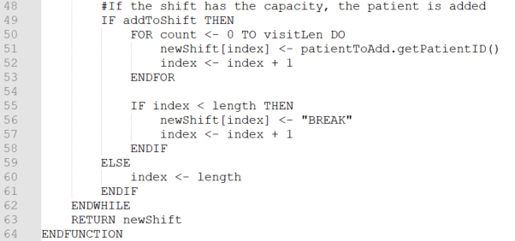Once the first loop has finished, the second runs, iterating until each of the patients in extendedPatients are enqueued back into patientsPQ. Then, patientToAdd (which either now holds a patient who does not require an extended visit, or has not changed since it was passed to the function), is returned.

In the code above, if a suitable patient to add to the shift is found, it’s unique patientID is stored in newShift, taking up visitLen index spaces in order to represent its visit length within the array. This is then followed by adding “BREAK” to the next available index in newShift (unless the visit and shift capacity end at the same index position). “BREAK” signifies the 30 minutes between two visits which the nurse has for travel and a break.

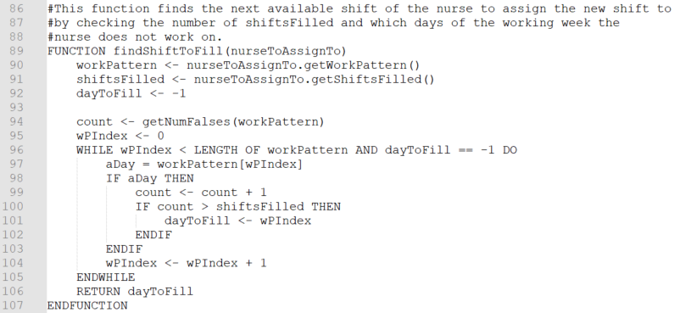The method then returns the newShift created if the shift has been filled (or the loop iterates, repeating this process until it has). Then, in schedule(), the nurse with the most shifts available to fill is dequeued from nursePQ and is passed as an argument to the function findShiftToFill(), which is shown in the pseudocode below.

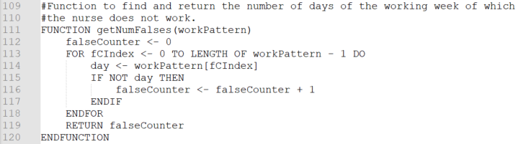This pseudocode uses the NurseObject attributes workPattern and shiftsFilled to find and return the index position of the next available shift. It does this by calling getNumFalses() (which is shown below), to find the number of days which the nurse does not work.

The integer which getNumFalses returns is assigned to count in findShiftToFill(), then the nurse’s work pattern is iterated through, incrementing count and checking whether it is greater than shiftsFilled each time the boolean aDay (which represents workPattern[wPIndex]), is true.

As a result of this, once count is greater than shiftFilled, wPIndex will be equal to the index position of that nurse’s first available shift, which dayToFill is set to. This then causes the loop to finish and the value of dayToFill to be returned to schedule().

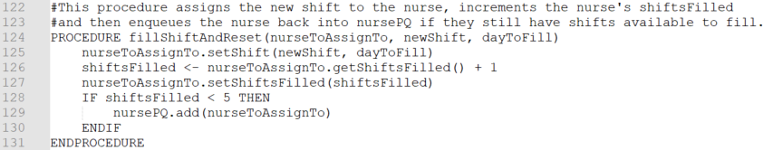

In schedule(), fillShiftAndReset() is then called, passing nurseToAssignTo, dayToFill and newShift to the function as arguments. The pseudocode for this method is shown above, in which the shift of nurseToAssignTo at index position dayToFill is set to newShift. Next, nurseToAssignTo’s shiftsFilled attribute is incremented and, if it is still less than five (meaning that the nurse still has shifts which are available to fill), nurseToAssignTo is enqueued back into nursePQ.

The procedure then ends, and this entire process repeats until the loop in schedule() terminates when there are either no more patients to assign to shifts or no more nurses with shifts available.

**Data Structures Used**

In order to complete the scheduling and store the results, priority queues are used.

A priority queue is a queue (a first-in-first-out abstract data structure), where the order of items in the queue is determined by their priority according to a metric, with the highest priority items at the front of the queue (and therefore dequeued first), and the lowest priority items at the back. In this algorithm, the priority queues patientPQ and nursePQ group patients in order of highest priority descending and group nurses in the order of most shifts available descending. This ensures that the highest priority patients are allocated to shifts first to provide them with the highest chance of receiving a visit possible, and that nurses have shifts allocated in a fair, more balanced manner.

Priority queues are suited for this purpose as they can automatically sort items efficiently, so do not need to be updated manually (unlike arrays where items are sorted to represent them in order), therefore ensuring that the item dequeued is always that of highest priority, and increasing efficiency if items need to be enqueued and dequeued regularly.

## Optimisation Algorithm (Dijkstra’s Shortest Path Algorithm)

The optimisation algorithm below uses a modified version of Dijkstra’s Shortest Path algorithm[5]. Dijkstra’s algorithm finds the shortest route between an initial node and every other node on a weighted graph, using a priority queue to store and process each node, as well as to traverse the graph in the order of shortest route first.

The version of this algorithm used in the solution below instead finds the closest node of a patient assigned to the shift of the highest priority level, then sets that as the initial node and repeats until all patients’ nodes for that particular shift have been visited (re-setting the priority queue and ArrayList of visited nodes each time a patient’s node of the target priority level is found).

The routes for each leg of the journey, each time a patient’s node has been found, are held in the route attributes of the patient’s location which then becomes the initial node. As a result, the route is gradually appended to each time a patient’s node is reached meaning that the node of the final patient to visit will contain the optimised route for the whole shift.

In order to create the optimised routes for each shift (and meet objectives 1.41 and 1.41.1), an adjacency matrix (represented through the class AdjMatrix), is created and uses instances of the Location class to represent each node. During the process, the routes for each nurse’s shifts are created and saved one-by-one, until all routes have been calculated.

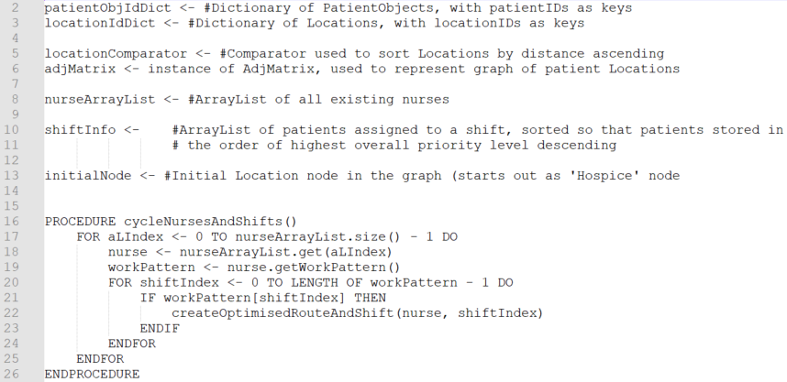This algorithm is explained below.

The pseudocode above shows the attributes of OptAlg, which are used throughout the optimisation algorithm. In order to start optimisation, the method cycleNursesAndShifts() is called; this method iterates through nurseArrayList, calling createOptimisedRouteAndShift() for each day that the nurse works.

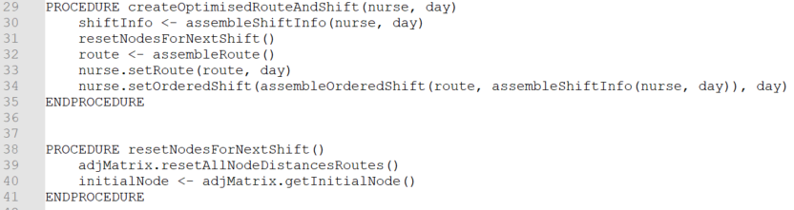

The createOptimisedRouteAndShift() procedure, as is shown above, creates an optimised shift and route for a nurse, then stores it in the corresponding attributes in NurseObject. It does this by first calling the method assembleShiftInfo() to initialise the ArrayList shiftInfo so that it contains the instances of PatientObject representing the patients assigned to the current shift.

Next, the procedure calls resetNodesForNextShift(), which resets the distance and route attributes of each Location node in the graph represented by adjMatrix and sets the value of the variable initialNode to the instance of Location in the graph which represents the Hospice, as each nurse would start their shift from the Hospice. When the route and distances are re-set, if the location is not the initial Hospice node, its distance is set to 999 and route to an empty string, otherwise, the distance is set to 0 and route to the node’s locationID.

It then calls the method assembleRoute() which creates the optimised route for the shift, storing it in the variable route. This is used to set the corresponding attribute for the current nurse. After this the method assembleOrderedShift is called and the value it returns is used to again, to set the corresponding attribute for the current nurse. This is explained in more detail below.

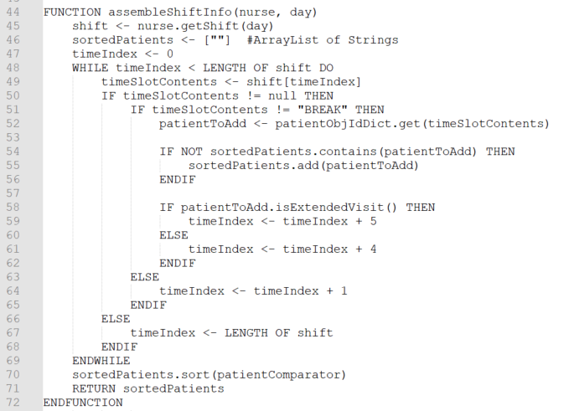

The function above assembles the variable shiftInfo by getting the corresponding shift of the nurse being processed and iterates over this, getting the unique patientIDs for each patient that is due a visit. Once it has found an ID, the function uses it to lookup the corresponding instance of PatientObject in the dictionary patientIdDict which it then adds to the ArrayList sortedPatients. This ArrayList is then sorted using an instance of PatientComparator to sort the patients by overall priority level in descending order. Once the loop has terminated the sorted patient list is returned and stored in shiftInfo in createOptimisedRouteAndShift().

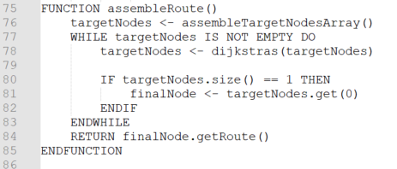

In createOptimisedRouteAndShift() once shiftInfo has been assembled, the method assembleRoute(), shown above, is called. This function assembles the optimised route for a shift by first creating an ArrayList of the locations of patients to visit (named targetNodes) by calling the method assembleTargetNodesArray(). It iterates through targetNodes calling the method dijkstras() until the targetNodes is empty. When there is only one node left in targetNodes it stores this in finalNode, the route of which is then returned by the method once the loop has terminated.

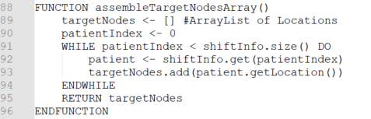

The method above returns an Array of the locations of patients assigned to the current shift that is being processed. It achieves this by iterating through shiftInfo, getting the location of each patient and appending it to the ArrayList targetNodes.

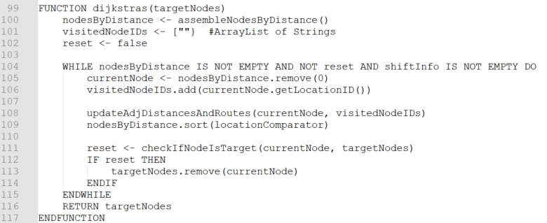

The function dijkstras() updates the distances and routes of each location on the graph represented by adjMatrix and initialNode (which is first set as the hospice location for the start of any route).

It first gets an ArrayList of all the locations in the graph, sorted in ascending order of distance from the initialNode by calling the function assembleNodesByDistance(). Next it iterates over this ArrayList removing the closest node and adding its location ID to visitedNodeIDs. The iteration process continues until either nodesByDistance is empty or a target node is found. In each iteration the first node in nodesByDistance is removed and the method updateAdjDistancesAndRoutes() is called to update the distance and route of the nodes adjacent to that current node.

After this, the method checkIfNodeIsTarget() is run to determine if the current node is a target node. If it is, then this method returns true, the current node is removed from targetNodes, the loop terminates and targetNodes is returned to assembleRoute(). Otherwise, the loop continues.

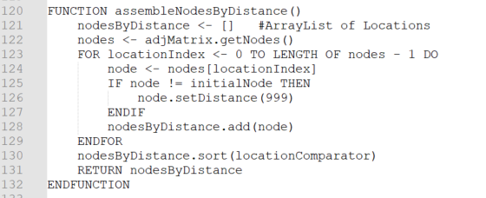

The function above is called in dijkstras() to initialise an ArrayList of locations sorted by distance from the initialNode in ascending order. When the function is called it gets all of the nodes from adjMatrix, iterating over them and adding each to nodesByDistance. If a node is not equal to initialNode, then it’s distance is set to 999 before it is added. Once the loop has been terminated the locations are sorted using locationComparator and the ArrayList nodesByDistance is returned.

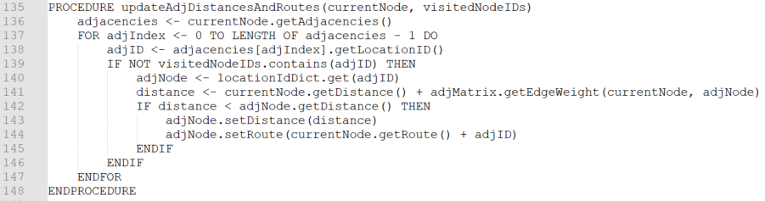

The method above, updateAdjDistancesAndRoutes() is called in dijkstras() in order to update the distance and routes of the currentNode’s adjacencies. First the method fetches the adjacencies of the current node, storing them in the array adjacencies. Next, the method iterates over each of currentNode’s adjacencies checking whether their IDs are in visitedNodeIDs (therefore whether they have been already visited). If they have not, the distance of each adjacency is updated where the distance between the adjacency and the initial node (via the current node) is less than the current distance of the adjacency, and the route to the adjacent node is set to the route to currentNode and the adjacent node’s locationID. This ensures that the shortest route to the adjacency is found and, once each adjacency has been processed, the loop terminates and the procedure ends.

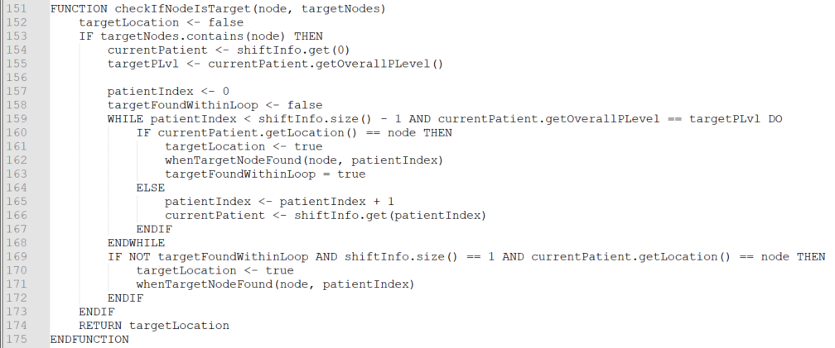

During dijkstras(), in order to check if the current node being processed is the location of a patient assigned to the shift, the function checkIfNodeIsTarget() is called. This function (shown by the pseudocode above), checks if the current node is a member of targetNodes. If it is, the method gets the overall priority level of the first patient in shiftInfo which is the highest priority level of the patients left to visit, and therefore is set as targetPLvl (the target priority level).

Next, the method iterates through the patients of the targetPLvl in shiftInfo(), checking the locations of each to see if they are equal to the current node. If they are, target location is set to true and the method whenTargetNodeFound() is called. Otherwise, the method continues to iterate through shiftInfo.

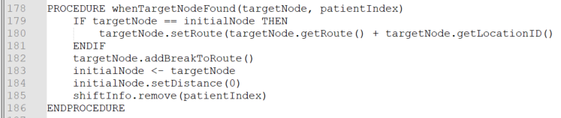

The procedure whenTargetNodeFound above adds “BREAK” to the route of targetNode signifying that a visit location has been reached. If the targetNode is equal to the initialNode the ID of the node is appended to the route and “BREAK” is added. After this, the initalNode is set to equal targetNode and distance is reset to zero in order to set up the initialNode for the next run of dijkstras(). The corresponding patient for the visit is also removed from shiftInfo.

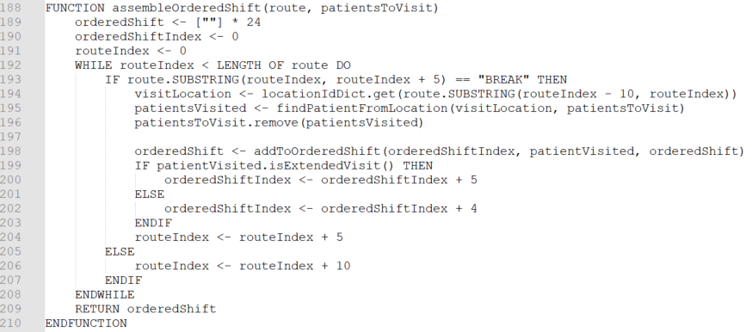

The function assembleOrderedShift() (shown in the pseudocode above), is called during createOptimisedRouteAndShift() in order to create a nurses ordered shift for a specific day. In order to produce the shift the method iterates through the optimised route that has been created for the nurse by the method AssembleRoute(). Each time the algorithm encounters a “BREAK” it finds the corresponding location of the locationID before the “BREAK” in route. Next, the patient at this location is found by calling the method findPatientFromLocation() and is removed from patientsToVisit (an ArrayList of each of the patients to visit on this shift). The array orderedShift is then updated through a call to the method addToOrderedShift(). This is then repeated until every patient to visit has been added to orderedShift which is then returned.   
  
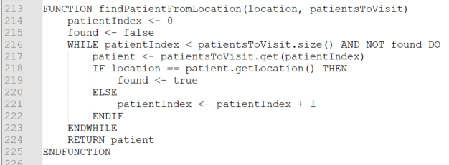  
  
  
The method findPatientFromLocation(), as shown above, iterates through patientsToVisit, checking if the location of each is equal to location. If it is, the loop terminates, and the corresponding patient is returned.   
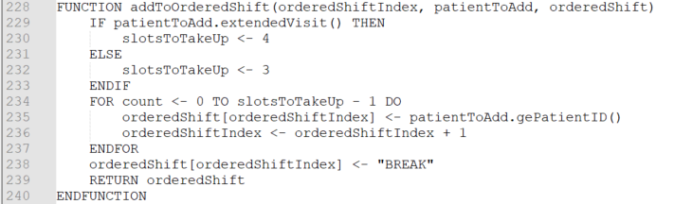  
  
  
The method addToOrderedShift() (shown above), adds the patient ID of patientToAdd to orderedShift starting at orderedShiftIndex. The patient either takes up three or four slots depending on whether they require and extended visit or not, and the method then adds “BREAK” into the next available index position and returns the updated version of orderedShift.

**Data Structures Used**

In this algorithm, both an adjacency matrix and a weighted graph are used. The weighted graph is used to represent patient’s address areas (LocationObjects), and the relative distances between them so that optimised routes for each shift can be calculated. The weighted graph is implemented through an adjacency matrix, represented by the class AdjMatrix (which is further explained in the OOP Model section).

An adjacency matrix – where each column and row represents a node, and the integer at their intersections represents an edge weight - has been selected to represent the graph instead of an adjacency list (which consists of a list of all the nodes, with each node directly connect to a list of its adjacent nodes paired with the edge weights between them), as a matrix can be implemented as a 2D array, instead of a list of dictionaries (where each key-value pair is the name of an adjacent node and the edge weight), which is needed to implement an adjacency list. The matrix is therefore better suited to the system than the list as it is more easily represented and manipulated due to the data structures required to implement it being more simplistic and flexible.

Dijkstra’s algorithm often uses a priority queue to traverse the graph and track the distances between nodes and the initial node, but a dynamic array (which will be implemented as an ArrayList in Java), is better suited in this scenario as the items in priority queues can only be accessed by dequeueing them in order of priority, whereas items in the ArrayList can be sorted in order of priority and accessed in any order. The ArrayList is therefore better suited to the implementation of this algorithm as it can perform all the functions of a priority queue, while also enabling the programmer to directly access and amend items randomly instead of serially, so it is more flexible and easier to implement.

# Technical Solution

## Graphical user interface Description automatically generated with low confidenceProgram Listing

### Overview

The file structure of the technical solution is shown to the left.

The main, complex optimisation and scheduling algorithms, which use queue operations and graph traversal, are stored in the classes OptAlg and ScheduleAlg on pages 78 onwards.

The package guiLayout contains the controllers for each scene of the GUI, which enable the user to view shift and route data. AdminEditController also contains methods which update, insert and delete records from the MySQL database and can be found on pages 102 onwards.

The package oopModel contains the main classes and interfaces used in the program, including the AdjMatrix class (page 89 onwards), which represents a graph stored as an adjacency matrix and is used for graph traversal in the modified Dijkstra’s algorithm in OptAlg.

Also, the package oopModel.storage contains the class DataStructures (from page 70), in which data is read from the database and dictionary operations are performed in order to maintain the program’s state.

The package resources.com.guiLayout contains the .fxml files in which the structure of each GUI scene is stored for the controllers to interact with.

## Objectives

The table below lists the objectives for this project (as defined in the Analysis section), and the page numbers of algorithms where they are achieved.

To evidence completeness and complexity, the code achieving the more complex objectives (highlighted in **bold** in the table below) is described with annotated screenshots within this section, unit testing is also included for the scheduling and optimisation algorithms.

The less complex objectives will be evidenced throughout the testing section.

|  |  |  |  |
| --- | --- | --- | --- |
| Objective ID | Requirement | Objective met? | Page no. |
| 1.01 | The system should have unique logins and passwords for individual users | Yes | 108 |
| 1.02 | Admin users should have accounts with greater access rights | Yes | 108-112 |
| **1.02.1** | Admin users should be able to modify data about, add or delete nurses and patients | Yes | 110-112 |
| **1.02.2** | Admin users should be able to add, amend or delete patient address areas (Locations), and their relative distances | Yes | 102-105  108,109 |
| **1.02.3** | Admin users should be able to add and remove other Admin or End User accounts | Yes | 109-111 |
| **1.02.31** | Admin users should be able to reset the passwords of other Admin and End User accounts | Yes | 109, 111 |
| 1.02.4 | Admin user should be able to view the routes of all nurses in the system | Yes | 112 |
| 1.03 | Nurses should have access to simpler accounts with fewer access rights | Yes | 112-113 |
| 1.03.1 | Nurses should be able to view their shifts over a five-day period | Yes | 112-113 |
| 1.03.2 | Nurses should be able to the view the optimised route for each of their shifts | Yes | 112-113 |
| 1.11 | Shifts for nurses should be presented in a clear, simple format | Yes | 112-113 |
| 1.12 | Routes for each shift should be presented in a clear way, and should be easy to navigate to | Yes | 112-113 |
| **1.21** | Data for each patient should be stored persistently | Yes | 111-112 |
| **1.21.1** | The system should store the name and address of each patient | Yes | 111-112 |
| **1.21.2** | The system should store the priority level of each patient, and whether they require an extended visit time | Yes | 111-112 |
| **1.22** | Data for each nurse should be stored persistently | Yes | 110-111 |
| **1.22.1** | The system should store the working patterns; the details of each 12-hour shift; and corresponding routes for each nurse | Yes | 111-112 |
| **1.23** | The username and password for each Admin account should be stored securely and persistently | Yes | 109 |
| **1.24** | The username and password for each End User account should be stored securely and persistently | Yes | 110-112 |
| **1.25** | Data for locations of patient addresses and their relative distances should be stored persistently | Yes | 108 |
| **1.31** | The system should organise visits to patients over a five-day period | Yes | 78-84 |
| **1.31.1** | The system should schedule higher priority patients first | Yes | 78-84 |
| **1.41** | The system should determine the most efficient route between patients for each shift of each nurse | Yes | 85-101 |
| **1.41.1** | The system should prioritise patient priority over minimising travel distance when creating optimised routes | Yes | 93-101 |

## A Level Standard

The table below contains detail on how this project is of A Level complexity, as well as how and where this standard is met.

|  |  |  |
| --- | --- | --- |
| Technical Skill | How skill is used | Page number for evidence of use |
| Complex data model in database (eg: several interlinked tables) | The database is comprised of several tables, interlinked with foreign keys to implement multiple one-to-one and one-to-many relationships. | 40  108-112 |
| Queue operations | The scheduling algorithm uses two priority queues in order to assign patients to shifts and shifts to nurses. | 78-81 |
| Graph traversal | The optimisation algorithm uses graph traversal to link patient addresses and generate the most efficient route between them for each shift. | 93-98 |
| Hashing | Hashing is used to generate unique IDs for each individual nurse, patient, admin and location – as well as to securely store account passwords. These IDs are implemented as attributes in objects and primary keys in tables to identify specific data. | 88  108-112 |
| Complex user defined algorithms | Both the scheduling and optimisation algorithms are complex, user-defined algorithms. | 78-84 93-101 |
| User defined use of complex OOP model | When the user interacts with the system, their actions result in use of the complex OOP model, which contains several classes linked by aggregation, composition, inheritance and the implementation of an interface. | 24  70-76  85-92 |
| Dynamic generation of objects based on user-defined use of OOP model | Interaction with the system (especially by admin users attempting to modify data stored in the database), results in the dynamic generation of objects using either data from the database or from user input. | 102-106  108-112 |
| Use of dictionaries | Dictionaries are utilised throughout the system in order to quickly look up and identify specific objects to modify or display. | 38  70-76 |
| Use of multi-dimensional arrays | Multi-dimensional arrays are used to represent the shifts stored for each nurse, and to represent the adjacency matrix. | 26, 33  78-81  89-92  93-99 |
| JSON parsing | JSON parsing is used to simplify the storage of the orderedShifts which is a multi-dimensional array (and an attribute of NurseObject), in the database. | 40 73-74  76 |

## Code that implements more complex objectives

The code used for implementing the project’s more complex objectives is shown and explained below. This includes code for querying the database; maintenance of the program’s state while the user interacts with the user interface; scheduling nurses and patients according to constraints; and handling the optimisation of routes. The scheduling and optimisation algorithms include a representative sample of testing.

The screenshots below are annotated in grey font within the lines of code to provide explanation.

### Maintaining the program’s current state

As the system is running and the user is interacting with it, an instance of the class DataStructures is used to maintain the program’s state and hold data, enabling the system to meet objectives 1.21 – 1.25.

In order to do this, DataStructures uses the attribute dBaseConnection (an instance of DBaseConnection), to make queries to the database. The methods in dBaseConnection which allow for queries to be made are described below.

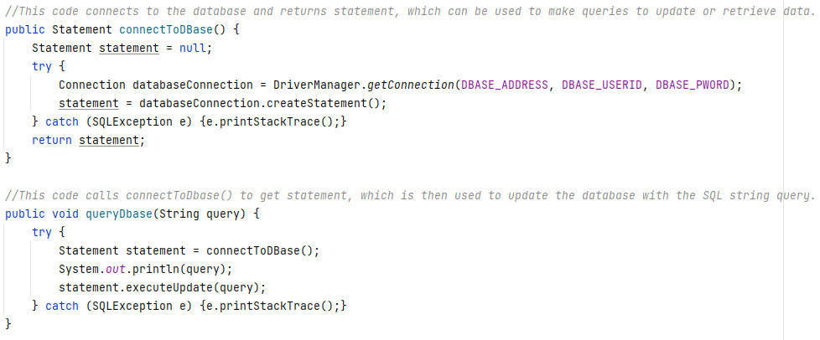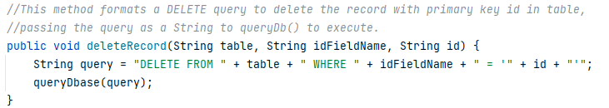These methods enable INSERT, UPDATE and DELETE queries to be made to the database, therefore allowing the system to save the changes of admin users’ input.

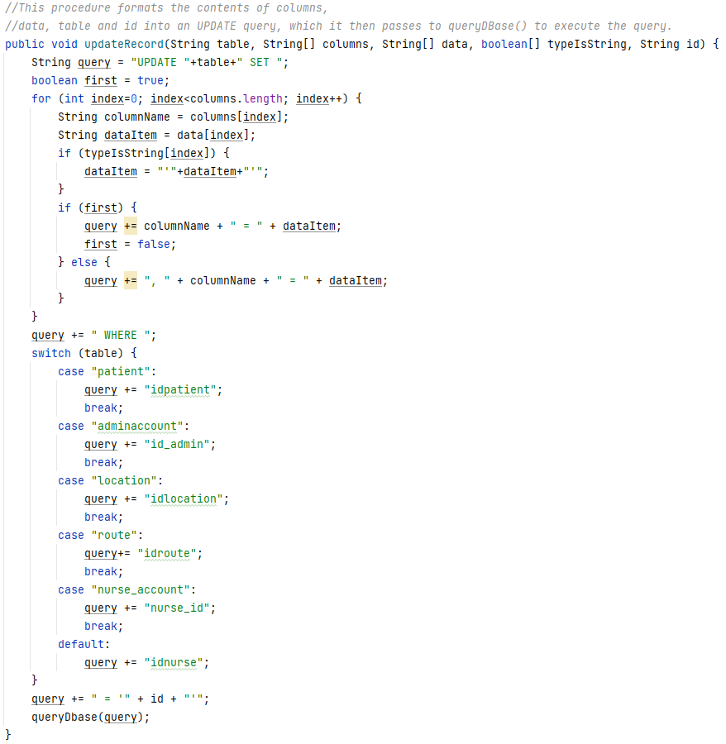

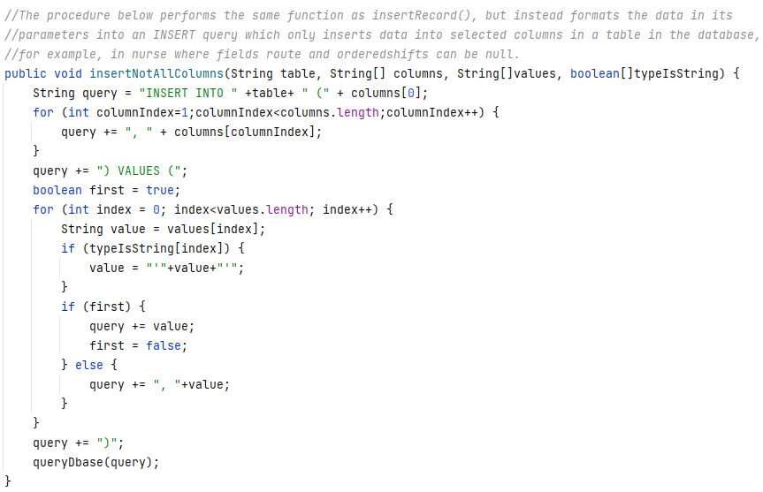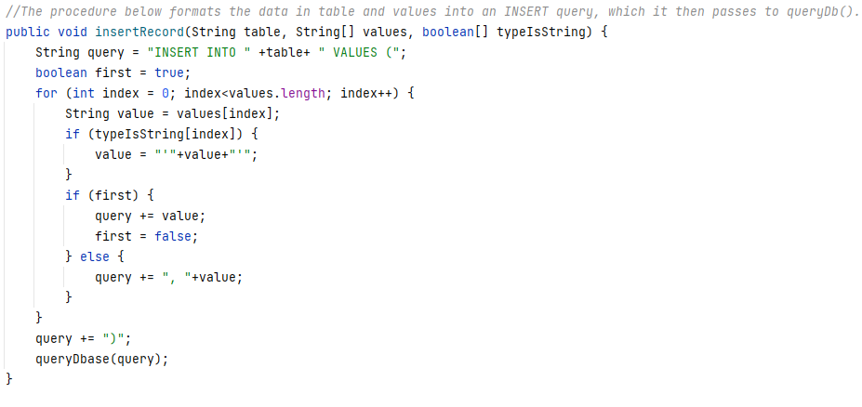

Using dBaseConnection, DataStructures maintains the state of the program. First, via fetching nurse, patient, location and account data from the database and using it to instantiate objects, and then through making queries to update the database when an admin user makes changes.

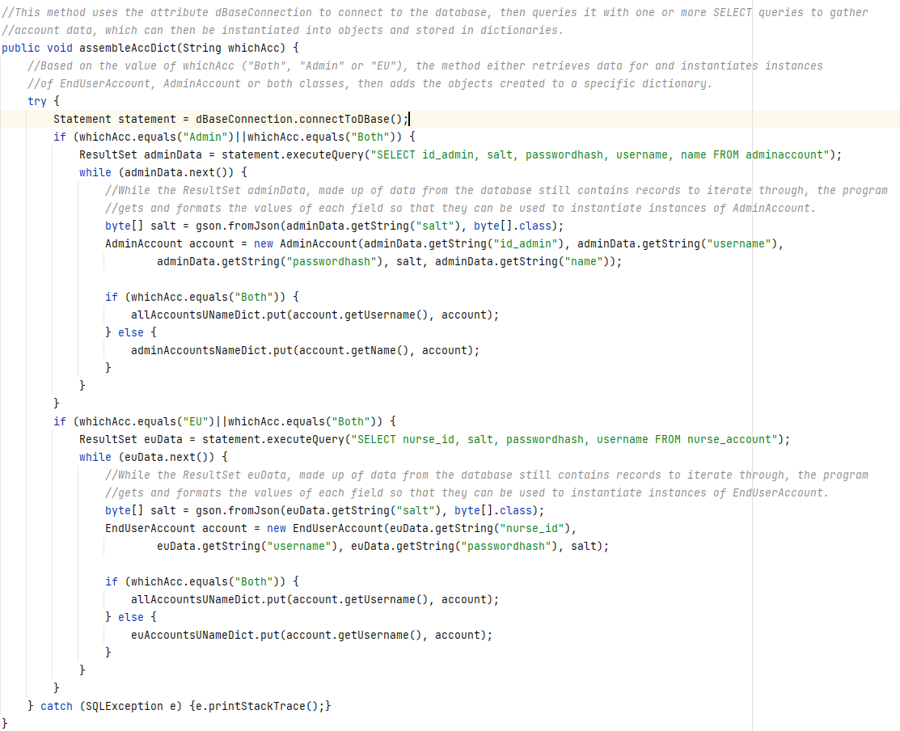Example methods called to get data from the database, instantiate it into objects and store it within data structures such as ArrayLists or dictionaries are shown below (the full set of methods is provided in Appendix A).

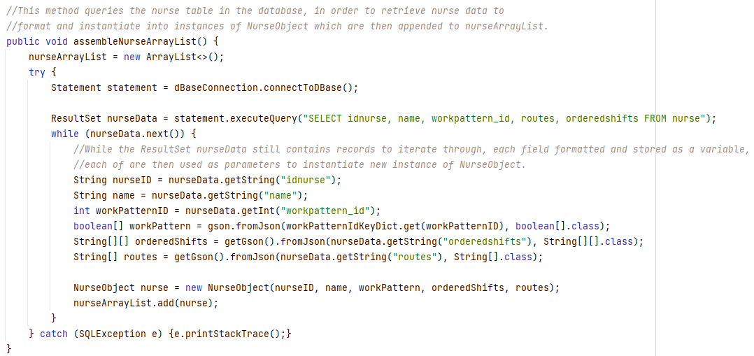

The second way in which DataStructures maintains the program’s state is through making changes to its attributes and data in the database in response to admin user input.

Example methods of how DataStructures keeps its attributes for nurse, patient, location and account data are shown below, as well as methods showing how it calls dBaseConnection to make changes to the database.

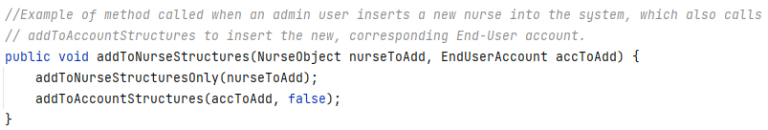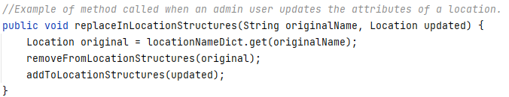

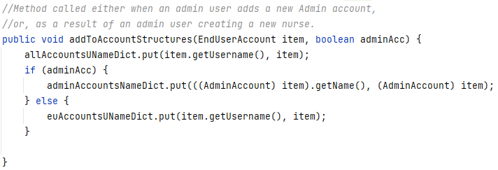

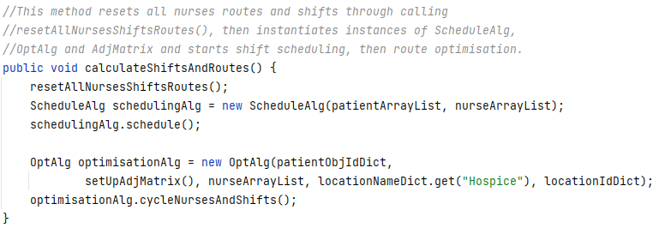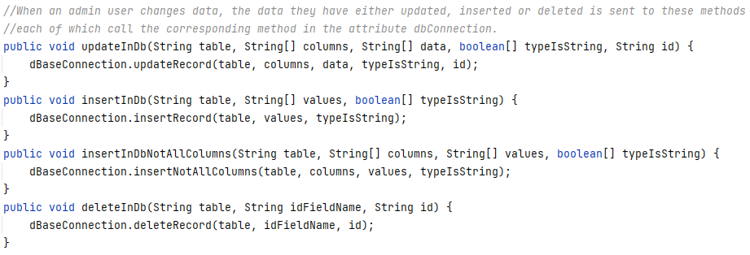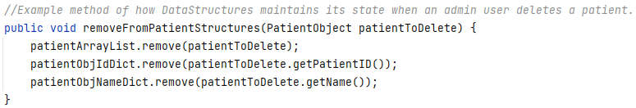As part of maintaining the program’s state, the final role of DataStructures is to trigger the scheduling and optimisation of routes and shifts, and then save those changes to the database. The methods which handle this process are shown below.

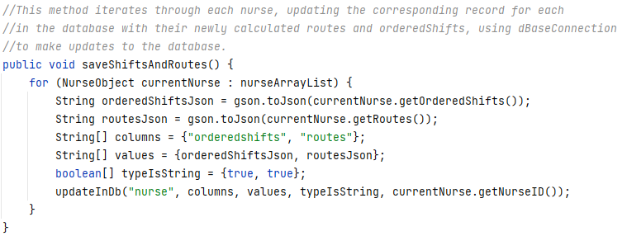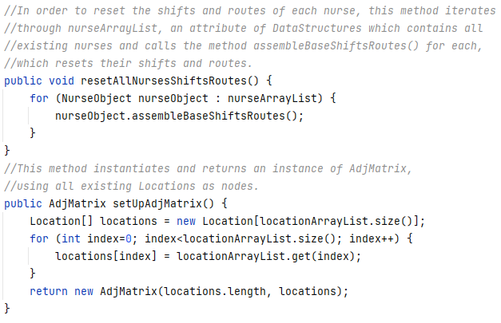

### Main algorithms

The main complex scheduling and optimisation algorithms (which meet objectives 1.31-1.41.1), are explained below. They are both implemented as classes to take advantage of attributes acting as global variables, for looking up data in dictionaries, for example. The classes AdjMatrix and Location are annotated and explained below as they are used to implement the graph for the route optimisation algorithm.

More detail on how each main algorithm works has been explained above under the heading: Scheduling Algorithm and Optimisation Algorithm in the Design section (between pages 52 and 65).

These algorithms are run when an admin user, after changing data in the database on the Admin Edit page, clicks the “Update All Routes and Shifts” button in order to enable them to navigate off that page of the UI (as both the back and logout buttons are disabled after any changes are made).

Pressing this button calls the method updateAllShiftsAndRoutes(), which calls the DataStructures method calculateShiftsAndRoutes(). This method instantiates instances of ScheduleAlg, OptAlg and AdjMatrix, then runs the complex algorithms and updates the nurse ArrayList and dictionary attributes of the DataStructures instance with the recalculated routes shifts, which are then saved to the database with the saveShiftsAndRoutes() method.

#### Automatic scheduling algorithm with constraints

The class ScheduleAlg is used to implement the scheduling algorithm annotated under the heading Scheduling Algorithm in the Design section.

This algorithm assembles NurseObjects and PatientObjects into two priority queues of each type of object, then assigns patients to nurses’ shifts based on:

* Patient priority level
* Whether patients require extended visit times
* Which days of the working week (Monday to Friday), each nurse works

The algorithm schedules patients with higher priority first - in order to maximise the chances of them receiving a visit - and fills the shifts in order of the most available nurses first. This ensures that patients are allocated as evenly as possible, with the least available nurses likely to receive the fewest patients to visit.

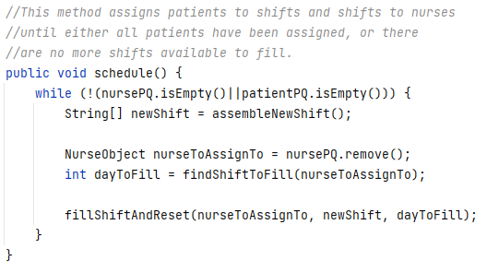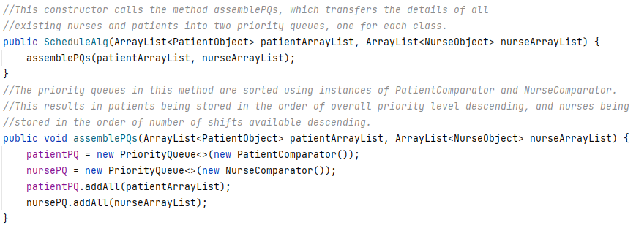An overview of the class’s main methods is shown below.

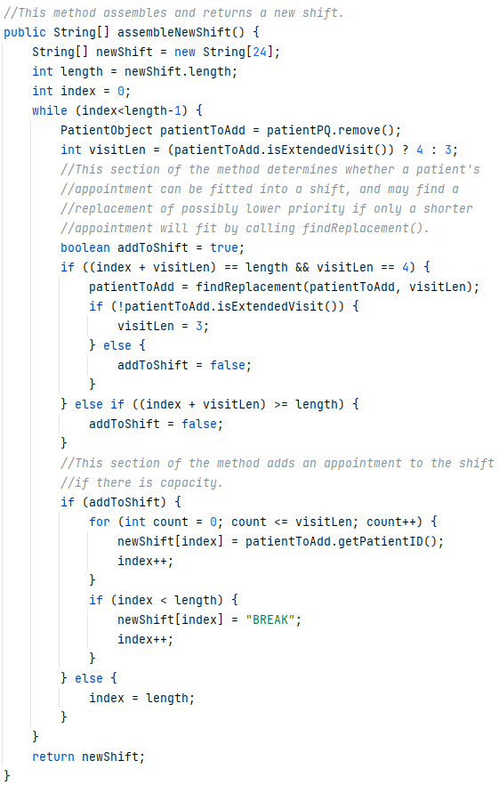

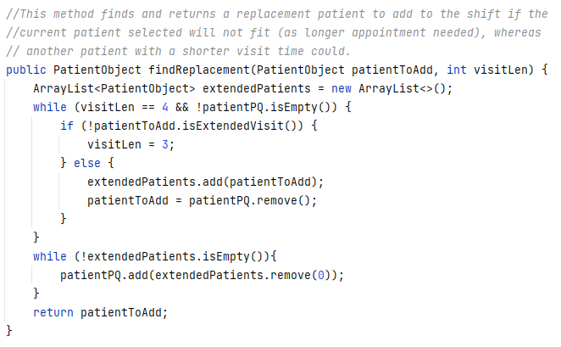

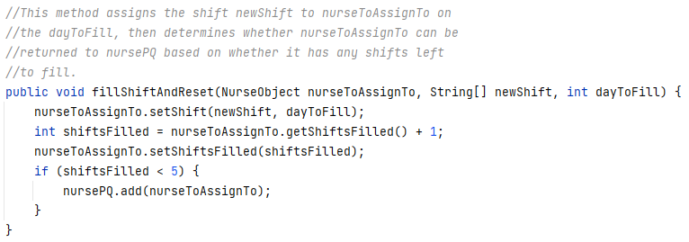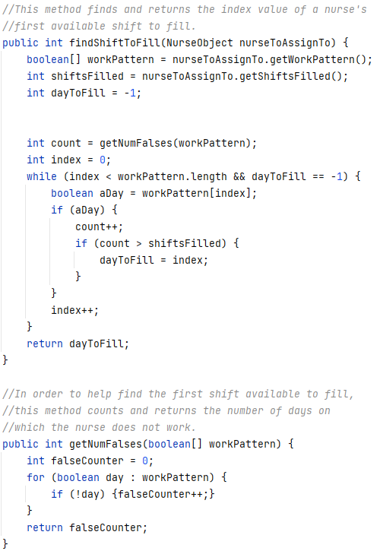

##### Unit Testing

During the development process, unit testing has been carried out to ensure that the scheduling algorithm works correctly. A sample of test data and the program’s output are shown below, alongside a solution worked out manually.

The patient data for this test has been generated randomly, and the work pattern of the nurse whose shifts are scheduled is shown below:

* Nurse1: {true, false, true, false, false}

The random patient data for this test is shown below, where each patient’s name is structured in this format: “*number*patient, p:*priorityLevel*, ev:*extendedVisit*”. For example: “2patient, p:1, ev:true” is patient number two, who is priority level one and requires extended visit times.

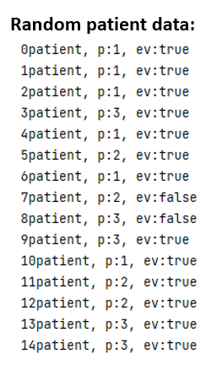

Once entered into the algorithm, the shifts produced for each nurse are shown below, with the first (left) column representing Nurse1’s shifts and the second (right) column representing Nurse2’s shifts.

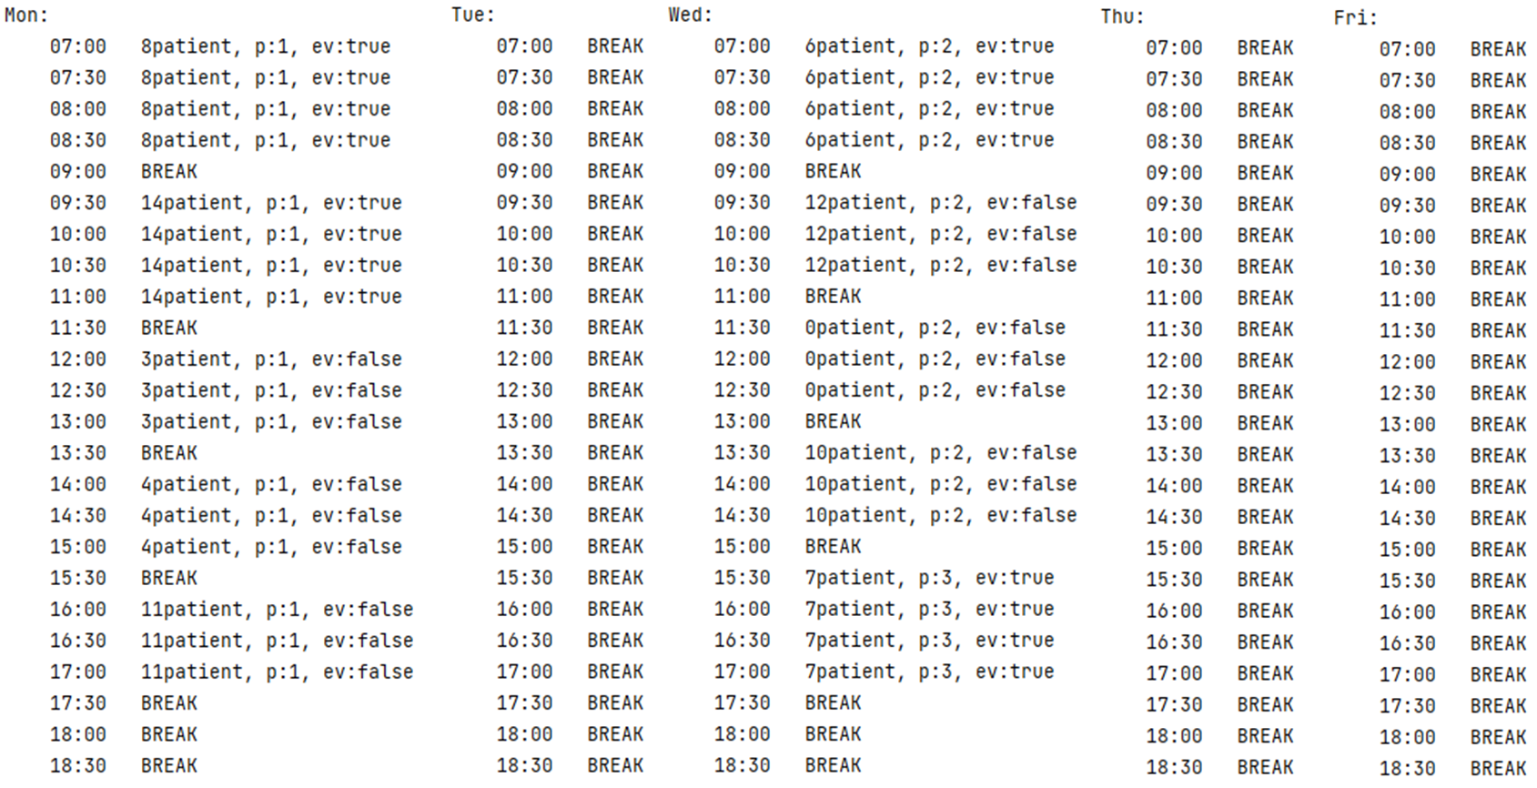

A manually worked out solution is shown below (please note, patient names have been shortened so that, for example, what would have previously been called “7patient, p:1, ev:true” would now be called “7p1t”).

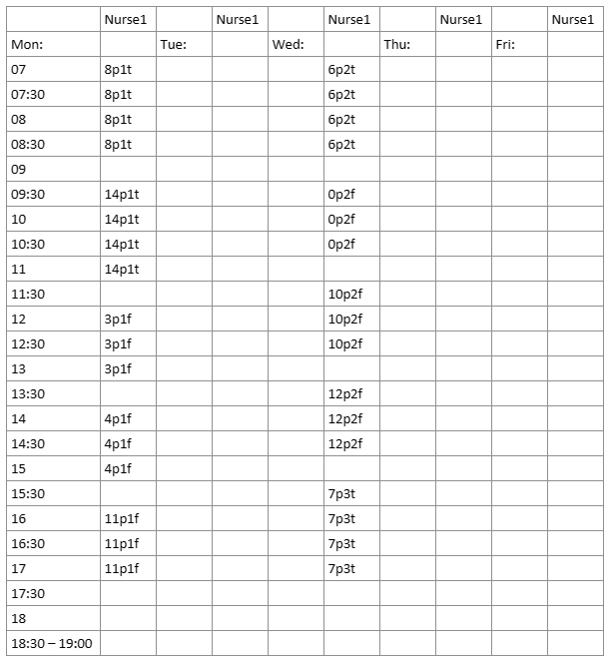

As is shown in the two solutions, it is clear that the algorithm can schedule patients as efficiently as a manual solution, and in much less time. This is evidenced above where both the manual solution and algorithm have allocated 10 patients, in the same number of shifts.

The algorithm has also taken account of patient priority level and has ensured that higher priority patients are allocated to shifts first.

#### Route optimisation algorithm using graph traversal

The class OptAlg is used to implement the route optimisation algorithm annotated under the heading Optimisation Algorithm in the Design section. An explanation of the classes AdjMatrix and Location are also included below as they are used to implement the graph traversed using the optimisation algorithm.

##### Location Class

The class Location is used to represent the locations/areas in which patients live. Instances of the class are also used to as the nodes on a graph, which an instance of AdjMatrix represents in order to implement the route optimisation.

An overview of the class’s structure is shown below.

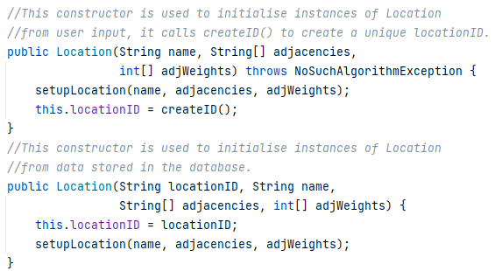

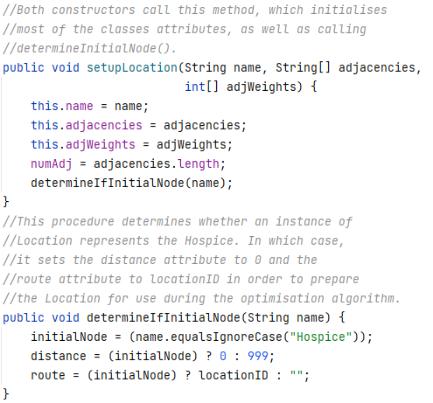

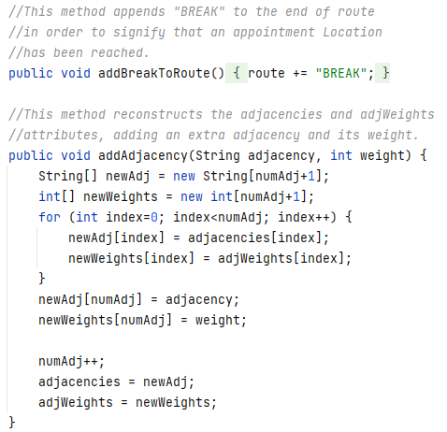

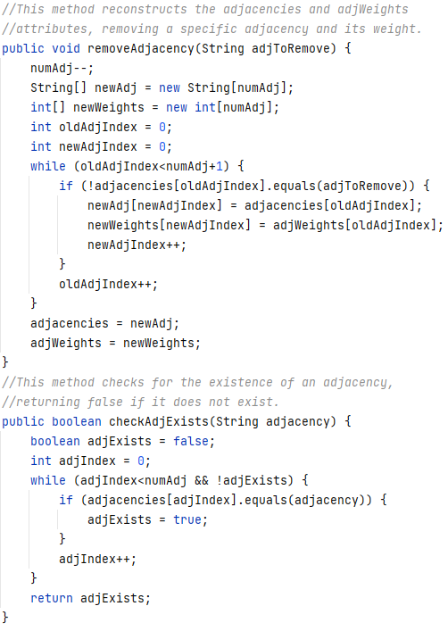

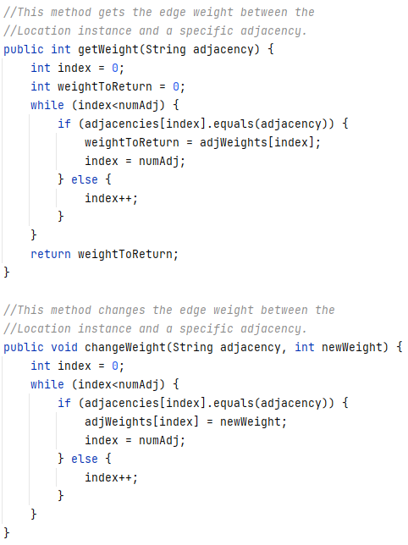

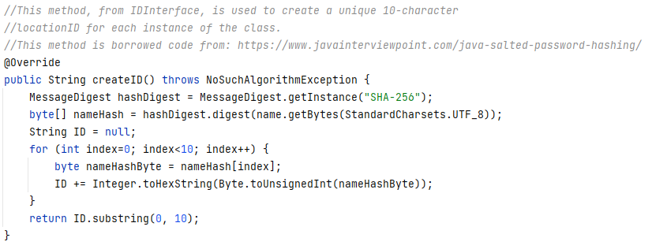

##### AdjMatrix class

The class AdjMatrix is used to represent a graph of patients’ Locations, in order to construct a representation of where patients live and the relative distances between them so that the routes nurses take for each shift can be optimised for efficiency.

The graph is represented by an adjacency matrix implemented with a two-dimensional array, where each node is an instance of Location which is stored in the attribute nodes. A brief overview of the class is shown below**.**

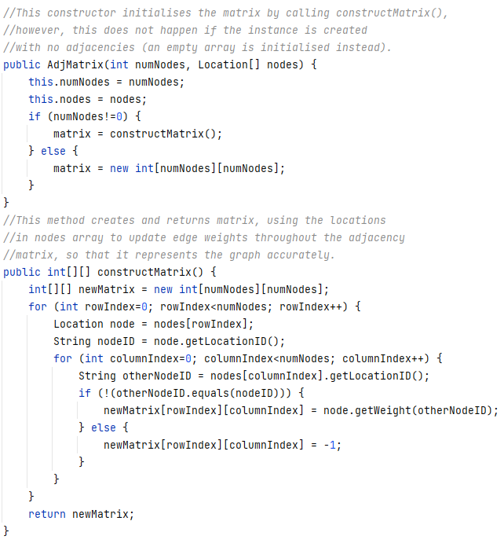

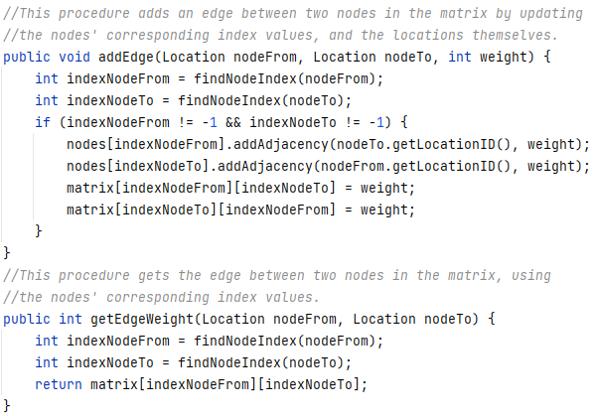

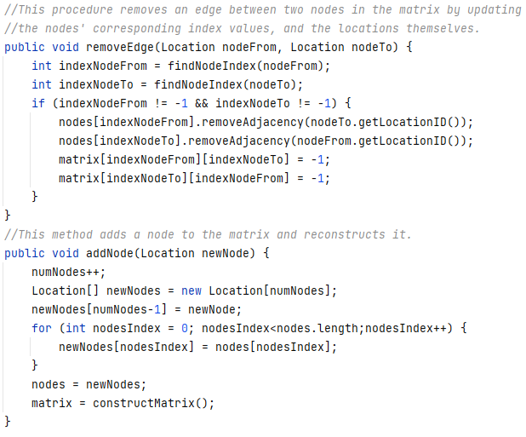

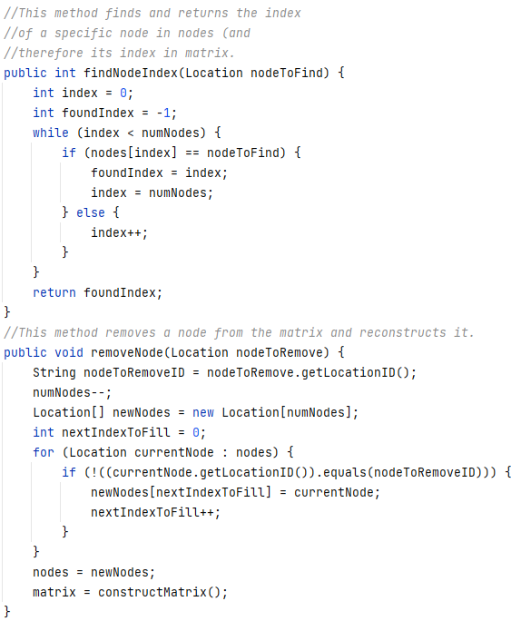

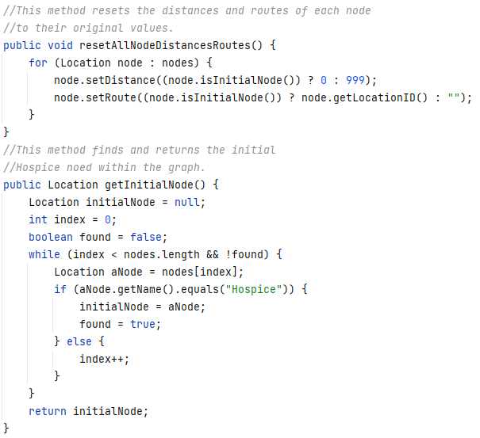

##### OptAlg class

This class performs the route optimisation algorithm, where each shift of each nurse is processed to find the most efficient route between patients (but still in order of priority level). This therefore produces the multi-dimensional arrays of strings: routes and orderedShifts, which are used to update the corresponding attributes of their corresponding NurseObject instances and are then saved to the database.

The algorithm uses a modified version of Dijkstra’s shortest path algorithm, where (starting with the Hospice as the initial node), for each shift of each nurse, it finds the nearest highest priority patient yet to be visited and appends the route of the corresponding shift with the route to that patient – as well as adding that patient into the corresponding time slot (index), of the corresponding day in the orderedShifts attribute of the corresponding NurseObject.

This process is then repeated - with the Location of the last patient visited acting as the initial node, until all of the patients on that shift have been allocated to a time slot and have had the route to them optimised – for each shift of each NurseObject.

An overview of OptAlg’s structure is shown below:

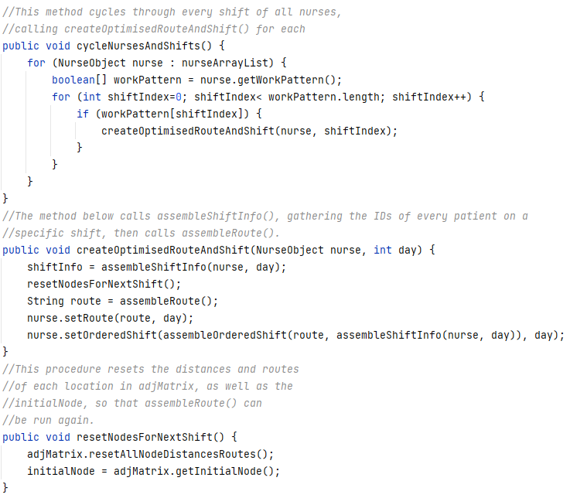

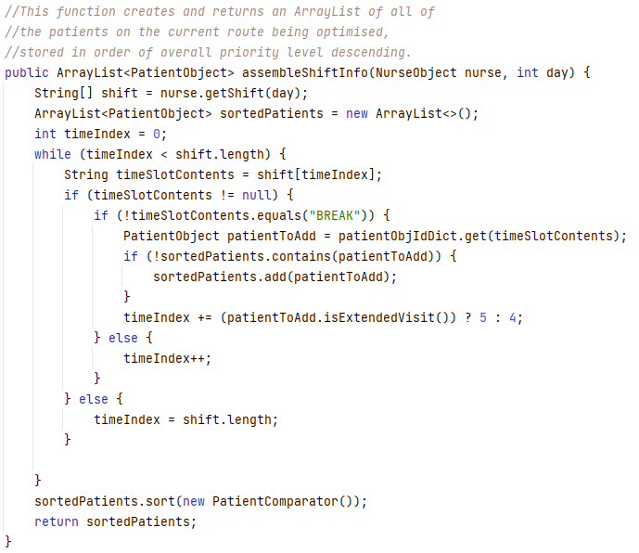

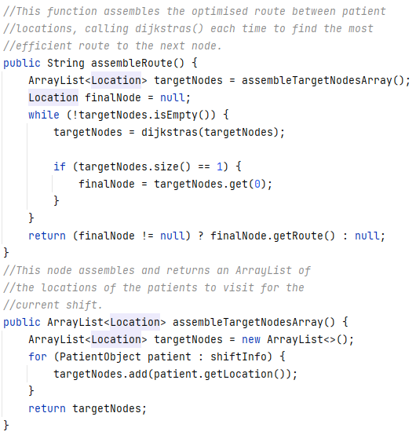

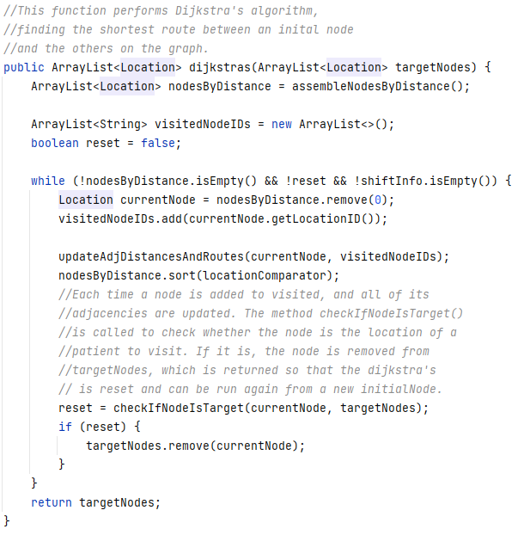

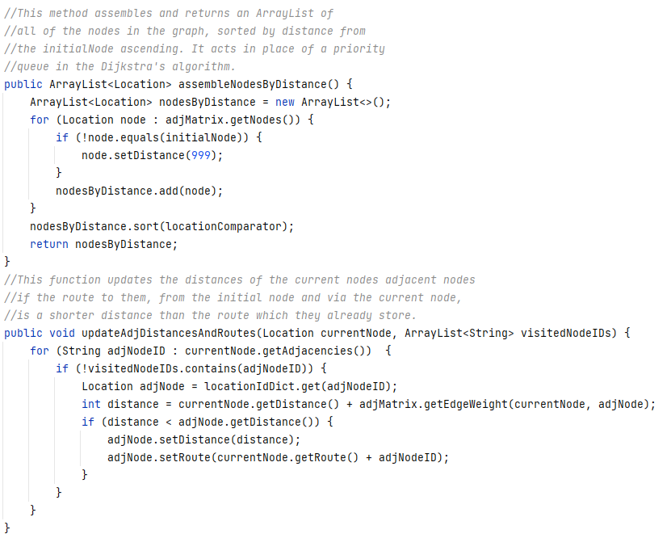

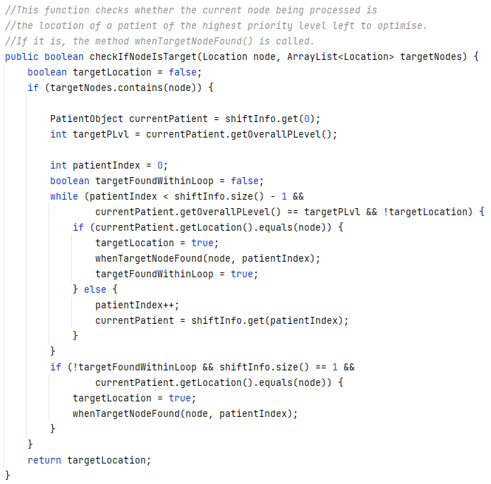

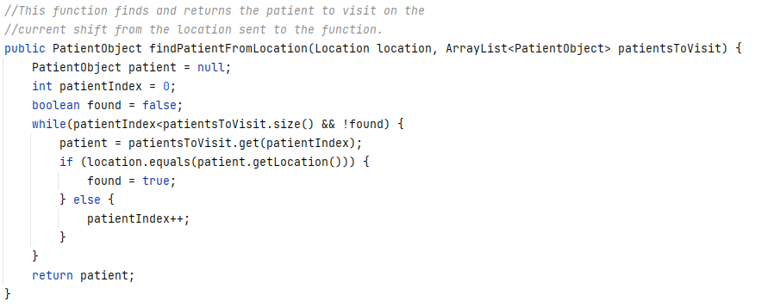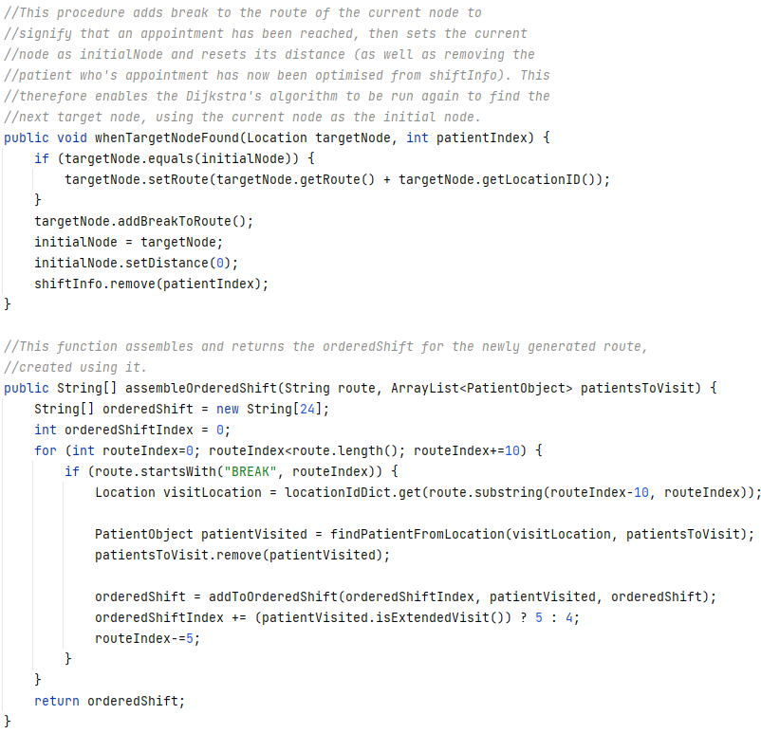

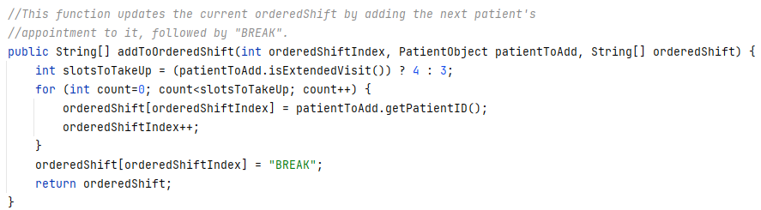

###### Unit Testing

Unit testing has been carried out during the development of the optimisation algorithm to ensure that it works correctly. A sample of test data, the algorithm’s output and a manually worked solution are shown below.

The graph of Locations used to run the algorithm is shown below.

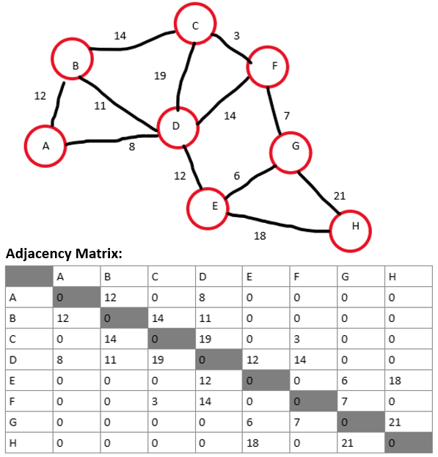

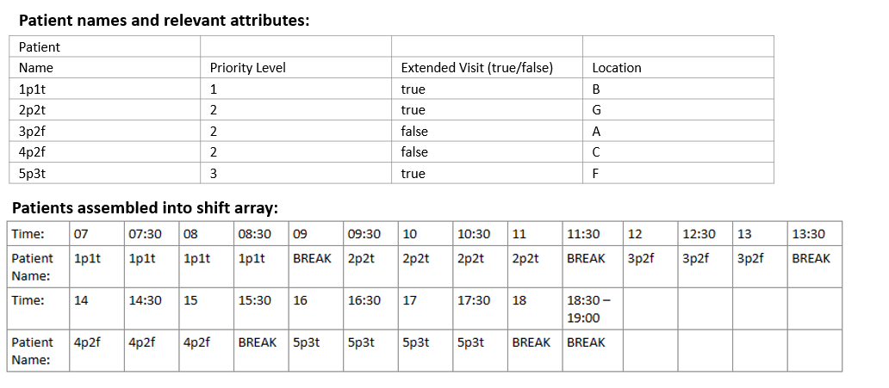The randomly generated patient data is shown below, including each patient’s details. These patients are also shown in a shift format, which will be input into the algorithm.

The algorithm’s output is shown below.

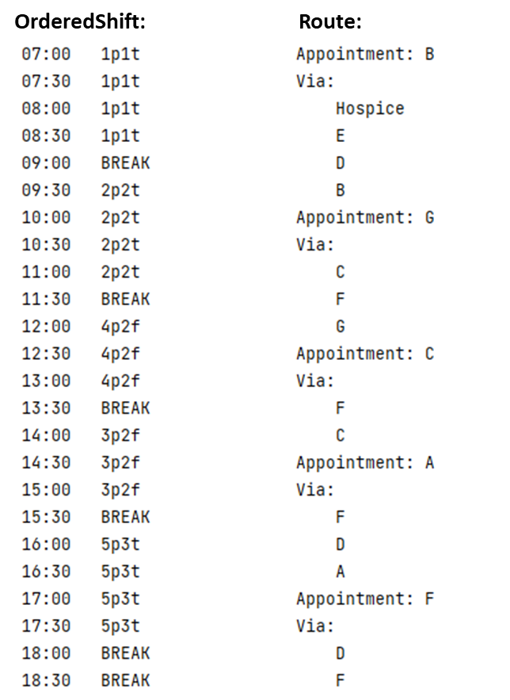

The manually worked out solution is shown below.

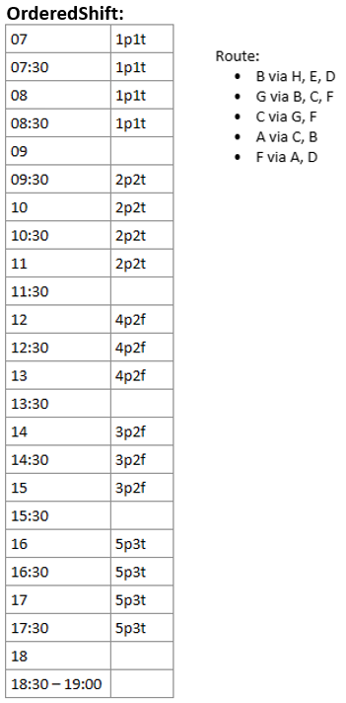

As is shown in the two solutions, the algorithm is able to optimise routes more efficiently than the manual solution. This is evidenced above where the manual solution and goes from C to A via B (distance: 26), whereas the algorithm goes via F and D (distance: 25).

The algorithm has also taken account of patient priority level and has ensured that higher priority patients are visited first, and that patients of equal priority can be visited in the most efficient order.

### Updating the database while the application is running

When an admin user logs into the application and opens the Admin Edit window, they have the option to add, amend or remove data from any of the tables in the database. This is implemented through the use of the SQL commands: INSERT, UPDATE and DELETE, and implements objectives 1.02.1 to 1.02.31.

When the user makes a change to the database by selecting the type data they want to amend using the table dropdown box, then updating the grid pane displayed on the Admin Edit page, and finally pressing either the Insert, Delete or Update button; the values entered into the table are fetched, validated and then used to update the structures stored by DataStructures and make the relevant query to the database.

Generic methods are used to make the actual query to the database, while specific methods are used to format the details entered by the user into a format appropriate for being stored as an object, then a format appropriate for being stored in the database.

By way of example, the methods for updating or inserting a location, and deleting a nurse, are shown below (the full set of methods is provided in Appendix A).

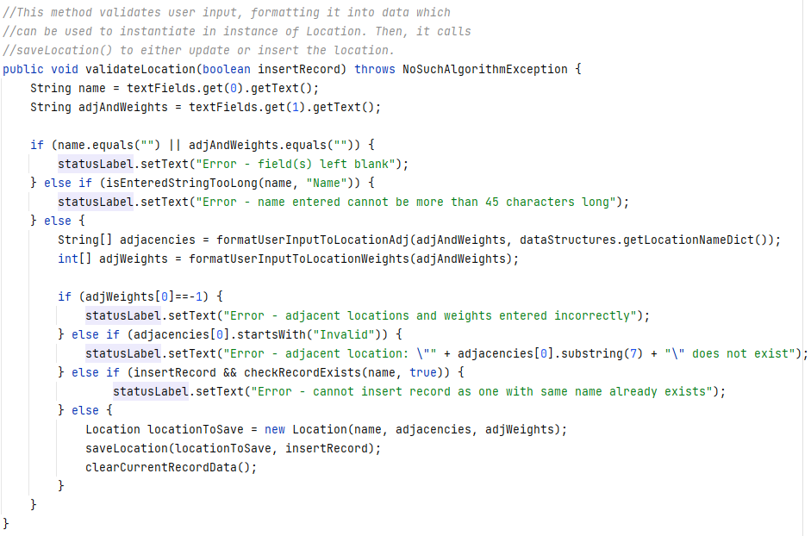

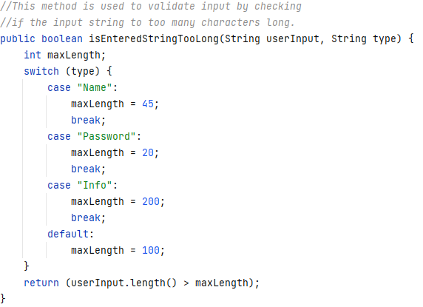

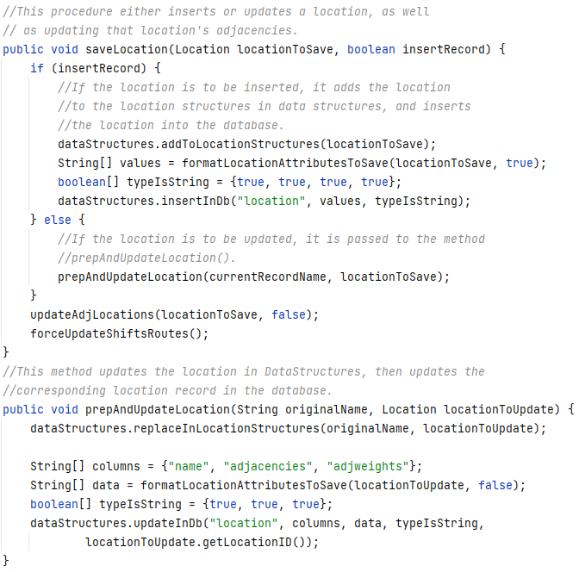

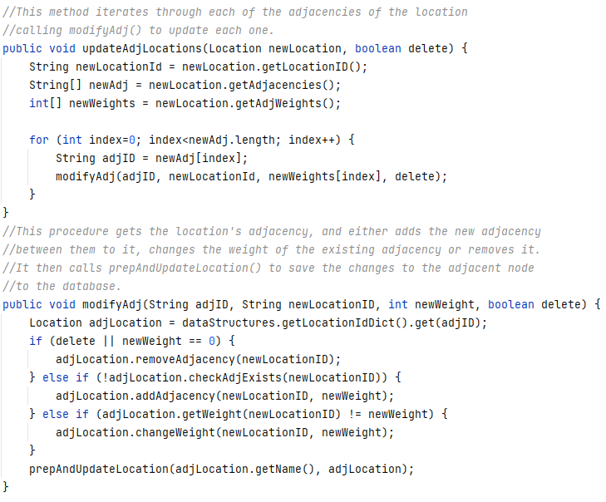

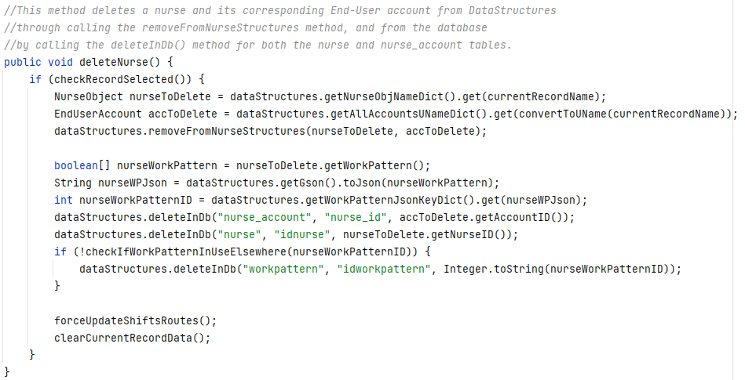

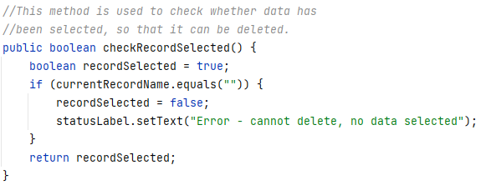

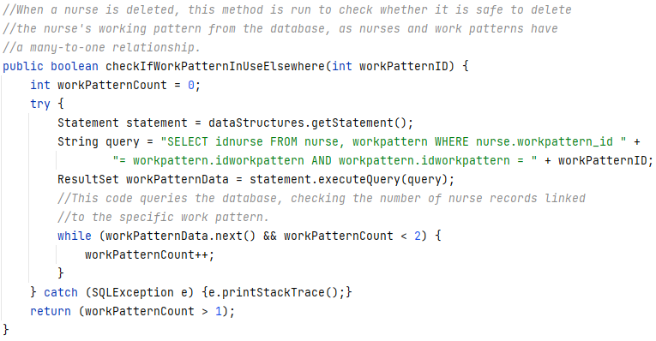

# Testing

During the development of the technical solution, unit testing has been undertaken to ensure that the objectives of the project have been met.

A sample of the testing that has been completed is shown below to demonstrate that the system meets its main objectives. This also includes a sample of validation of user input to ensure that the system is robust and can respond to erroneous and boundary data if it is entered.

Please note: throughout the development process, unit testing has been undertaken to ensure that the programs working as it intended so that objectives can be met. Therefore, in depth testing of the main, complex algorithms of this solution (scheduling and route optimisation), have been included in the Technical Solution section above (please see pages 82 and 99),where they have been shown to meet the relevant objectives.

## Test Plan

The test plan is shown below. Evidence of the tests is provided in video links below and the timestamps for each test are included in the plan.

As part of the testing, several items including nurses (NurseOne and Nurse Zero), locations (A-F and a Hospice location), an admin user (JohnSmith), and several patients (with randomly generated priority levels and names in the format: *Number*patient, p:*Priority level*, ev:*ExtendedVisit*, for example: “12patient, p: 1, ev:true” is the name of a patient who is priority level one and requires extended visits). This data has been entered in order to provide the system with enough data to schedule and optimise routes, so that displaying these details correctly can be tested.

**Video Links**

The video links for the testing are listed below:

* Video One, testing for Locations (tests 1 – 2.1.3.2):
  + <https://youtu.be/vouSflNaqkQ>
* Video Two, testing for Admin accounts (tests 2.2.1.1 – 2.2.3):
  + <https://youtu.be/tz07eBk2UXc>
* Video Three, testing for Nurses and End User accounts (tests 2.3.1.1 – 2.3.3):
  + <https://youtu.be/KcapU75MVXo>
* Video Four, testing for Patients, shifts and routes (tests 2.4.1.1 – 3.2):
  + <https://youtu.be/AEHpsb_82fE>

|  |  |  |  |  |  |
| --- | --- | --- | --- | --- | --- |
| **Test ID** | **Test Data** | **Purpose** | **Expected result** | **Test passed (Y/N)?** | **Video time stamp** |
| 1 | Username: “JohnSmith”  Password:  “password” | Log in to the system as an admin user to meet objective 1.01. | The system directs the user to the Admin Landing page, displaying the account username (JohnSmith) at the top of the screen. | Y | Video 1  00:01 |
| 2.1.1.1 | tableToEdit:  Location  Insert  Name: “A”  Adjacencies and weights: “B: 12” | Erroneous data | The system should display the error message: *“Error - cannot insert record as one with same name already exists”* | Y | Video 1  00:12 |
| 2.1.1.2 | tableToEdit:  Location  Insert  Name: “P”  Adjacencies and weights: “A: 10” | Demonstrate that location data can be added to the database to meet objectives 1.02.2, 1.02 and 1.25. | The location is inserted into the database, so its details are displayed if P is entered into the search box and, upon searching for A, an adjacency with P should be displayed in the Adjacent locations and weights field. | Y | Video 1  00:20 |
| 2.1.2.1 | tableToEdit:  Location  Search  SearchField: “O” | Erroneous data | The system should display the error message: *“Error - record with name: ‘O’ does not exist in Location data”* | Y | Video 1  00:42 |
| 2.1.2.2 | tableToEdit:  Location  Update  SearchField: “A”  Adjacencies and weights:  “B: 12, D: 8, P: 10, C: 5” | Demonstrate that stored location data can be amended to meet objectives 1.02.2, 1.02 and 1.25. | The location, and its adjacencies are updated so that searching and displaying the details for D (which previously had an adjacency with A), will not return an adjacency with A.  Searching for C will also now display an adjacency with A, which did not previously exist, and searching for B will show that the weight of the adjacency between B and A has changed from 7 to 12.  Searching for either D or P will show that their adjacencies have not changed as well. | Y | Video 1  00:49 |
| 2.1.3.2 | tableToEdit:  Location  Delete  SearchField: “P” | Demonstrate that stored location data can be deleted to meet objectives 1.02.2 and 1.02. | Location P is deleted, so searching for P returns the same error as the result of test 2.1.2.1 (but for P instead of O). Searching and displaying the details for A will also no longer show an adjacency with P. | Y | Video 1  01:50 |
| 2.2.1.1 | tableToEdit: Admin  Insert  Name: “”  Password: “123”  Confirm password: “123” | Erroneous data | The system should display the error message: *“Error - field(s) left blank”* | Y | Video 2  00:19 |
| 2.2.1.2 | tableToEdit: Admin  Insert  Name: “Test One”  Password: “123”  Confirm password: “123” | Demonstrate that Admin users can create new Admin accounts to meet objectives 1.02.3, 1.02 and 1.23 | Account Test One has been added to the database, meaning that the user can log in as Test One with username: TestOne and password: 123. | Y | Video 2  00:25 |
| 2.2.2.1 | tableToEdit: Admin  Update  SearchField: “John Smith”  Password: “123”  Confirm password: “1234” | Erroneous data | The system should display the error message: *“Error - passwords do not match”* | Y | Video 2  01:20 |
| 2.2.2.2 | tableToEdit: Admin  Update  SearchField: “Jon Smith”  Password: “1234”  Confirm password: “1234” | Demonstrate that Admin users can set the passwords of other accounts to meet objectives 1.02.3, 1.02.31, 1.02 and 1.23. | The record for John Smith has been updated in the database so that “Jon Smith” is now displayed at the top of the page when this account is logged in. Furthermore, a user can now log into this account with username: JonSmith and password: 1234. | Y | Video 2  01:30 |
| 2.2.3 | tableToEdit: Admin  Delete  SearchField: “Test One” | Demonstrate that Admin users can delete other admin accounts to meet objectives 1.02.3 and 1.02. | The record for Jon Smith is deleted from the system so the username TestOne is no longer recognised on the login page, and searching for Jon Smith on the Admin Edit page will produce an error stating that the record does not exist. | Y | Video 2  02:02 |
| 2.3.1.1 | tableToEdit:  Nurse  Insert  Name: “Test Two”  Days off: “Mon, Tue Thur”  Password: “1”  Confirm password: “1” | Erroneous data | The system should display the error message: *“Error - days off entered incorrectly”* | Y | Video 3  00:14 |
| 2.3.1.2 | tableToEdit:  Nurse  Insert  Name: “Test Two”  Days off: “Mon, Tue, Thu”  Password: “1”  Confirm password: “1” | Demonstrate that Admin users can create new End User accounts and add nurse data to the database to meet objectives 1.02.1, 1.02-1.02.3, 1.22-1.22.1 and 1.24. | The records which represent Test Two are added to the database, meaning that the user can log in to the TestTwo account using username: TestTwo and password: 1. The user can then view this nurse’s shifts and routes on the End User landing and Routes pages as well. | Y | Video 3  00:27 |
| 2.3.2.1 | tableToEdit: Nurse  Update  SearchField: “Test Two”  Password: 21 characters and matching confirm password | Erroneous boundary data | The system should display the error message: *“Error - password entered cannot be more than 20 characters long”* | Y | Video 3  01:42 |
| 2.3.2.2 | tableToEdit: Nurse  Update  SearchField: “Test Two”  Password: 20 characters and matching confirm password | Demonstrate that Admin users can reset End User account passwords and manipulate stored nurse data, therefore meeting objectives 1.02, 1.02.1, 1.02.3-1.02.31, 1.22-1.22.1 and 1.24. | The records which represent Test Two in the Nurse and NurseAccount tables have been updated, meaning that the user can log in to the Test Two End User account and view this nurse’s shifts and optimised routes. | Y | Video 3  02:00 |
| 2.3.3 | tableToEdit: Nurse  Delete  SearchField: “Test Two” | Demonstrate that Admin users can delete End User accounts and nurse data from the database in order to meet objectives 1.02, 1.02.1 and 1.02.3. | The records which represented Test Two have been removed from the database, meaning that the system no longer recognises the username TestTwo, and that searching for Test Two on the Admin Edit will return an error message stating that no nurse data with the name Test Two exists. | Y | Video 3  02:43 |
| 2.4.1.1 | tableToEdit: Patient  Insert  Name: “Test Three”  Information: “Example information”  Priority level: 4  Extended visit: “Y”  Address line: “1, Example Road”  Location: “A” | Erroneous boundary data | The system should display the error message: *“Error - priority level formatted incorrectly, must enter 1, 2 or 3”* | Y | Video 4  00:11 |
| 2.4.1.2 | tableToEdit: Patient  Insert  Name: “Test Three”  Information: “Example information”  Priority level: 1  Extended visit: “Y”  Address line: “1, Example Road”  Location: “A” | Demonstrate that Admin users can enter patient data to be stored in the database, therefore meeting the requirements of objectives 1.02, 1.02.1 and 1.21-1.21.2. | The patient table in the database now contains the record Test Three. | Y | Video 4  00:34 |
| 2.4.2.1 | tableToEdit: Patient  Update  SearchField: “Test Three”  Location: “O” | Erroneous data | The system should display the error message: *“Error - location name entered does not exist”* | Y | Video 4  01:09 |
| 2.4.2.2 | tableToEdit: Patient  Update  SearchField: “Test Three”  Location: “B” | Demonstrate that Admin users can amend stored patient data, meeting objectives 1.02, 1.02.1 and 1.21-1.21.2. | The Test Three record in the Patient table in the database now has the ID of location B (“nulldf7e70”), for the location_id field, instead of that of A (“null559aea”). | Y | Video 4  01:16 |
| 2.4.3.1 | tableToEdit: Patient  Delete  SearchField: “Test Three” | Demonstrate that Admin users can delete patient data stored in the database, achieving objectives 1.02 and 1.02.1. | The Test Three record has now been removed from the Patient table in the database. | Y | Video 4  01:37 |
| 3.1 | View Nurse 0’s optimised routes and shift details through the Admin View page  Update Nurse 0’s days off to Tue, Thu on the Admin Edit page | Demonstrate that routes and shifts are recalculated after each change to the database is made, and that admin users can view the routes of all nurses to meet objective 1.02.4 | The routes for Nurse 0 have changed after their work pattern has been updated, showing that the user pressing the Update Shifts/Routes button when they wish to navigate off of the Admin Edit page (after making changes to the database) causes each nurse’s shifts and optimised routes to be recalculated so that they remain accurate and up to date. | Y | Video 4  01:59 |
| 3.2 | View shifts and routes for Nurse 0 through the End User Landing and Routes pages. | Demonstrate that nurses can view their optimised routes and shifts over the five-day period through a simple interface with less functionality in order to meet objectives 1.03-1.03.2 and 1.11-1.12. | The routes and shifts for Nurse 0 are displayed in a clear and simple format, which is easy to understand. It is also clear how to navigate to the routes for each shift. | Y | Video 4  02:57 |

# Evaluation

This section of the document details how effectively each individual objective has been met. It also includes end user feedback of the entire system together with reflection on the overall effectiveness of the solution and how it might be improved or extended.

## Objectives

This table illustrates that all of the fully objectives were met. The commentary discusses where in the system each of these objectives have been achieved.

|  |  |  |  |
| --- | --- | --- | --- |
| **Objective ID** | **Requirement** | **Objective met?** | **Commentary** |
| 1.01 | The system should have unique logins and passwords for individual users | Yes | The system enables Admin users to generate unique logins and passwords for Admin and End User accounts. |
| 1.02 | Admin users should have accounts with greater access rights | Yes | Admin accounts have greater access rights as they can view the shifts and routes of all nurses. They can also amend patient, nurse, location and account data within the system. |
| 1.02.1 | Admin users should be able to modify data about, add or delete nurses and patients | Yes | Via the Admin Edit page, Admin users are able to modify data about nurses and patients. |
| 1.02.2 | Admin users should be able to add, amend or delete patient address areas (Locations), and their relative distances | Yes | Via the Admin Edit page, Admin users are able to add, remove and amend location data. |
| 1.02.3 | Admin users should be able to add, and remove other Admin or End User accounts | Yes | Via the Admin Edit page, Admin users are able to modify add, amend or delete both Admin and End User accounts. |
| 1.02.31 | Admin users should be able to reset the passwords of other Admin and End User accounts | Yes | Via the Admin Edit page, Admin users are able amend the passwords of both Admin and End User accounts. |
| 1.02.4 | Admin user should be able to view the routes of all nurses in the system | Yes | Via the Admin View page, Admin users are able to view the routes of all nurses. |
| 1.03 | Nurses should have access to simpler accounts with fewer access rights | Yes | Nurses have access only to view their own account details, shifts and routes. They also have a simpler UI with fewer available functions. |
| 1.03.1 | Nurses should be able to view their shifts over a five-day period | Yes | Via the End User Landing page, nurses are able to view the details of each of their shifts broken down into half hour timeslots. |
| 1.03.2 | Nurses should be able to view the optimised route for each of their shifts | Yes | By selecting the relevant shift on the End User Landing page, the user is re-directed to the End User Routes page where the details of the corresponding optimised route are displayed. |
| 1.11 | Shifts for nurses should be presented in a clear, simple format | Yes | Shifts for nurses are represented by an easy to read table. |
| 1.12 | Routes for each shift should be presented in a clear way, and should be easy to navigate to | Yes | Routes for each shift are presented in a simple to understand visual. This can be viewed by selecting the relevant button for each day. |
| 1.21 | Data for each patient should be stored persistently | Yes | Data for each patient is stored in the Patient table of the database. |
| 1.21.1 | The system should store the name and address of each patient | Yes | Names and addresses for each patient are stored in the Patient table in the database. |
| 1.21.2 | The system should store the priority level of each patient, and whether they require an extended visit time | Yes | The priority level and visit time details are stored as fields in the Patient table in the database. |
| 1.22 | Data for each nurse should be stored persistently | Yes | Data for each nurse is stored in the NurseAccount, Nurse, Route and WorkPattern tables in the database. |
| 1.22.1 | The system should store the working patterns; the details of each 12-hour shift; and corresponding routes for each nurse | Yes | The working pattern, shift and route details are stored in the WorkPattern, Nurse and Route tables in the database. These tables are interconnected. |
| 1.23 | The username and password for each Admin account should be stored securely and persistently | Yes | The usernames and passwords for each Admin account are stored in the AdminAccount table in the database. Before being stored, the password is hashed and salted in order to store it securely. |
| 1.24 | The username and password for each End User account should be stored securely and persistently | Yes | The usernames and passwords for each End User account are stored in the NurseAccount table in the database. Before being stored, the password is hashed and salted in order to store it securely. |
| 1.25 | Data for locations of patient addresses and their relative distances should be stored persistently | Yes | Patient locations are stored in the Location and Patient tables in the database. This includes the relative distance between different locations. |
| 1.31 | The system should organise visits to patients over a five-day period | Yes | The system assigns patient appointments to nurse shifts over a five-day period from Monday to Friday. |
| 1.31.1 | The system should schedule higher priority patients first | Yes | The Scheduling algorithm prioritises patients by their priority level (1-3) to ensure higher priority patients are seen first. |
| 1.41 | The system should determine the most efficient route between patients for each shift of each nurse | Yes | The Route Optimisation algorithm organises appointments for each shift so that they are routed (by distance) in the most efficient way based on priority level. |
| 1.41.1 | The system should prioritise patient priority over minimising travel distance when creating optimised routes | Yes | The Route Optimisation algorithm will always prioritise the highest priority patient over the most efficient route between appointments for all patients. |

## Third Party Feedback

As part of this project, third party feedback was gathered verbally. A selection of comments are included below:

*“The system has saved me lots of time as I’m no longer relying on complex spreadsheets.”*

*“I like the fact that it’s easy to use and understand.”*

*“I can see exactly where I need to be for each shift on one page. It also saves me a lot of time in planning my travel.”*

*“I would love it if the system could email me my route so I can view it without logging in.”*

*“The system lets me change patient priority and then quickly re-calculates the route. This saves so much time as before it was all done manually.”*

## Overall Effectiveness of the Solution and Possible Improvements / Extensions

Overall, the feedback has been largely positive with some good suggestions for improvement. A key aspect of the system was to save time and manpower in the administrative and nursing teams, and this has been achieved.

Some improvements have been suggested by stakeholders including the development of email functionality which would allow shift routes to be emailed to nurses so that they don’t have to log into the system each time they want to view, or the output of any patients who cannot be assigned to shifts, when scheduling is performed.

In addition to this, a possible future extension of the system could include using geolocation API in order to automatically provide the distances between locations rather than manually inputting them. This could save time and allow for more accurate route optimisation.

# Appendices

## Appendix A: Program Code

The program code is listed below. Please note that the methods involving hashing in the classes EndUserAccount, Location, NurseObject and PatientObject use borrowed code[6]. The GUI controllers also use borrowed code to switch between scenes (in the setScene() and getScene() methods)[7].

### main\java\com\algorithms\FormattingMethods

package com.algorithms;  
  
import com.oopModel.matrix.Location;  
  
import java.util.ArrayList;  
import java.util.HashMap;  
  
public class FormattingMethods {  
 public static String formatExtendedVisitToSave(Boolean extendedVisit) {  
 return (extendedVisit) ? "TRUE" : "FALSE";  
 }  
 public static String formatExtendedVisitToView(boolean extendedVisit) {  
 return (extendedVisit) ? "Y" : "N";  
 }  
 public static Boolean formatUserInputToExtendedVisit(String visitString) {  
 Boolean extendedVisit;  
 switch (visitString) {  
 case "Y":  
 extendedVisit = true;  
 break;  
 case "N":  
 extendedVisit = false;  
 break;  
 default:  
 extendedVisit = null;  
 }  
 return extendedVisit;  
 }  
  
 public static String[] formatWorkPatternToSave(boolean[] workPattern) {  
 String[] formattedWorkPattern = new String[5];  
 for (int index=0; index<5; index++) {  
 formattedWorkPattern[index] = (workPattern[index]) ? "TRUE" : "FALSE";  
 }  
 return formattedWorkPattern;  
 }  
 public static String formatWorkPatternToView(boolean[] workPattern) {  
 String formattedString = "";  
 for (int index = 0; index< workPattern.length; index++) {  
 if (!workPattern[index]) {  
 String dayToAdd;  
 switch (index) {  
 case 1:  
 dayToAdd="Tue";  
 break;  
 case 2:  
 dayToAdd="Wed";  
 break;  
 case 3:  
 dayToAdd="Thu";  
 break;  
 case 4:  
 dayToAdd="Fri";  
 break;  
 default:  
 dayToAdd="Mon";  
 }  
 formattedString += dayToAdd+", ";  
 }  
 }  
 formattedString = formattedString.substring(0, formattedString.length()-2);  
 return formattedString;  
 }  
 public static boolean[] formatUserInputToWorkPattern(String formattedString) {  
 boolean[] workPattern = {true, true, true, true, true};  
 int index = 0;  
 boolean invalid = false;  
 if (!formattedString.equals("")) {  
 while (index < formattedString.length()-3 && !invalid) {  
 if (index != 0 && !formattedString.startsWith(", ", index)) {  
 invalid = true;  
 } else {  
 index += (index != 0) ? 2 : 0;  
 String day = formattedString.substring(index, index+3);  
 switch (day) {  
 case "Mon":  
 workPattern[0] = false;  
 break;  
 case "Tue":  
 workPattern[1] = false;  
 break;  
 case "Wed":  
 workPattern[2] = false;  
 break;  
 case "Thu":  
 workPattern[3] = false;  
 break;  
 case "Fri":  
 workPattern[4] = false;  
 break;  
 default:  
 invalid = true;  
 }  
 index+=3;  
 }  
 if (invalid) {  
 workPattern = null;  
 }  
 }  
 }  
 return workPattern;  
 }  
  
 public static int formatUserInputToPLevel(String pString) {  
 int pLevel;  
 switch (pString) {  
 case "1":  
 pLevel = 1;  
 break;  
 case "2":  
 pLevel = 2;  
 break;  
 case "3":  
 pLevel = 3;  
 break;  
 default:  
 pLevel = -1;  
 }  
 return pLevel;  
 }  
  
 public static String formatAdjAndWeightsToView(String[] adjacencies, int[] adjWeights, HashMap<String, Location> locationIdDict) {  
 String formattedString = "";  
 for (int index = 0; index<adjacencies.length; index++) {  
 formattedString += locationIdDict.get(adjacencies[index]).getName() + ": " + adjWeights[index];  
 if (index != adjacencies.length - 1) {  
 formattedString += ", ";  
 }  
 }  
 return formattedString;  
 }  
 public static Location formatUserInputToLocationName(String locationName, HashMap<String, Location> locationNameDict) {  
 return locationNameDict.getOrDefault(locationName, null);  
 }  
 public static String[] formatUserInputToLocationAdj(String formattedString, HashMap<String, Location> locationNameDict) {  
 ArrayList<String> locationList = new ArrayList<>();  
 String[] locationArray = {"Invalid"};  
 int index = 0;  
 String currentName = "";  
 boolean gettingNextName = true;  
 boolean invalidLocation = false;  
 while (index < formattedString.length() && !invalidLocation) {  
 char currentChar = formattedString.charAt(index);  
  
 if (currentChar == ',') {  
 index += 2;  
 gettingNextName = true;  
 currentName = "";  
 currentChar = formattedString.charAt(index);  
 } else if (currentChar == ':') {  
 gettingNextName = false;  
 if (locationNameDict.containsKey(currentName)) {  
 locationList.add(locationNameDict.get(currentName).getLocationID());  
 } else {  
 locationArray[0] += currentName;  
 invalidLocation = true;  
 }  
 }  
  
 if (gettingNextName) {  
 currentName += currentChar;  
 }  
 index++;  
 }  
  
 if (!invalidLocation && locationList.size()>0) {  
 locationArray = new String[locationList.size()];  
 for (int arrayListIndex = 0; arrayListIndex < locationList.size(); arrayListIndex++) {  
 locationArray[arrayListIndex] = locationList.get(arrayListIndex);  
 }  
 }  
 return locationArray;  
 }  
 public static int[] formatUserInputToLocationWeights(String formattedString) {  
 ArrayList<Integer> weightsList = new ArrayList<>();  
 int[] weightsArray = {-1};  
 int index = -1;  
 String currentWeight = "";  
 boolean gettingNextWeight = false;  
 boolean invalidWeight = false;  
 while (index < formattedString.length()-1 && !invalidWeight) {  
 index++;  
 char currentChar = formattedString.charAt(index);  
  
 if (currentChar == ':') {  
 index += 2;  
 gettingNextWeight = true;  
 currentWeight = "";  
 currentChar = formattedString.charAt(index);  
 }  
  
 if (gettingNextWeight) {  
 if (currentChar == ',') {  
 gettingNextWeight = false;  
 weightsList.add(Integer.*parseInt*(currentWeight));  
 } else if (index == formattedString.length() - 1) {  
 weightsList.add(Integer.*parseInt*(currentWeight + currentChar));  
 } else {  
 try {  
 Integer.*parseInt*(Character.*toString*(currentChar));  
 currentWeight += currentChar;  
 } catch (NumberFormatException e) {  
 invalidWeight = true;  
 }  
 }  
 }  
 }  
 if (!invalidWeight && weightsList.size()>0) {  
 weightsArray = new int[weightsList.size()];  
 for (int arrayIndex = 0; arrayIndex<weightsList.size(); arrayIndex++) {  
 weightsArray[arrayIndex] = weightsList.get(arrayIndex);  
 }  
 }  
 return weightsArray;  
 }  
  
 public static String convertToUName(String name) {  
 int index = 0;  
 String uName = "";  
 while (index<name.length()) {  
 if (name.charAt(index)!= ' ') {  
 uName += name.charAt(index);  
 }  
 index++;  
 }  
 return uName;  
 }  
}

### main\java\com\algorithms\ViewRouteMethods

package com.algorithms;  
  
import com.oopModel.NurseObject;  
import com.oopModel.PatientObject;  
import com.oopModel.matrix.Location;  
import javafx.geometry.HPos;  
import javafx.scene.control.Label;  
import javafx.scene.layout.GridPane;  
  
import java.time.LocalTime;  
import java.util.ArrayList;  
import java.util.HashMap;  
  
public class ViewRouteMethods {  
  
 public static String[][] assembleRouteLabelContents(String route, String[] orderedShift, HashMap<String, PatientObject> patientObjIdDict,  
 HashMap<String, Location> locationIdDict) {  
 ArrayList<PatientObject> patientsToVisit = *getPatients*(orderedShift, patientObjIdDict);  
 ArrayList<String> patientAddressDetails = *getPatientAddressDetails*(patientsToVisit);  
 ArrayList<String> visitLegDetails = *getLocationsForEachLeg*(route, locationIdDict);  
 ArrayList<LocalTime> visitTimes = *getTimesForVisits*(orderedShift);  
  
 String[][] routelabelsContent = new String[4][patientsToVisit.size()];  
 for (int rowIndex=0; rowIndex<4; rowIndex++) {  
 for (int arrayListIndex=0; arrayListIndex< patientsToVisit.size(); arrayListIndex++) {  
 String textToAdd = "";  
 switch (rowIndex) {  
 case 0:  
 textToAdd = String.*valueOf*(visitTimes.get(arrayListIndex));  
 break;  
 case 1:  
 PatientObject currentPatient = patientsToVisit.get(arrayListIndex);  
 textToAdd = currentPatient.getName() + "\n" + currentPatient.getInformation();  
 break;  
 case 2:  
 textToAdd = patientAddressDetails.get(arrayListIndex);  
 break;  
 default:  
 textToAdd = visitLegDetails.get(arrayListIndex);  
 }  
 routelabelsContent[rowIndex][arrayListIndex] = textToAdd;  
 }  
 }  
 return routelabelsContent;  
 }  
  
 public static ArrayList<PatientObject> getPatients(String[] orderedShift, HashMap<String, PatientObject> patientIdDict) {  
 ArrayList<PatientObject> patientsToVisit = new ArrayList<>();  
 boolean lastIndexWasBreak = true;  
 for (int index = 0; index< orderedShift.length; index++) {  
 String currentTimeSlot = orderedShift[index];  
 if (lastIndexWasBreak && currentTimeSlot != null) {  
 lastIndexWasBreak = false;  
 patientsToVisit.add(patientIdDict.get(currentTimeSlot));  
 } else if (currentTimeSlot != null && currentTimeSlot.equals("BREAK")) {  
 lastIndexWasBreak = true;  
 }  
 }  
 return patientsToVisit;  
 }  
 public static ArrayList<String> getPatientAddressDetails(ArrayList<PatientObject> patientsToVisit) {  
 ArrayList<String> patientLocationDetails = new ArrayList<>();  
 for (PatientObject currentPatient : patientsToVisit) {  
 String patientAddressDetails = currentPatient.getAddressLineOne()+", "+currentPatient.getLocation().getName();  
 patientLocationDetails.add(patientAddressDetails);  
 }  
 return patientLocationDetails;  
 }  
  
 public static ArrayList<String> getLocationsForEachLeg(String route, HashMap<String, Location> locationIdDict) {  
 ArrayList<String> locationsToGoVia = new ArrayList<>();  
 String locationsForLeg = "";  
 boolean firstLocForLeg = true;  
 for (int index=0; index<route.length(); index+=10) {  
 if (route.startsWith("BREAK", index)) {  
 index -= 5;  
 locationsToGoVia.add(locationsForLeg);  
 locationsForLeg = "";  
 firstLocForLeg = true;  
 } else {  
 String nextLocationId = route.substring(index, index+10);  
 if (firstLocForLeg) {  
 locationsForLeg += locationIdDict.get(nextLocationId).getName();  
 firstLocForLeg = false;  
 } else {  
 locationsForLeg += ",\n" + locationIdDict.get(nextLocationId).getName();  
 }  
 }  
 }  
 return locationsToGoVia;  
 }  
 public static ArrayList<LocalTime> getTimesForVisits(String[] orderedShift) {  
 ArrayList<LocalTime> visitTimes = new ArrayList<>();  
 LocalTime baseTime = LocalTime.*of*(7, 0);  
 boolean lastIndexWasBreak = true;  
 for (int index=0; index<orderedShift.length; index++) {  
 if (lastIndexWasBreak) {  
 lastIndexWasBreak = false;  
 visitTimes.add(baseTime.plusMinutes((index+1)* 30L));  
 } else if (orderedShift[index] != null && orderedShift[index].equals("BREAK")) {  
 lastIndexWasBreak = true;  
 }  
 }  
 return visitTimes;  
 }  
  
 public static int findDayIndex(String day) {  
 int dayIndex;  
 switch (day) {  
 case "Monday":  
 dayIndex = 0;  
 break;  
 case "Tuesday":  
 dayIndex = 1;  
 break;  
 case "Wednesday":  
 dayIndex = 2;  
 break;  
 case "Thursday":  
 dayIndex = 3;  
 break;  
 default:  
 dayIndex = 4;  
 }  
 return dayIndex;  
 }  
}

### main\java\com\guiLayout\ProtoApplication

package com.guiLayout;  
  
import com.guiLayout.controllers.*;  
import com.guiLayout.controllers.admin.AdminEditController;  
import com.guiLayout.controllers.admin.AdminLandingController;  
import com.guiLayout.controllers.admin.AdminViewController;  
import com.guiLayout.controllers.endUser.EULandingController;  
import com.guiLayout.controllers.endUser.EURoutesController;  
import javafx.application.Application;  
import javafx.fxml.FXMLLoader;  
import javafx.scene.Scene;  
import javafx.stage.Stage;  
  
import java.io.IOException;  
  
public class ProtoApplication extends Application {  
  
 @Override  
 public void start(Stage stage) throws IOException, ClassNotFoundException {  
 stage.setTitle("ProtoApplication");  
  
 *//Login Screen Loader* FXMLLoader loginLoader = new FXMLLoader(ProtoApplication.class.getResource("loginPage.fxml"));  
 Scene loginScene = new Scene(loginLoader.load(), 350, 250);  
  
 *//End User Landing Loader* FXMLLoader euLandingLoader = new FXMLLoader(ProtoApplication.class.getResource("endUserLanding.fxml"));  
 Scene euLandingScene = new Scene(euLandingLoader.load(), 1000, 700);  
  
 *//End User Route Loader* FXMLLoader euRouteLoader = new FXMLLoader(ProtoApplication.class.getResource("endUserRoutes.fxml"));  
 Scene euRouteScene = new Scene(euRouteLoader.load(), 1000, 500);  
  
 *//Admin Landing Loader* FXMLLoader adminLandingLoader = new FXMLLoader(ProtoApplication.class.getResource("adminLanding.fxml"));  
 Scene adminLandingScene = new Scene(adminLandingLoader.load(), 400, 250);  
  
 *//Admin View Loader* FXMLLoader adminViewLoader = new FXMLLoader(ProtoApplication.class.getResource("adminView.fxml"));  
 Scene adminViewScene = new Scene(adminViewLoader.load(), 1000, 500);  
  
 *//Admin Edit Loader* FXMLLoader adminEditLoader = new FXMLLoader(ProtoApplication.class.getResource("adminEdit.fxml"));  
 Scene adminEditScene = new Scene(adminEditLoader.load(), 650, 650);  
  
 *//The code used for the setScene() methods below is borrowed  
 // from https://stackoverflow.com/questions/12804664/how-to-swap-screens-in-a-javafx-application-in-the-controller-class  
  
 //Login Controller, setting EULanding and AdminLanding Scenes* LoginController loginController = loginLoader.getController();  
 loginController.setEUlandingScene(euLandingScene);  
 loginController.setAdminLandingScene(adminLandingScene);  
  
 *//End User Landing Controller, setting EURoute and Login Scenes* EULandingController euLandingController = euLandingLoader.getController();  
 euLandingController.setLoginScene(loginScene);  
 euLandingController.setEURouteScene(euRouteScene);  
  
 *//End User Route Controller, setting EULanding and Login Scenes* EURoutesController euRoutesController = euRouteLoader.getController();  
 euRoutesController.setLoginScene(loginScene);  
 euRoutesController.setEULandingScene(euLandingScene);  
  
 *//AdminLanding Controller, setting AdminEdit, AdminView and Login Scenes* AdminLandingController adminLandingController = adminLandingLoader.getController();  
 adminLandingController.setAdminEditScene(adminEditScene);  
 adminLandingController.setAdminViewScene(adminViewScene);  
 adminLandingController.setLoginScene(loginScene);  
  
 *//Admin View Controller, setting AdminLanding and Login Scenes* AdminViewController adminViewController = adminViewLoader.getController();  
 adminViewController.setAdminLandingScene(adminLandingScene);  
 adminViewController.setLoginScene(loginScene);  
  
 *//Admin Edit Controller, setting AdminLanding and Login Scenes* AdminEditController adminEditController = adminEditLoader.getController();  
 adminEditController.setAdminLandingScene(adminLandingScene);  
 adminEditController.setLoginScene(loginScene);  
  
  
 stage.setScene(loginScene);  
 stage.show();  
  
 }  
  
 public static void main(String[] args) {  
 *launch*();  
 }  
  
}

### main\java\com\guiLayout\LoginController

package com.guiLayout.controllers;  
  
import com.oopModel.account.AdminAccount;  
import com.oopModel.account.EndUserAccount;  
import com.oopModel.storage.DataStructures;  
import javafx.event.ActionEvent;  
import javafx.fxml.FXML;  
import javafx.scene.Scene;  
import javafx.scene.control.Button;  
import javafx.scene.control.Label;  
import javafx.scene.control.PasswordField;  
import javafx.scene.control.TextField;  
import javafx.stage.Stage;  
  
import java.security.NoSuchAlgorithmException;  
import java.sql.SQLException;  
import java.util.HashMap;  
  
public class LoginController {  
 @FXML  
 private Label loginErrorLab;  
 @FXML  
 private TextField uNameField;  
 @FXML  
 private PasswordField pWordField;  
 @FXML  
 private Button loginButton;  
  
  
 private Scene euLandingScene;  
 private Scene adminLandingScene;  
  
  
 private DataStructures dataStructures;  
 private HashMap<String, EndUserAccount> accountsDictionary;  
 private boolean setDataStructures;  
  
 public void initialize() {  
 dataStructures = new DataStructures();  
 accountsDictionary = dataStructures.getAllAccountsUNameDict();  
 setDataStructures = true;  
 }  
  
 @FXML protected void attemptLogin() throws SQLException, NoSuchAlgorithmException {  
 loginErrorLab.setText("");  
 if (validateLogin()) {  
 EndUserAccount accountToLoginTo = accountsDictionary.get(uNameField.getText());  
 if (!accountToLoginTo.compareToPassword(pWordField.getText())) {  
 loginErrorLab.setText("Error - incorrect password");  
 } else {  
 openLandingScene(accountToLoginTo);  
 }  
 }  
  
 uNameField.clear();  
 pWordField.clear();  
 }  
  
 public boolean validateLogin() {  
 boolean loginValid = false;  
 String uName = uNameField.getText();  
 if (uName.equals("")) {  
 loginErrorLab.setText("Error - no username entered");  
 } else if (pWordField.getText().equals("")) {  
 loginErrorLab.setText("Error - no password entered");  
 } else if (!accountsDictionary.containsKey(uName)) {  
 loginErrorLab.setText("Error - account with username '" + uName + "' does not exist");  
 } else {  
 loginValid = true;  
 }  
 return loginValid;  
 }  
  
 *//Parts of the methods below are borrowed code from https://stackoverflow.com/questions/12804664/how-to-swap-screens-in-a-javafx-application-in-the-controller-class* public void setAdminLandingScene(Scene scene) {adminLandingScene = scene;}  
 public void openLandingScene(EndUserAccount account) throws SQLException {  
 Stage stage = (Stage) loginButton.getScene().getWindow();  
 dataStructures.setAccountLoggedIn(account);  
 dataStructures.initialiseStructures();  
 Scene sceneToSet;  
 if (account instanceof AdminAccount) {  
 sceneToSet = adminLandingScene;  
 } else {  
 sceneToSet = euLandingScene;  
 }  
 if (setDataStructures) {  
 stage.setUserData(dataStructures);  
 setDataStructures = false;  
 }  
 stage.setScene(sceneToSet);  
 }  
  
  
}

### main\java\com\guiLayout\endUser\EULandingController

package com.guiLayout.controllers.endUser;  
  
import com.oopModel.NurseObject;  
import com.oopModel.PatientObject;  
import com.oopModel.account.EndUserAccount;  
import com.oopModel.storage.DataStructures;  
import javafx.event.ActionEvent;  
import javafx.fxml.FXML;  
import javafx.geometry.HPos;  
import javafx.scene.Scene;  
import javafx.scene.control.Button;  
import javafx.scene.control.Label;  
import javafx.scene.control.ScrollBar;  
import javafx.scene.control.ScrollPane;  
import javafx.scene.input.MouseEvent;  
import javafx.scene.input.ScrollEvent;  
import javafx.scene.layout.AnchorPane;  
import javafx.scene.layout.GridPane;  
import javafx.scene.text.Font;  
import javafx.stage.Stage;  
  
import java.util.HashMap;  
  
public class EULandingController {  
 @FXML  
 private Button logoutButton;  
 @FXML  
 private Button routeButton;  
 @FXML  
 private Label currentAccount;  
 @FXML  
 private GridPane shiftGrid;  
 @FXML  
 AnchorPane anchorPane;  
  
 private Stage stage;  
 private Scene loginScene;  
 private Scene euRouteScene;  
 private boolean onSceneOpen;  
  
 private DataStructures dataStructures;  
 private NurseObject nurseObject;  
 private EndUserAccount accountLoggedIn;  
  
 public void initialize() {  
 onSceneOpen = true;  
 }  
  
 @FXML protected void setUpScene() {  
 if (onSceneOpen) {  
 stage = (Stage) logoutButton.getScene().getWindow();  
 dataStructures = (DataStructures) stage.getUserData();  
 accountLoggedIn = dataStructures.getAccountLoggedIn();  
 nurseObject = dataStructures.getNurseObjIdDict().get(accountLoggedIn.getAccountID());  
 displayShifts();  
 onSceneOpen = false;  
 }  
 currentAccount.setText(accountLoggedIn.getUsername());  
  
 }  
  
 public void displayShifts() {  
 HashMap<String, PatientObject> patientObjIdDict = dataStructures.getPatientObjIdDict();  
 String[][] orderedShifts = nurseObject.getOrderedShifts();  
 for (int dayIndex=0; dayIndex<5; dayIndex++) {  
 for (int slotIndex=0; slotIndex<24; slotIndex++) {  
 String slotData = "";  
 if (patientObjIdDict.containsKey(orderedShifts[dayIndex][slotIndex])) {  
 PatientObject currentPatient = patientObjIdDict.get(orderedShifts[dayIndex][slotIndex]);  
 slotData = currentPatient.getName();  
 }  
 Label slotLabel = new Label(slotData);  
 shiftGrid.add(slotLabel, dayIndex+1, slotIndex+1);  
 GridPane.*setHalignment*(slotLabel, HPos.*CENTER*);  
 }  
 }  
 }  
  
 *//The methods below are borrowed code from https://stackoverflow.com/questions/12804664/how-to-swap-screens-in-a-javafx-application-in-the-controller-class* public void setEURouteScene(Scene scene) {euRouteScene = scene;}  
 @FXML protected void openEURouteScene() {  
 stage.setScene(euRouteScene);  
 }  
  
 public void setLoginScene(Scene scene) {loginScene = scene;}  
 @FXML protected void openLoginScene() {stage.setScene(loginScene);}  
}

### main\java\com\guiLayout\endUser\EURoutesController

package com.guiLayout.controllers.endUser;  
  
import com.oopModel.NurseObject;  
import com.oopModel.storage.DataStructures;  
import javafx.event.ActionEvent;  
import javafx.fxml.FXML;  
import javafx.geometry.HPos;  
import javafx.scene.Scene;  
import javafx.scene.control.Button;  
import javafx.scene.control.ComboBox;  
import javafx.scene.control.Label;  
import javafx.scene.layout.AnchorPane;  
import javafx.scene.layout.GridPane;  
import javafx.stage.Stage;  
  
import java.util.ArrayList;  
  
import static com.algorithms.ViewRouteMethods.*;  
  
public class EURoutesController {  
 @FXML  
 private Label currentAccount;  
 @FXML  
 private Button backButton;  
 @FXML  
 private Button logoutButton;  
 @FXML  
 private GridPane routeGrid;  
 @FXML  
 private AnchorPane anchorPane;  
 @FXML  
 private ComboBox<String> dayComboBox;  
 @FXML  
 private Label statusLabel;  
  
 private Stage stage;  
 private Scene loginScene;  
 private Scene euLandingScene;  
  
 private DataStructures dataStructures;  
 private boolean onSceneOpen;  
 ArrayList<ArrayList<Label>> routeLabels;  
  
 public void initialize() {  
 onSceneOpen = true;  
 }  
  
 @FXML protected void setUpScene() {  
 if (onSceneOpen) {  
 stage = (Stage) anchorPane.getScene().getWindow();  
 dataStructures = (DataStructures) stage.getUserData();  
 dayComboBox.getItems().addAll("Monday", "Tuesday", "Wednesday", "Thursday", "Friday");  
 setUpGrid();  
 onSceneOpen = false;  
 }  
 currentAccount.setText(dataStructures.getAccountLoggedIn().getUsername());  
 }  
 @FXML protected void displayDay() {  
 statusLabel.setText("");  
 clearGrid();  
 int day = *findDayIndex*(dayComboBox.getValue());  
 NurseObject nurseToDisplay = dataStructures.getNurseObjIdDict().get(dataStructures.getAccountLoggedIn().getAccountID());  
 String routeToDisplay = nurseToDisplay.getRoute(day);  
 if (routeToDisplay == null || routeToDisplay.equals("BREAK")) {  
 statusLabel.setText("No shift and route scheduled for "+dayComboBox.getValue());  
 } else {  
 fillGridPane(routeToDisplay, nurseToDisplay.getOrderedShift(day));  
 }  
 }  
 public void setUpGrid() {  
 routeLabels = new ArrayList<>();  
 for (int rowIndex=0; rowIndex<4; rowIndex++) {  
 routeLabels.add(new ArrayList<>());  
 for (int columnIndex=0; columnIndex<6; columnIndex++) {  
 routeLabels.get(rowIndex).add(new Label());  
 routeGrid.add(routeLabels.get(rowIndex).get(columnIndex), columnIndex+1, rowIndex);  
 GridPane.*setHalignment*(routeLabels.get(rowIndex).get(columnIndex), HPos.*CENTER*);  
 }  
 }  
 }  
 public void clearGrid() {  
 for (ArrayList<Label> labelRow : routeLabels) {  
 for (Label label : labelRow) {  
 label.setText("");  
 }  
 }  
 }  
 public void fillGridPane(String route, String[] orderedShift) {  
 String[][] routeLabelContents = *assembleRouteLabelContents*(route, orderedShift, dataStructures.getPatientObjIdDict(), dataStructures.getLocationIdDict());  
 for (int rowIndex=0; rowIndex<4; rowIndex++) {  
 for (int columnIndex=0; columnIndex<routeLabelContents[rowIndex].length; columnIndex++) {  
 String textToAdd = routeLabelContents[rowIndex][columnIndex];  
 routeLabels.get(rowIndex).get(columnIndex).setText(textToAdd);  
 }  
 }  
 }  
  
  
 *//The methods below are borrowed code from https://stackoverflow.com/questions/12804664/how-to-swap-screens-in-a-javafx-application-in-the-controller-class* public void setEULandingScene(Scene scene) {euLandingScene=scene;}  
 public void openEULandingScene(ActionEvent actionEvent) {stage.setScene(euLandingScene);}  
  
 public void setLoginScene(Scene scene) {loginScene=scene;}  
 public void openLoginScene(ActionEvent actionEvent) {stage.setScene(loginScene);}  
}

### main\java\com\guiLayout\admin\AdminLandingController

package com.guiLayout.controllers.admin;  
  
import com.oopModel.storage.DataStructures;  
import javafx.event.ActionEvent;  
import javafx.fxml.FXML;  
import javafx.scene.Scene;  
import javafx.scene.control.Button;  
import javafx.scene.control.Label;  
import javafx.scene.input.MouseEvent;  
import javafx.scene.layout.AnchorPane;  
import javafx.stage.Stage;  
  
public class AdminLandingController {  
 @FXML  
 private Label logoutTimer;  
 @FXML  
 private Label currentAccount;  
 @FXML  
 private Button logoutButton;  
 @FXML  
 private Button adminViewButton;  
 @FXML  
 private Button adminEditButton;  
 @FXML  
 private AnchorPane anchorPane;  
  
 private Scene loginScene;  
 private Scene adminEditScene;  
 private Scene adminViewScene;  
 private Stage stage;  
  
 private boolean onSceneOpen;  
 DataStructures dataStructures;  
  
 public void initialize() {  
 onSceneOpen = true;  
 }  
 @FXML protected void setUpScene() {  
 if (onSceneOpen) {  
 stage = (Stage) currentAccount.getScene().getWindow();  
 dataStructures = (DataStructures) stage.getUserData();  
 currentAccount.setText(dataStructures.getAccountLoggedIn().getUsername());  
 onSceneOpen = false;  
 }  
 currentAccount.setText(dataStructures.getAccountLoggedIn().getUsername());  
 }  
  
   
 *//The methods below are borrowed code from https://stackoverflow.com/questions/12804664/how-to-swap-screens-in-a-javafx-application-in-the-controller-class* public void setLoginScene(Scene scene) {loginScene=scene;}  
 @FXML protected void openLoginScene() {  
 stage.setScene(loginScene);  
 }  
  
 public void setAdminEditScene(Scene scene) {adminEditScene=scene;}  
 @FXML protected void openAdminEditScene() {  
 stage.setScene(adminEditScene);  
 }  
  
 public void setAdminViewScene(Scene scene) {adminViewScene=scene;}  
 @FXML protected void openAdminViewScene() {  
 stage.setScene(adminViewScene);  
 }  
}

### main\java\com\guiLayout\admin\AdminEditController

package com.guiLayout.controllers.admin;  
  
import com.oopModel.NurseObject;  
import com.oopModel.PatientObject;  
import com.oopModel.account.AdminAccount;  
import com.oopModel.account.EndUserAccount;  
import com.oopModel.matrix.Location;  
import com.oopModel.storage.DataStructures;  
import javafx.fxml.FXML;  
import javafx.scene.Scene;  
import javafx.scene.control.Button;  
import javafx.scene.control.ComboBox;  
import javafx.scene.control.Label;  
import javafx.scene.control.TextField;  
import javafx.scene.layout.AnchorPane;  
import javafx.scene.layout.GridPane;  
import javafx.stage.Stage;  
  
import java.security.NoSuchAlgorithmException;  
import java.sql.*;  
import java.util.ArrayList;  
import java.util.HashMap;  
  
import static com.algorithms.FormattingMethods.*;  
  
public class AdminEditController {  
 @FXML  
 private Label currentAccount;  
 @FXML  
 private Button backButton;  
 @FXML  
 private Button logoutButton;  
 @FXML  
 private AnchorPane anchorPane;  
 @FXML  
 private Button saveAllButton;  
  
  
 @FXML  
 private GridPane dataGrid;  
 @FXML  
 private ComboBox<String> tableComboBox;  
 @FXML  
 private TextField recordSearchTextField;  
 @FXML  
 private Button searchRecordsButton;  
 @FXML  
 private Label statusLabel;  
  
 private ArrayList<Label> labels;  
 private ArrayList<TextField> textFields;  
  
 private Stage stage;  
 private Scene loginScene;  
 private Scene adminLandingScene;  
 private boolean onSceneOpen;  
  
 private DataStructures dataStructures;  
  
 private String tableToEdit;  
 private String currentRecordName;  
 private int fieldNum;  
  
*//---------------SCENE-SETUP/SWITCHING---------------* public void initialize() {  
 onSceneOpen = true;  
 }  
 @FXML protected void setUpScene() {  
 if (onSceneOpen) {  
 stage = (Stage) anchorPane.getScene().getWindow();  
 dataStructures = (DataStructures) stage.getUserData();  
  
  
 tableComboBox.getItems().addAll("Nurse", "Patient", "Admin", "Location");  
 tableToEdit = "";  
 fieldNum = 0;  
 setUpGrid();  
  
 onSceneOpen = false;  
 }  
 currentAccount.setText(dataStructures.getAccountLoggedIn().getUsername());  
 }  
  
 *//The next four methods below are borrowed code from https://stackoverflow.com/questions/12804664/how-to-swap-screens-in-a-javafx-application-in-the-controller-class* public void setLoginScene(Scene scene) {loginScene = scene;}  
 @FXML protected void openLoginScene() {  
 stage.setScene(loginScene);  
 }  
  
 public void setAdminLandingScene(Scene scene) {adminLandingScene = scene;}  
 @FXML protected void openAdminLandingScene() {  
 stage.setScene(adminLandingScene);  
 }  
*//---------------SCENE-SETUP/SWITCHING---------------  
  
  
//-----------------------GRIDPANE-FORMATTING-----------------------* public void setUpGrid() {  
 labels = new ArrayList<>();  
 textFields = new ArrayList<>();  
 int labelCounter = 0;  
 int fieldCounter = 0;  
 for (int index = 0; index < 12; index++) {  
 if (index%2==0) {  
 labels.add(new Label());  
 dataGrid.add(labels.get(labelCounter), 1, index);  
 labelCounter++;  
 if (index==0) {  
 Button updateButton = initialiseButton("Update");  
 dataGrid.add(updateButton, 0, index);  
 } else if (index==2) {  
 Button insertButton = initialiseButton("Insert");  
 dataGrid.add(insertButton, 0, index);  
 }  
 } else {  
 textFields.add(new TextField());  
 dataGrid.add(textFields.get(fieldCounter), 1, index);  
 fieldCounter++;  
 if (index==1) {  
 Button deleteButton = initialiseButton("Delete");  
 dataGrid.add(deleteButton, 0, index);  
 }  
 }  
 }  
 }  
 public Button initialiseButton(String buttonAction) {  
 Button button = new Button();  
 button.setText(buttonAction);  
 button.setOnAction(actionEvent -> {  
 forceUpdateShiftsRoutes();  
 statusLabel.setText(null);  
 try {  
 switch (tableToEdit) {  
 case "Location":  
 switch (buttonAction) {  
 case "Update":  
 validateLocation(false);  
 break;  
 case "Insert":  
 validateLocation(true);  
 break;  
 default:  
 deleteLocation();  
 }  
 break;  
 case "Admin":  
 switch (buttonAction) {  
 case "Update":  
 validateAdmin(false);  
 break;  
 case "Insert":  
 validateAdmin(true);  
 break;  
 default:  
 deleteAdmin();  
 }  
 break;  
 case "Nurse":  
 switch (buttonAction) {  
 case "Update":  
 validateNurse(false);  
 break;  
 case "Insert":  
 validateNurse(true);  
 break;  
 default:  
 deleteNurse();  
 }  
 break;  
 case "Patient":  
 switch (buttonAction) {  
 case "Update":  
 validatePatient(false);  
 break;  
 case "Insert":  
 validatePatient(true);  
 break;  
 default:  
 deletePatient();  
 }  
 break;  
 default:  
 statusLabel.setText("Error - cannot perform action when no table selected");  
 }  
 } catch (NoSuchAlgorithmException e) {e.printStackTrace();}  
 });  
 return button;  
 }  
  
 @FXML protected void onTableToEditUpdate() {  
 tableToEdit = tableComboBox.getValue();  
 recordSearchTextField.clear();  
 clearCurrentRecordData();  
 updateLabelNames();  
 }  
 public void updateLabelNames() {  
 String[] labelNames = {""};  
 refreshLabels(labelNames, true);  
  
 switch (tableToEdit) {  
 case "Location":  
 fieldNum = 2;  
 labelNames = new String[]{"Name", "Adjacent locations and distances (in format: \"Name: distance(km), Name: distance, ...\")"};  
 break;  
 case "Admin":  
 fieldNum = 3;  
 labelNames = new String[]{"Name", "Set new password", "Confirm new password"};  
 break;  
 case "Nurse":  
 fieldNum = 4;  
 labelNames = new String[]{"Name", "Days off (in format: \"Mon, Wed, Thu, ...\")", "Set new password", "Confirm new password"};  
 break;  
 default:  
 fieldNum = 6;  
 labelNames = new String[]{"Name", "Information", "Priority level (1-3)", "Requires extended visit (Y/N)", "Address line one", "Location name"};  
 }  
 refreshLabels(labelNames, false);  
 }  
 public void refreshLabels(String[] labelNames, boolean clear) {  
 for (int index = 0; index<fieldNum; index++) {  
 String textToSet = (clear) ? "" : labelNames[index];  
 labels.get(index).setText(textToSet);  
 }  
 }  
*//-----------------------GRIDPANE-FORMATTING-----------------------  
  
//-----------------------SEARCH+DISPLAY-RECORD-----------------------* @FXML protected void onRecordSearch() {  
 statusLabel.setText("");  
 clearCurrentRecordData();  
 if (tableToEdit == null) {  
 statusLabel.setText("Error - table not selected");  
 } else {  
 String nameToFind = recordSearchTextField.getText();  
 if (nameToFind.equals("")) {  
 statusLabel.setText("Error - search field empty");  
 } else if (!checkRecordExists(nameToFind, false)) {  
 statusLabel.setText("Error - record with name: \""+nameToFind+"\" does not exist in "+tableToEdit+" data");  
 recordSearchTextField.clear();  
 } else {  
 currentRecordName = nameToFind;  
 displayRecordData();  
 }  
 }  
 }  
 public void clearCurrentRecordData() {  
 for (int index=0; index<fieldNum; index++) {  
 textFields.get(index).clear();  
 }  
 currentRecordName = "";  
 }  
 public boolean checkRecordExists(String name, boolean checkForInsert) {  
 boolean alreadyExists = false;  
 switch (tableToEdit) {  
 case "Location":  
 alreadyExists = dataStructures.getLocationNameDict().containsKey(name);  
 break;  
 case "Admin":  
 alreadyExists = dataStructures.getAdminAccountsNameDict().containsKey(name);  
 break;  
 case "Nurse":  
 alreadyExists = dataStructures.getNurseObjNameDict().containsKey(name);  
 break;  
 default:  
 alreadyExists = dataStructures.getPatientObjNameDict().containsKey(name);  
 }  
 if (alreadyExists && checkForInsert) {  
 statusLabel.setText("Error - cannot insert record as it already exists, search for and update instead");  
 }  
 return alreadyExists;  
 }  
 public void displayRecordData() {  
 switch (tableToEdit) {  
 case ("Location"):  
 setLocationFields();  
 break;  
 case ("Admin"):  
 setAdminFields();  
 break;  
 case ("Nurse"):  
 setNurseFields();  
 break;  
 default:  
 setPatientFields();  
 }  
 }  
  
 public void setLocationFields() {  
 Location currentRecord = dataStructures.getLocationNameDict().get(currentRecordName);  
 textFields.get(0).setText(currentRecordName);  
 textFields.get(1).setText(formatAdjAndWeightsToView(currentRecord.getAdjacencies(), currentRecord.getAdjWeights(), dataStructures.getLocationIdDict()));  
 }  
 public void setAdminFields() {  
 textFields.get(0).setText(currentRecordName);  
 }  
 public void setNurseFields() {  
 NurseObject currentRecord = dataStructures.getNurseObjNameDict().get(currentRecordName);  
 textFields.get(0).setText(currentRecordName);  
 textFields.get(1).setText(formatWorkPatternToView(currentRecord.getWorkPattern()));  
 }  
 public void setPatientFields() {  
 PatientObject currentRecord = dataStructures.getPatientObjNameDict().get(currentRecordName);  
 textFields.get(0).setText(currentRecordName);  
 textFields.get(1).setText(currentRecord.getInformation());  
 textFields.get(2).setText(Integer.toString(currentRecord.getpLevel()));  
 textFields.get(3).setText(formatExtendedVisitToView(currentRecord.isExtendedVisit()));  
 textFields.get(4).setText(currentRecord.getAddressLineOne());  
 textFields.get(5).setText(currentRecord.getLocation().getName());  
 }  
*//-----------------------SEARCH+DISPLAY-RECORD-----------------------  
  
  
 //This method is used to check whether data has  
 //been selected, so that it can be deleted.* public boolean checkRecordSelected() {  
 boolean recordSelected = true;  
 if (currentRecordName.equals("")) {  
 recordSelected = false;  
 statusLabel.setText("Error - cannot delete, no data selected");  
 }  
 return recordSelected;  
 }  
 *//This method is used to validate input by checking  
 //if the input string to too many characters long.* public boolean isEnteredStringTooLong(String userInput, String type) {  
 int maxLength;  
 switch (type) {  
 case "Name":  
 maxLength = 45;  
 break;  
 case "Password":  
 maxLength = 20;  
 break;  
 case "Info":  
 maxLength = 200;  
 break;  
 default:  
 maxLength = 100;  
 }  
 return (userInput.length() > maxLength);  
 }  
  
 *//This method validates user input, formatting it into data which  
 //can be used to instantiate in instance of Location. Then, it calls  
 //saveLocation() to either update or insert the location.* public void validateLocation(boolean insertRecord) throws NoSuchAlgorithmException {  
 String name = textFields.get(0).getText();  
 String adjAndWeights = textFields.get(1).getText();  
  
 if (name.equals("") || adjAndWeights.equals("")) {  
 statusLabel.setText("Error - field(s) left blank");  
 } else if (isEnteredStringTooLong(name, "Name")) {  
 statusLabel.setText("Error - name entered cannot be more than 45 characters long");  
 } else {  
 String[] adjacencies = formatUserInputToLocationAdj(adjAndWeights, dataStructures.getLocationNameDict());  
 int[] adjWeights = formatUserInputToLocationWeights(adjAndWeights);  
  
 if (adjWeights[0]==-1) {  
 statusLabel.setText("Error - adjacent locations and weights entered incorrectly");  
 } else if (adjacencies[0].startsWith("Invalid")) {  
 statusLabel.setText("Error - adjacent location: \"" + adjacencies[0].substring(7) + "\" does not exist");  
 } else if (insertRecord && checkRecordExists(name, true)) {  
 statusLabel.setText("Error - cannot insert record as one with same name already exists");  
 } else {  
 Location locationToSave = new Location(name, adjacencies, adjWeights);  
 saveLocation(locationToSave, insertRecord);  
 clearCurrentRecordData();  
 }  
 }  
 }  
  
  
 *//This procedure either inserts or updates a location, as well  
 // as updating that location's adjacencies.* public void saveLocation(Location locationToSave, boolean insertRecord) {  
 if (insertRecord) {  
 *//If the location is to be inserted, it adds the location  
 //to the location structures in data structures, and inserts  
 //the location into the database.* dataStructures.addToLocationStructures(locationToSave);  
 String[] values = formatLocationAttributesToSave(locationToSave, true);  
 boolean[] typeIsString = {true, true, true, true};  
 dataStructures.insertInDb("location", values, typeIsString);  
 } else {  
 *//If the location is to be updated, it is passed to the method  
 //prepAndUpdateLocation().* prepAndUpdateLocation(currentRecordName, locationToSave);  
 }  
 updateAdjLocations(locationToSave, false);  
 forceUpdateShiftsRoutes();  
 }  
 *//This method updates the location in DataStructures, then updates the  
 //corresponding location record in the database.* public void prepAndUpdateLocation(String originalName, Location locationToUpdate) {  
 dataStructures.replaceInLocationStructures(originalName, locationToUpdate);  
  
 String[] columns = {"name", "adjacencies", "adjweights"};  
 String[] data = formatLocationAttributesToSave(locationToUpdate, false);  
 boolean[] typeIsString = {true, true, true};  
 dataStructures.updateInDb("location", columns, data, typeIsString,  
 locationToUpdate.getLocationID());  
 }  
  
 *//This method iterates through each of the adjacencies of the location  
 //calling modifyAdj() to update each one.* public void updateAdjLocations(Location newLocation, boolean delete) {  
 String newLocationId = newLocation.getLocationID();  
 String[] newAdj = newLocation.getAdjacencies();  
 int[] newWeights = newLocation.getAdjWeights();  
  
 for (int index=0; index<newAdj.length; index++) {  
 String adjID = newAdj[index];  
 modifyAdj(adjID, newLocationId, newWeights[index], delete);  
 }  
 }  
 *//This procedure gets the location's adjacency, and either adds the new adjacency  
 //between them to it, changes the weight of the existing adjacency or removes it.  
 //It then calls prepAndUpdateLocation() to save the changes to the adjacent node  
 //to the database.* public void modifyAdj(String adjID, String newLocationID, int newWeight, boolean delete) {  
 Location adjLocation = dataStructures.getLocationIdDict().get(adjID);  
 if (delete || newWeight == 0) {  
 adjLocation.removeAdjacency(newLocationID);  
 } else if (!adjLocation.checkAdjExists(newLocationID)) {  
 adjLocation.addAdjacency(newLocationID, newWeight);  
 } else if (adjLocation.getWeight(newLocationID) != newWeight) {  
 adjLocation.changeWeight(newLocationID, newWeight);  
 }  
 prepAndUpdateLocation(adjLocation.getName(), adjLocation);  
 }  
  
 public void deleteLocation() {  
 if (checkRecordSelected()) {  
 Location locationToDelete = dataStructures.getLocationNameDict().get(currentRecordName);  
 if (checkLocationNotInUse(locationToDelete)) {  
 statusLabel.setText("Error - cannot delete location as is in use");  
 } else {  
 dataStructures.removeFromLocationStructures(locationToDelete);  
 dataStructures.deleteInDb("location", "idlocation", locationToDelete.getLocationID());  
 updateAdjLocations(locationToDelete, true);  
 clearCurrentRecordData();  
 forceUpdateShiftsRoutes();  
 }  
 }  
 }  
 public boolean checkLocationNotInUse(Location location) {  
 ArrayList<PatientObject> patientArrayList = dataStructures.getPatientArrayList();  
 boolean locationInUse = false;  
 int index = 0;  
 while (index<patientArrayList.size() && !locationInUse) {  
 PatientObject currentPatient = patientArrayList.get(index);  
 if (currentPatient.getLocation().equals(location)) {  
 locationInUse = true;  
 } else {  
 index++;  
 }  
 }  
 return locationInUse;  
 }  
  
 public String[] formatLocationAttributesToSave(Location location, boolean attributesToInsert) {  
 String[] values = new String[3];  
 if (attributesToInsert) {  
 values = new String[]{location.getLocationID(), location.getName(),  
 dataStructures.getGson().toJson(location.getAdjacencies()),  
 dataStructures.getGson().toJson(location.getAdjWeights())};  
 } else {  
 values[0] = location.getName();  
 values[1] = dataStructures.getGson().toJson(location.getAdjacencies());  
 values[2] = dataStructures.getGson().toJson(location.getAdjWeights());  
 }  
 return values;  
 }  
  
 public void validateAdmin(boolean insertRecord) throws NoSuchAlgorithmException {  
 String name = textFields.get(0).getText();  
 String pWord = textFields.get(1).getText();  
 String pWordConfirm = textFields.get(2).getText();  
  
 if (name.equals("") || (insertRecord && (pWord.equals("")||pWordConfirm.equals("")))) {  
 statusLabel.setText("Error - field(s) left blank");  
 } else if (isEnteredStringTooLong(name, "Name")) {  
 statusLabel.setText("Error - name entered cannot be more than 45 characters long");  
 } else if (!name.contains(" ")) {  
 statusLabel.setText("Error - must enter name in format: \"FirstName Surname\"");  
 } else if (!pWord.equals(pWordConfirm)) {  
 statusLabel.setText("Error - passwords do not match");  
 } else if (isEnteredStringTooLong(pWord, "Password")) {  
 statusLabel.setText("Error - password entered cannot be more than 20 characters long");  
 } else if (insertRecord && checkRecordExists(name, true)) {  
 statusLabel.setText("Error - cannot insert record as one with same name already exists");  
 } else {  
 if (insertRecord) {  
 AdminAccount newAccount = new AdminAccount(name, pWord);  
 insertAdmin(newAccount);  
 } else {  
 AdminAccount accToUpdate = dataStructures.getAdminAccountsNameDict().get(currentRecordName);  
 prepAndUpdateAdmin(accToUpdate, name, pWord);  
 }  
 clearCurrentRecordData();  
 }  
 }  
 public void prepAndUpdateAdmin(AdminAccount accToUpdate, String name, String pWord) throws NoSuchAlgorithmException {  
 accToUpdate.setName(name);  
  
 String[] columns = new String[2];  
 String[] data = new String[2];  
 boolean[] typeIsString = new boolean[2];  
 if (!pWord.equals("")) {  
 accToUpdate.setNewPassword(pWord);  
 columns = new String[3];  
 columns[2] = "passwordhash";  
 data = new String[3];  
 data[2] = accToUpdate.getPasswordHash();  
 typeIsString = new boolean[3];  
 typeIsString[2] = true;  
 }  
 columns[0] = "name";  
 data[0] = name;  
 typeIsString[0] = true;  
  
 columns[1] = "username";  
 data[1] = accToUpdate.getUsername();  
 typeIsString[1] = true;  
  
 dataStructures.replaceInAccountStructures(convertToUName(currentRecordName), accToUpdate, true);  
 dataStructures.updateInDb("adminaccount", columns, data, typeIsString, accToUpdate.getAccountID());  
  
 if (!accToUpdate.getUsername().equals(currentAccount.getText()) && currentRecordName.equals(dataStructures.getAccountLoggedIn().getUsername())) {  
 currentAccount.setText(accToUpdate.getUsername());  
 }  
 }  
 public void insertAdmin(AdminAccount accToSave) {  
 dataStructures.addToAccountStructures(accToSave, true);  
 String[] values = {accToSave.getAccountID(), dataStructures.getGson().toJson(accToSave.getSalt()),  
 accToSave.getPasswordHash(), accToSave.getUsername(), accToSave.getName()};  
 boolean[] typeIsString = {true, true, true, true, true};  
 dataStructures.insertInDb("adminaccount", values, typeIsString);  
 }  
  
 public void deleteAdmin() {  
 if (checkRecordSelected() && !checkIfAdminToDeleteLoggedIn()) {  
 AdminAccount accToDelete = dataStructures.getAdminAccountsNameDict().get(currentRecordName);  
 dataStructures.removeFromAccountStructures(accToDelete, true);  
 dataStructures.deleteInDb("adminaccount", "id_admin", accToDelete.getAccountID());  
 clearCurrentRecordData();  
 }  
 }  
 public boolean checkIfAdminToDeleteLoggedIn() {  
 boolean loggedIn = false;  
 AdminAccount accountLoggedIn = (AdminAccount) dataStructures.getAccountLoggedIn();  
 if (accountLoggedIn.getUsername().equals(convertToUName(currentRecordName))) {  
 loggedIn = true;  
 statusLabel.setText("Error - cannot delete your own account while logged in");  
 }  
 return loggedIn;  
 }  
  
 public void validateNurse(boolean insertRecord) throws NoSuchAlgorithmException {  
 String name = textFields.get(0).getText();  
 boolean[] daysOff = formatUserInputToWorkPattern(textFields.get(1).getText());  
 String pWord = textFields.get(2).getText();  
 String pWordConfirm = textFields.get(3).getText();  
  
 if (name.equals("") || textFields.get(1).getText().equals("") || insertRecord && (pWord.equals("") || pWordConfirm.equals(""))) {  
 statusLabel.setText("Error - field(s) left blank");  
 } else if (isEnteredStringTooLong(name, "Name")) {  
 statusLabel.setText("Error - name entered cannot be more than 45 characters long");  
 } else if (!pWord.equals(pWordConfirm)) {  
 statusLabel.setText("Error - passwords do not match");  
 } else if (isEnteredStringTooLong(pWord, "Password")) {  
 statusLabel.setText("Error - password entered cannot be more than 20 characters long");  
 } else if (daysOff==null) {  
 statusLabel.setText("Error - days off entered incorrectly");  
 } else if (!name.contains(" ")) {  
 statusLabel.setText("Error - must enter name in format: \"FirstName Surname\"");  
 } else {  
 if (insertRecord) {  
 if (checkRecordExists(name, true)) {  
 statusLabel.setText("Error - cannot insert record as one with same name already exists");  
 } else {  
 NurseObject nurseToInsert = new NurseObject(name, daysOff);  
 EndUserAccount euAccToInsert = new EndUserAccount(name, pWord);  
 insertNurse(nurseToInsert, euAccToInsert);  
 forceUpdateShiftsRoutes();  
 }  
 } else {  
 formatAndUpdateNurse(name, daysOff);  
 formatAndUpdateEuAccount(name, pWord);  
 forceUpdateShiftsRoutes();  
 }  
 clearCurrentRecordData();  
 }  
 }  
 public void formatAndUpdateEuAccount(String name, String pWord) throws NoSuchAlgorithmException {  
 EndUserAccount accToUpdate = dataStructures.getEuAccountsUNameDict().get(convertToUName(currentRecordName));  
 accToUpdate.setUsername(name);  
 String[] columns = new String[1];  
 String[] data = new String[1];  
 boolean[] typeIsString = {true};  
  
 if (!pWord.equals("")) {  
 accToUpdate.setNewPassword(pWord);  
 columns = new String[]{"", "passwordhash"};  
 data = new String[]{"", accToUpdate.getPasswordHash()};  
 typeIsString = new boolean[]{true, true};  
 }  
 columns[0] = "username";  
 data[0] = accToUpdate.getUsername();  
 dataStructures.replaceInAccountStructures(convertToUName(currentRecordName), accToUpdate, false);  
 dataStructures.updateInDb("nurse_account", columns, data, typeIsString, accToUpdate.getAccountID());  
 }  
 public void formatAndUpdateNurse(String name, boolean[] daysOff) {  
 NurseObject nurseToUpdate = dataStructures.getNurseObjNameDict().get(currentRecordName);  
 nurseToUpdate.setName(name);  
 nurseToUpdate.setWorkPattern(daysOff);  
  
 String[] columns = {"name", "workPattern_id"};  
 String[] data = {name, Integer.toString(determineWorkPatternID(daysOff))};  
 boolean[] typeIsString = {true, false};  
  
 dataStructures.replaceInNurseStructures(currentRecordName, nurseToUpdate);  
 dataStructures.updateInDb("nurse", columns, data, typeIsString, nurseToUpdate.getNurseID());  
 }  
 public void insertNurse(NurseObject nurseToInsert, EndUserAccount euAccToInsert) {  
 dataStructures.addToNurseStructures(nurseToInsert, euAccToInsert);  
  
 int workPatternID = determineWorkPatternID(nurseToInsert.getWorkPattern());  
  
 String[] nurseValues = {nurseToInsert.getNurseID(), nurseToInsert.getName(), Integer.toString(workPatternID)};  
 String[] nurseColumns = {"idnurse", "name", "workpattern_id"};  
 boolean[] nurseTypeIsString = {true, true, false};  
 dataStructures.insertInDbNotAllColumns("nurse", nurseColumns, nurseValues, nurseTypeIsString);  
  
 String[] euAccValues = {euAccToInsert.getAccountID(), dataStructures.getGson().toJson(euAccToInsert.getSalt()),  
 euAccToInsert.getPasswordHash(), euAccToInsert.getUsername()};  
 boolean[] euTypeIsString = {true, true, true, true};  
 dataStructures.insertInDb("nurse_account", euAccValues, euTypeIsString);  
 }  
  
 *//This method deletes a nurse and its corresponding End-User account from DataStructures  
 //through calling the removeFromNurseStructures method, and from the database  
 //by calling the deleteInDb() method for both the nurse and nurse_account tables.* public void deleteNurse() {  
 if (checkRecordSelected()) {  
 NurseObject nurseToDelete = dataStructures.getNurseObjNameDict().get(currentRecordName);  
 EndUserAccount accToDelete = dataStructures.getAllAccountsUNameDict().get(convertToUName(currentRecordName));  
 dataStructures.removeFromNurseStructures(nurseToDelete, accToDelete);  
  
 boolean[] nurseWorkPattern = nurseToDelete.getWorkPattern();  
 String nurseWPJson = dataStructures.getGson().toJson(nurseWorkPattern);  
 int nurseWorkPatternID = dataStructures.getWorkPatternJsonKeyDict().get(nurseWPJson);  
 dataStructures.deleteInDb("nurse_account", "nurse_id", accToDelete.getAccountID());  
 dataStructures.deleteInDb("nurse", "idnurse", nurseToDelete.getNurseID());  
 if (!checkIfWorkPatternInUseElsewhere(nurseWorkPatternID)) {  
 dataStructures.deleteInDb("workpattern", "idworkpattern", Integer.toString(nurseWorkPatternID));  
 }  
  
 forceUpdateShiftsRoutes();  
 clearCurrentRecordData();  
 }  
 }  
 *//When a nurse is deleted, this method is run to check whether it is safe to delete  
 //the nurse's working pattern from the database, as nurses and work patterns have  
 //a many-to-one relationship.* public boolean checkIfWorkPatternInUseElsewhere(int workPatternID) {  
 int workPatternCount = 0;  
 try {  
 Statement statement = dataStructures.getStatement();  
 String query = "SELECT idnurse FROM nurse, workpattern WHERE nurse.workpattern_id " +  
 "= workpattern.idworkpattern AND workpattern.idworkpattern = " + workPatternID;  
 ResultSet workPatternData = statement.executeQuery(query);  
 *//This code queries the database, checking the number of nurse records linked  
 //to the specific work pattern.* while (workPatternData.next() && workPatternCount < 2) {  
 workPatternCount++;  
 }  
 } catch (SQLException e) {e.printStackTrace();}  
 return (workPatternCount > 1);  
 }  
  
 public int determineWorkPatternID(boolean[] workPattern) {  
 String workPatternJson = dataStructures.getGson().toJson(workPattern);  
 boolean patternAlreadyStored = dataStructures.getWorkPatternJsonKeyDict().containsKey(workPatternJson);  
 if (!patternAlreadyStored) {  
 String[] workPatternValues = formatWorkPatternToSave(workPattern);  
 String[] columns = {"day_one", "day_two", "day_three", "day_four", "day_five"};  
 boolean[] typeIsString = {false, false, false, false, false};  
 dataStructures.insertInDbNotAllColumns("workpattern", columns, workPatternValues, typeIsString);  
 dataStructures.assembleWorkPatternDict();  
 }  
 return dataStructures.getWorkPatternJsonKeyDict().get(workPatternJson);  
 }  
  
 public void validatePatient(boolean insertRecord) throws NoSuchAlgorithmException {  
 String name = textFields.get(0).getText();  
 String info = textFields.get(1).getText();  
 int pLevel = formatUserInputToPLevel(textFields.get(2).getText());  
 Boolean extendedVisit = formatUserInputToExtendedVisit(textFields.get(3).getText());  
 String addressLineOne = textFields.get(4).getText();  
 Location location = formatUserInputToLocationName(textFields.get(5).getText(), dataStructures.getLocationNameDict());  
  
 if (name.equals("")||info.equals("")||addressLineOne.equals("")) {  
 statusLabel.setText("Error - field(s) left blank");  
 } else if (isEnteredStringTooLong(name, "Name")) {  
 statusLabel.setText("Error - name entered cannot be more than 45 characters long");  
 } else if (isEnteredStringTooLong(info, "Info")) {  
 statusLabel.setText("Error - information entered cannot be more than 200 characters long");  
 } else if (isEnteredStringTooLong(addressLineOne, "Address")) {  
 statusLabel.setText("Error - address entered cannot be more than 100 characters long");  
 } else if (pLevel==-1) {  
 statusLabel.setText("Error - priority level formatted incorrectly, must enter 1, 2 or 3");  
 } else if (extendedVisit==null) {  
 statusLabel.setText("Error - extended visit formatted incorrectly, must enter \"Y\" or \"N\"");  
 } else if (location==null) {  
 statusLabel.setText("Error - location name entered does not exist");  
 } else if (insertRecord && checkRecordExists(name, true)) {  
 statusLabel.setText("Error - cannot insert record as one with same name already exists");  
 } else {  
 PatientObject patientToSave = new PatientObject(name, info, pLevel, extendedVisit, addressLineOne, location);  
 savePatient(patientToSave, insertRecord);  
 forceUpdateShiftsRoutes();  
 clearCurrentRecordData();  
 }  
 }  
 public void savePatient(PatientObject patientToSave, boolean insertRecord) {  
 if (insertRecord) {  
 insertPatient(patientToSave);  
 } else {  
 updatePatient(patientToSave);  
 }  
 }  
 public void insertPatient(PatientObject patientToInsert) {  
 dataStructures.addToPatientStructures(patientToInsert);  
 String[] values = {patientToInsert.getPatientID(), patientToInsert.getName(), patientToInsert.getInformation(),  
 Integer.toString(patientToInsert.getpLevel()), formatExtendedVisitToSave(patientToInsert.isExtendedVisit()),  
 patientToInsert.getAddressLineOne(), patientToInsert.getLocation().getLocationID()};  
 boolean[] typeIsString = {true, true, true, false, false, true, true};  
 dataStructures.insertInDb("patient", values, typeIsString);  
 }  
 public void updatePatient(PatientObject updatedPatient) {  
 String[] columns = {"name", "info", "plevel", "extendedvisit", "address_line_one", "location_id"};  
 String[] data = {updatedPatient.getName(), updatedPatient.getInformation(), Integer.toString(updatedPatient.getpLevel()),  
 formatExtendedVisitToSave(updatedPatient.isExtendedVisit()), updatedPatient.getAddressLineOne(), updatedPatient.getLocation().getLocationID()};  
 boolean[] typeIsString = {true, true, false, false, true, true};  
 dataStructures.updateInDb("patient", columns, data, typeIsString, updatedPatient.getPatientID());  
  
 dataStructures.replaceInPatientStructures(currentRecordName, updatedPatient);  
 }  
  
 public void deletePatient() {  
 if (checkRecordSelected()) {  
 PatientObject patientToDelete = dataStructures.getPatientObjNameDict().get(currentRecordName);  
 dataStructures.removeFromPatientStructures(patientToDelete);  
 dataStructures.deleteInDb("patient", "idpatient", patientToDelete.getPatientID());  
 forceUpdateShiftsRoutes();  
 clearCurrentRecordData();  
 }  
 }  
  
 public void forceUpdateShiftsRoutes() {  
 backButton.setDisable(true);  
 logoutButton.setDisable(true);  
 }  
 @FXML protected void updateAllShiftsRoutes() {  
 if (!initialNodeExists()) {  
 statusLabel.setText("Error - cannot set changes as no Hospice location exists");  
 } else {  
 dataStructures.calculateShiftsAndRoutes();  
 dataStructures.saveShiftsAndRoutes();  
  
 backButton.setDisable(false);  
 logoutButton.setDisable(false);  
 }  
 }  
 public boolean initialNodeExists() {  
 HashMap<String, Location> locationNameDict = dataStructures.getLocationNameDict();  
 return (locationNameDict.containsKey("Hospice"));  
 }  
}

### main\java\com\guiLayout\admin\AdminViewController

package com.guiLayout.controllers.admin;  
  
import com.oopModel.NurseObject;  
import com.oopModel.storage.DataStructures;  
import javafx.event.ActionEvent;  
import javafx.fxml.FXML;  
import javafx.geometry.HPos;  
import javafx.scene.Scene;  
import javafx.scene.control.Button;  
import javafx.scene.control.ComboBox;  
import javafx.scene.control.Label;  
import javafx.scene.layout.AnchorPane;  
import javafx.scene.layout.GridPane;  
import javafx.stage.Stage;  
  
import java.util.ArrayList;  
import java.util.HashMap;  
  
import static com.algorithms.ViewRouteMethods.*;  
  
public class AdminViewController {  
 @FXML  
 private Button backButton;  
 @FXML  
 private Button logoutButton;  
 @FXML  
 private ComboBox<String> nurseComboBox;  
 @FXML  
 private Label currentAccount;  
 @FXML  
 private AnchorPane anchorPane;  
 @FXML  
 private ComboBox<String> routeComboBox;  
 @FXML  
 private Label errorLabel;  
 @FXML  
 private GridPane routeGrid;  
  
 private Stage stage;  
 private Scene loginScene;  
 private Scene adminLandingScene;  
 private ArrayList<ArrayList<Label>> routeLabels;  
  
 private boolean onSceneOpen;  
 private DataStructures dataStructures;  
 private HashMap<String, NurseObject> nurseObjNameDict;  
  
 public void initialize() {  
 onSceneOpen = true;  
 }  
  
 @FXML protected void setUpScene() {  
 if (onSceneOpen) {  
 stage = (Stage) anchorPane.getScene().getWindow();  
 dataStructures = (DataStructures) stage.getUserData();  
 nurseObjNameDict = dataStructures.getNurseObjNameDict();  
 setUpComboBoxes(dataStructures.getNurseArrayList());  
 setUpGrid();  
 onSceneOpen = false;  
 }  
 currentAccount.setText(dataStructures.getAccountLoggedIn().getUsername());  
 }  
 public void setUpGrid() {  
 routeLabels = new ArrayList<>();  
 for (int rowIndex=0; rowIndex<4; rowIndex++) {  
 routeLabels.add(new ArrayList<>());  
 for (int columnIndex=0; columnIndex<6; columnIndex++) {  
 routeLabels.get(rowIndex).add(new Label());  
 routeGrid.add(routeLabels.get(rowIndex).get(columnIndex), columnIndex+1, rowIndex);  
 GridPane.*setHalignment*(routeLabels.get(rowIndex).get(columnIndex), HPos.*CENTER*);  
 }  
 }  
 }  
 public void clearGrid() {  
 for (ArrayList<Label> labelRow : routeLabels) {  
 for (Label label : labelRow) {  
 label.setText("");  
 }  
 }  
 }  
  
 public void setUpComboBoxes(ArrayList<NurseObject> nurseArrayList) {  
 routeComboBox.getItems().addAll("Monday", "Tuesday", "Wednesday", "Thursday", "Friday");  
 for (NurseObject nurse : nurseArrayList) {  
 nurseComboBox.getItems().add(nurse.getName());  
 }  
 }  
  
 @FXML protected void viewRouteDay() {  
 errorLabel.setText("");  
 clearGrid();  
 NurseObject nurseToView = nurseObjNameDict.get(nurseComboBox.getValue());  
 int dayToView = *findDayIndex*(routeComboBox.getValue());  
 String routeToView = nurseToView.getRoute(dayToView);  
 if (routeToView == null || routeToView.equals("BREAK")) {  
 errorLabel.setText("No shift and route scheduled for "+routeComboBox.getValue());  
 } else {  
 fillGridPane(routeToView, nurseToView.getOrderedShift(dayToView));  
 }  
 }  
  
 public void fillGridPane(String route, String[] orderedShift) {  
 String[][] routeLabelContents = *assembleRouteLabelContents*(route, orderedShift, dataStructures.getPatientObjIdDict(), dataStructures.getLocationIdDict());  
 for (int rowIndex=0; rowIndex<4; rowIndex++) {  
 for (int columnIndex=0; columnIndex<routeLabelContents[rowIndex].length; columnIndex++) {  
 String textToAdd = routeLabelContents[rowIndex][columnIndex];  
 routeLabels.get(rowIndex).get(columnIndex).setText(textToAdd);  
 }  
 }  
 }  
  
  
  
 *//The methods below are borrowed code from https://stackoverflow.com/questions/12804664/how-to-swap-screens-in-a-javafx-application-in-the-controller-class* public void setLoginScene(Scene scene) {loginScene=scene;}  
 @FXML protected void openLoginScene() {stage.setScene(loginScene);}  
  
 public void setAdminLandingScene(Scene scene) {adminLandingScene=scene;}  
 @FXML protected void openAdminLandingScene() {stage.setScene(adminLandingScene);}  
}

### main\java\com\oopModel\IDInterface

package com.oopModel;  
  
import java.security.NoSuchAlgorithmException;  
  
public interface IDInterface {  
 public abstract String createID() throws NoSuchAlgorithmException;  
}

### main\java\com\oopModel\NurseObject

package com.oopModel;  
  
import java.nio.charset.StandardCharsets;  
import java.security.MessageDigest;  
import java.security.NoSuchAlgorithmException;  
  
public class NurseObject implements IDInterface{  
 private String nurseID;  
 private String name;  
 private boolean[] workPattern;  
 private String[][] shifts;  
 private int shiftsFilled;  
 private String[] routes;  
 private String[][] orderedShifts;  
  
 public NurseObject(String name, boolean[] workPattern) throws NoSuchAlgorithmException {  
 this.name = name;  
 this.workPattern = workPattern;  
 nurseID = createID();  
  
 assembleBaseShiftsRoutes();  
 }  
 public NurseObject(String nurseID, String name, boolean[] workPattern, String [][] orderedShifts, String[] routes) {  
 this.nurseID = nurseID;  
 this.name = name;  
 this.workPattern = workPattern;  
 this.orderedShifts = orderedShifts;  
 this.routes = routes;  
 }  
 public NurseObject(String nurseID, String name, boolean[] workPattern) {  
 this.nurseID = nurseID;  
 this.name = name;  
 this.workPattern = workPattern;  
 assembleBaseShiftsRoutes();  
 }  
  
  
 public String getNurseID() {  
 return nurseID;  
 }  
 public String getName() {  
 return name;  
 }  
 public void setName(String name) {  
 this.name = name;  
 }  
 public boolean[] getWorkPattern() {  
 return workPattern;  
 }  
 public void setWorkPattern(boolean[] workPattern) {  
 this.workPattern = workPattern;  
 }  
  
 public String[] getShift(int day) {  
 return shifts[day];  
 }  
 public void setShift(String [] shift, int day) {  
 this.shifts[day] = shift;  
 }  
  
 public int getShiftsFilled() {  
 return shiftsFilled;  
 }  
 public void setShiftsFilled(int shiftsFilled) {  
 this.shiftsFilled = shiftsFilled;  
 }  
  
 public String[] getRoutes() {  
 return routes;  
 }  
 public String getRoute(int index) {  
 return routes[index];  
 }  
 public void setRoute(String route, int day) {  
 this.routes[day] = route;  
 }  
  
 public String[][] getOrderedShifts() {  
 return orderedShifts;  
 }  
 public String[] getOrderedShift(int day) {  
 return orderedShifts[day];  
 }  
 public void setOrderedShift(String[] orderedShift, int day) {  
 orderedShifts[day] = orderedShift;  
 }  
  
 public void assembleBaseShiftsRoutes() {  
 shifts = new String[5][24];  
 routes = new String[5];  
 orderedShifts = new String[5][24];  
 int count = 0;  
 for (int dayIndex=0; dayIndex < workPattern.length; dayIndex++) {  
 if (!workPattern[dayIndex]) {  
 count++;  
 routes[dayIndex] = "BREAK";  
 for (int slotIndex = 0; slotIndex<24; slotIndex++) {  
 shifts[dayIndex][slotIndex] = "BREAK";  
 orderedShifts[dayIndex][slotIndex] = "BREAK";  
 }  
 }  
 }  
 this.shiftsFilled = count;  
 }  
  
 *//This method is borrowed code from: https://www.javainterviewpoint.com/java-salted-password-hashing/* @Override  
 public String createID() throws NoSuchAlgorithmException {  
 MessageDigest hashDigest = MessageDigest.*getInstance*("SHA-256");  
 byte[] nameHash = hashDigest.digest(name.getBytes(StandardCharsets.*UTF_8*));  
 String ID = null;  
 for (int index=0; index<10; index++) {  
 byte nameHashByte = nameHash[index];  
 ID += Integer.*toHexString*(Byte.*toUnsignedInt*(nameHashByte));  
 }  
 return ID.substring(0, 10);  
 }  
}

### main\java\com\oopModel\PatientObject

package com.oopModel;  
  
  
import com.oopModel.matrix.Location;  
  
import java.nio.charset.StandardCharsets;  
import java.security.MessageDigest;  
import java.security.NoSuchAlgorithmException;  
  
public class PatientObject implements IDInterface {  
 private final String patientID;  
 private String name;  
 private String information;  
 private int pLevel;  
 private boolean extendedVisit;  
 private int overallPLevel;  
 private String addressLineOne;  
 private Location location;  
  
 public PatientObject(String name, String information, int pLevel, boolean extendedVisit, String addressLineOne, Location location) throws NoSuchAlgorithmException {  
 setUpObject(name, information, pLevel, extendedVisit, addressLineOne, location);  
 this.patientID = createID();  
 }  
 public PatientObject(String patientID, String name, String information, int pLevel, boolean extendedVisit, String addressLineOne, Location location) {  
 this.patientID = patientID;  
 setUpObject(name, information, pLevel, extendedVisit, addressLineOne, location);  
 }  
 public void setUpObject(String name, String information, int pLevel, boolean extendedVisit, String addressLineOne, Location location) {  
 this.name = name;  
 this.information = information;  
 this.pLevel = pLevel;  
 this.extendedVisit = extendedVisit;  
 this.addressLineOne = addressLineOne;  
 this.location = location;  
 this.overallPLevel = calcOverallPLevel();  
 }  
  
 public String getPatientID() {return patientID;}  
 public String getName() {return name;}  
 public void setName(String name) {this.name = name;}  
 public String getInformation() {return information;}  
 public void setInformation(String information) {this.information = information;}  
 public int getpLevel() {return pLevel;}  
 public void setpLevel(int pLevel) {this.pLevel = pLevel; calcOverallPLevel();}  
 public boolean isExtendedVisit() {return extendedVisit;}  
 public void setExtendedVisit(boolean extendedVisit) {this.extendedVisit = extendedVisit; calcOverallPLevel();}  
 public int getOverallPLevel() {return overallPLevel;}  
 public String getAddressLineOne() {return addressLineOne;}  
 public void setAddressLineOne(String addressLineOne) {this.addressLineOne = addressLineOne;}  
 public Location getLocation() {return location;}  
 public void setLocation(Location location) {this.location = location;}  
  
 public int calcOverallPLevel() {  
 int overallP = 0;  
 switch (pLevel) {  
 case 1:  
 overallP = 5;  
 break;  
 case 2:  
 overallP = 3;  
 break;  
 case 3:  
 overallP = 1;  
 break;  
 }  
 if (extendedVisit) {overallP++;}  
 return overallP;  
 }  
  
 *//This method is borrowed code from: https://www.javainterviewpoint.com/java-salted-password-hashing/* @Override  
 public String createID() throws NoSuchAlgorithmException {  
 MessageDigest hashDigest = MessageDigest.*getInstance*("SHA-256");  
 byte[] nameHash = hashDigest.digest(name.getBytes(StandardCharsets.*UTF_8*));  
 String ID = null;  
 for (int index=0; index<10; index++) {  
 byte nameHashByte = nameHash[index];  
 ID += Integer.*toHexString*(Byte.*toUnsignedInt*(nameHashByte));  
 }  
 return ID.substring(0, 10);  
 }  
}

### main\java\com\oopModel\account\EndUserAccount

package com.oopModel.account;  
  
import java.nio.charset.StandardCharsets;  
import java.security.MessageDigest;  
import java.security.NoSuchAlgorithmException;  
import java.security.SecureRandom;  
  
public class  
EndUserAccount {  
 protected final String accountID;  
 protected String username;  
 protected String passwordHash;  
 protected final byte[] salt;  
  
  
 public EndUserAccount(String name, String password) throws NoSuchAlgorithmException {  
 this.username = generateUsername(name); *// username structure, eg: JohnSmith* this.salt = generateSalt();  
 this.passwordHash = createHash(password, true);  
 this.accountID = createHash(name, false);  
 }  
 public EndUserAccount(String accountID, String username, String passwordHash, byte[] salt) {  
 this.accountID = accountID;  
 this.username = username;  
 this.passwordHash = passwordHash;  
 this.salt = salt;  
 }  
  
 public String getAccountID() {  
 return accountID;  
 }  
 public String getUsername() {  
 return username;  
 }  
 public void setUsername(String name) {  
 this.username = generateUsername(name);  
 }  
 public String getPasswordHash() {  
 return passwordHash;  
 }  
 public void setNewPassword(String password) throws NoSuchAlgorithmException {  
 this.passwordHash = createHash(password, true);  
 }  
 public byte[] getSalt() {  
 return salt;  
 }  
  
 public String generateUsername(String name) {  
 String username = null;  
 for (int index=0;index<name.length();index++) {  
 if (name.charAt(index) == ' ') {  
 username = name.substring(0, index) + name.substring(index+1);  
 }  
 }  
 return username;  
 }  
  
 *//Parts of the methods generateSalt(), createHash() and compareToPassword are  
 //borrowed code from: https://www.javainterviewpoint.com/java-salted-password-hashing/* public byte[] generateSalt() {  
 SecureRandom randomNum = new SecureRandom();  
 byte[] saltBytes = new byte[5];  
 randomNum.nextBytes(saltBytes);  
 return saltBytes;  
 }  
 public String createHash(String itemToHash, boolean isPassword) throws NoSuchAlgorithmException {  
 MessageDigest hashDigest = MessageDigest.*getInstance*("SHA-256");  
 String hashedItem = null;  
 if (isPassword) {hashDigest.update(salt);}  
  
 byte[] hash = hashDigest.digest(itemToHash.getBytes(StandardCharsets.*UTF_8*));  
 int stopHashingIndex = (isPassword) ? hash.length : 10;  
 for (int index=0; index<stopHashingIndex; index++) {  
 byte HashByte = hash[index];  
 hashedItem += Integer.*toHexString*(Byte.*toUnsignedInt*(HashByte));  
 }  
 return (isPassword) ? hashedItem : hashedItem.substring(0, 10);  
 }  
 public boolean compareToPassword(String passWToCompare) throws NoSuchAlgorithmException {  
 String passWToCompareHash = createHash(passWToCompare, true);  
 boolean same = passWToCompareHash.equals(passwordHash);  
 return same;  
 }  
}

### main\java\com\oopModel\account\AdminAccount

package com.oopModel.account;  
  
import java.security.NoSuchAlgorithmException;  
  
public class AdminAccount extends EndUserAccount {  
 private String name;  
  
 public AdminAccount(String name, String password) throws NoSuchAlgorithmException {  
 super(name, password);  
 this.name = name;  
 }  
 public AdminAccount(String accountID, String username, String passwordHash, byte[] salt, String name) {  
 super(accountID, username, passwordHash, salt);  
 this.name = name;  
 }  
  
 public String getName() {  
 return name;  
 }  
 public void setName(String name) {  
 this.name = name;  
 this.username = generateUsername(name);  
 }  
  
}

### main\java\com\oopModel\algs\OptAlg

package com.oopModel.algs;  
  
  
import com.oopModel.NurseObject;  
import com.oopModel.PatientObject;  
import com.oopModel.comparator.LocationComparator;  
import com.oopModel.comparator.PatientComparator;  
import com.oopModel.matrix.AdjMatrix;  
import com.oopModel.matrix.Location;  
  
import java.util.ArrayList;  
import java.util.HashMap;  
  
public class OptAlg {  
 private HashMap<String, PatientObject> patientObjIdDict;  
 private HashMap<String, Location> locationIdDict;  
  
 private LocationComparator locationComparator;  
 private AdjMatrix adjMatrix;  
  
 private ArrayList<NurseObject> nurseArrayList;  
  
 private ArrayList<PatientObject> shiftInfo;  
  
 private Location initialNode;  
  
 public OptAlg(HashMap<String, PatientObject> patientObjIdDict, AdjMatrix adjMatrix,  
 ArrayList<NurseObject> nurseArrayList, Location initialNode,  
 HashMap<String, Location> locationIdDict) {  
 this.patientObjIdDict = patientObjIdDict;  
 this.locationIdDict = locationIdDict;  
  
 this.nurseArrayList = nurseArrayList;  
  
 this.adjMatrix = adjMatrix;  
 this.initialNode = initialNode;  
  
 locationComparator = new LocationComparator();  
 }  
  
 *//This method cycles through every shift of all nurses,  
 //calling createOptimisedRouteAndShift() for each* public void cycleNursesAndShifts() {  
 for (NurseObject nurse : nurseArrayList) {  
 boolean[] workPattern = nurse.getWorkPattern();  
 for (int shiftIndex=0; shiftIndex< workPattern.length; shiftIndex++) {  
 if (workPattern[shiftIndex]) {  
 createOptimisedRouteAndShift(nurse, shiftIndex);  
 }  
 }  
 }  
 }  
 *//The method below calls assembleShiftInfo(), gathering the IDs of every patient on a  
 //specific shift, then calls assembleRoute().* public void createOptimisedRouteAndShift(NurseObject nurse, int day) {  
 shiftInfo = assembleShiftInfo(nurse, day);  
 resetNodesForNextShift();  
 String route = assembleRoute();  
 nurse.setRoute(route, day);  
 nurse.setOrderedShift(assembleOrderedShift(route, assembleShiftInfo(nurse, day)), day);  
 }  
 *//This procedure resets the distances and routes  
 //of each location in adjMatrix, as well as the  
 //initialNode, so that assembleRoute() can  
 //be run again.* public void resetNodesForNextShift() {  
 adjMatrix.resetAllNodeDistancesRoutes();  
 initialNode = adjMatrix.getInitialNode();  
 }  
 *//This function creates and returns an ArrayList of all of  
 //the patients on the current route being optimised,  
 //stored in order of overall priority level descending.* public ArrayList<PatientObject> assembleShiftInfo(NurseObject nurse, int day) {  
 String[] shift = nurse.getShift(day);  
 ArrayList<PatientObject> sortedPatients = new ArrayList<>();  
 int timeIndex = 0;  
 while (timeIndex < shift.length) {  
 String timeSlotContents = shift[timeIndex];  
 if (timeSlotContents != null) {  
 if (!timeSlotContents.equals("BREAK")) {  
 PatientObject patientToAdd = patientObjIdDict.get(timeSlotContents);  
 if (!sortedPatients.contains(patientToAdd)) {  
 sortedPatients.add(patientToAdd);  
 }  
 timeIndex += (patientToAdd.isExtendedVisit()) ? 5 : 4;  
 } else {  
 timeIndex++;  
 }  
 } else {  
 timeIndex = shift.length;  
 }  
  
 }  
 sortedPatients.sort(new PatientComparator());  
 return sortedPatients;  
 }  
  
 *//This function assembles the optimised route between patient  
 //locations, calling dijkstras() each time to find the most  
 //efficient route to the next node.* public String assembleRoute() {  
 ArrayList<Location> targetNodes = assembleTargetNodesArray();  
 Location finalNode = null;  
 while (!targetNodes.isEmpty()) {  
 targetNodes = dijkstras(targetNodes);  
  
 if (targetNodes.size() == 1) {  
 finalNode = targetNodes.get(0);  
 }  
 }  
 return (finalNode != null) ? finalNode.getRoute() : null;  
 }  
 *//This node assembles and returns an ArrayList of  
 //the locations of the patients to visit for the  
 //current shift.* public ArrayList<Location> assembleTargetNodesArray() {  
 ArrayList<Location> targetNodes = new ArrayList<>();  
 for (PatientObject patient : shiftInfo) {  
 targetNodes.add(patient.getLocation());  
 }  
 return targetNodes;  
 }  
 *//This function performs Dijkstra's algorithm,  
 //finding the shortest route between an inital node  
 //and the others on the graph.* public ArrayList<Location> dijkstras(ArrayList<Location> targetNodes) {  
 ArrayList<Location> nodesByDistance = assembleNodesByDistance();  
  
 ArrayList<String> visitedNodeIDs = new ArrayList<>();  
 boolean reset = false;  
  
 while (!nodesByDistance.isEmpty() && !reset && !shiftInfo.isEmpty()) {  
 Location currentNode = nodesByDistance.remove(0);  
 visitedNodeIDs.add(currentNode.getLocationID());  
  
 updateAdjDistancesAndRoutes(currentNode, visitedNodeIDs);  
 nodesByDistance.sort(locationComparator);  
 *//Each time a node is added to visited, and all of its  
 //adjacencies are updated. The method checkIfNodeIsTarget()  
 //is called to check whether the node is the location of a  
 //patient to visit. If it is, the node is removed from  
 //targetNodes, which is returned so that the dijkstra's  
 // is reset and can be run again from a new initialNode.* reset = checkIfNodeIsTarget(currentNode, targetNodes);  
 if (reset) {  
 targetNodes.remove(currentNode);  
 }  
 }  
 return targetNodes;  
 }  
  
 *//This method assembles and returns an ArrayList of  
 //all of the nodes in the graph, sorted by distance from  
 //the initialNode ascending. It acts in place of a priority  
 //queue in the Dijkstra's algorithm.* public ArrayList<Location> assembleNodesByDistance() {  
 ArrayList<Location> nodesByDistance = new ArrayList<>();  
 for (Location node : adjMatrix.getNodes()) {  
 if (!node.equals(initialNode)) {  
 node.setDistance(999);  
 }  
 nodesByDistance.add(node);  
 }  
 nodesByDistance.sort(locationComparator);  
 return nodesByDistance;  
 }  
 *//This function updates the distances of the current nodes adjacent nodes  
 //if the route to them, from the initial node and via the current node,  
 //is a shorter distance than the route which they already store.* public void updateAdjDistancesAndRoutes(Location currentNode, ArrayList<String> visitedNodeIDs) {  
 for (String adjNodeID : currentNode.getAdjacencies()) {  
 if (!visitedNodeIDs.contains(adjNodeID)) {  
 Location adjNode = locationIdDict.get(adjNodeID);  
 int distance = currentNode.getDistance() + adjMatrix.getEdgeWeight(currentNode, adjNode);  
 if (distance < adjNode.getDistance()) {  
 adjNode.setDistance(distance);  
 adjNode.setRoute(currentNode.getRoute() + adjNodeID);  
 }  
 }  
 }  
 }  
  
 *//This function checks whether the current node being processed is  
 //the location of a patient of the highest priority level left to optimise.  
 //If it is, the method whenTargetNodeFound() is called.* public boolean checkIfNodeIsTarget(Location node, ArrayList<Location> targetNodes) {  
 boolean targetLocation = false;  
 if (targetNodes.contains(node)) {  
  
 PatientObject currentPatient = shiftInfo.get(0);  
 int targetPLvl = currentPatient.getOverallPLevel();  
  
 int patientIndex = 0;  
 boolean targetFoundWithinLoop = false;  
 while (patientIndex < shiftInfo.size() - 1 &&  
 currentPatient.getOverallPLevel() == targetPLvl && !targetLocation) {  
 if (currentPatient.getLocation().equals(node)) {  
 targetLocation = true;  
 whenTargetNodeFound(node, patientIndex);  
 targetFoundWithinLoop = true;  
 } else {  
 patientIndex++;  
 currentPatient = shiftInfo.get(patientIndex);  
 }  
 }  
 if (!targetFoundWithinLoop && shiftInfo.size() == 1 &&  
 currentPatient.getLocation().equals(node)) {  
 targetLocation = true;  
 whenTargetNodeFound(node, patientIndex);  
 }  
 }  
 return targetLocation;  
 }  
  
 *//This procedure adds break to the route of the current node to  
 //signify that an appointment has been reached, then sets the current  
 //node as initialNode and resets its distance (as well as removing the  
 //patient who's appointment has now been optimised from shiftInfo). This  
 //therefore enables the Dijkstra's algorithm to be run again to find the  
 //next target node, using the current node as the initial node.* public void whenTargetNodeFound(Location targetNode, int patientIndex) {  
 if (targetNode.equals(initialNode)) {  
 targetNode.setRoute(targetNode.getRoute() + targetNode.getLocationID());  
 }  
 targetNode.addBreakToRoute();  
 initialNode = targetNode;  
 initialNode.setDistance(0);  
 shiftInfo.remove(patientIndex);  
 }  
  
 *//This function assembles and returns the orderedShift for the newly generated route,  
 //created using it.* public String[] assembleOrderedShift(String route, ArrayList<PatientObject> patientsToVisit) {  
 String[] orderedShift = new String[24];  
 int orderedShiftIndex = 0;  
 for (int routeIndex=0; routeIndex<route.length(); routeIndex+=10) {  
 if (route.startsWith("BREAK", routeIndex)) {  
 Location visitLocation = locationIdDict.get(route.substring(routeIndex-10, routeIndex));  
  
 PatientObject patientVisited = findPatientFromLocation(visitLocation, patientsToVisit);  
 patientsToVisit.remove(patientVisited);  
  
 orderedShift = addToOrderedShift(orderedShiftIndex, patientVisited, orderedShift);  
 orderedShiftIndex += (patientVisited.isExtendedVisit()) ? 5 : 4;  
 routeIndex-=5;  
 }  
 }  
 return orderedShift;  
 }  
  
 *//This function finds and returns the patient to visit on the  
 //current shift from the location sent to the function.* public PatientObject findPatientFromLocation(Location location, ArrayList<PatientObject> patientsToVisit) {  
 PatientObject patient = null;  
 int patientIndex = 0;  
 boolean found = false;  
 while(patientIndex<patientsToVisit.size() && !found) {  
 patient = patientsToVisit.get(patientIndex);  
 if (location.equals(patient.getLocation())) {  
 found = true;  
 } else {  
 patientIndex++;  
 }  
 }  
 return patient;  
 }  
  
 *//This function updates the current orderedShift by adding the next patient's  
 //appointment to it, followed by "BREAK".* public String[] addToOrderedShift(int orderedShiftIndex, PatientObject patientToAdd, String[] orderedShift) {  
 int slotsToTakeUp = (patientToAdd.isExtendedVisit()) ? 4 : 3;  
 for (int count=0; count<slotsToTakeUp; count++) {  
 orderedShift[orderedShiftIndex] = patientToAdd.getPatientID();  
 orderedShiftIndex++;  
 }  
 orderedShift[orderedShiftIndex] = "BREAK";  
 return orderedShift;  
 }  
  
}

### main\java\com\oopModel\algs\ScheduleAlg

package com.oopModel.algs;  
  
import com.oopModel.NurseObject;  
import com.oopModel.PatientObject;  
import com.oopModel.comparator.NurseComparator;  
import com.oopModel.comparator.PatientComparator;  
  
import java.util.ArrayList;  
import java.util.PriorityQueue;  
  
public class ScheduleAlg {  
 private PriorityQueue<PatientObject> patientPQ;  
 private PriorityQueue<NurseObject> nursePQ;  
  
 *//This constructor calls the method assemblePQs, which transfers the details of all  
 //existing nurses and patients into two priority queues, one for each class.* public ScheduleAlg(ArrayList<PatientObject> patientArrayList, ArrayList<NurseObject> nurseArrayList) {  
 assemblePQs(patientArrayList, nurseArrayList);  
 }  
 *//The priority queues in this method are sorted using instances of PatientComparator and NurseComparator.  
 //This results in patients being stored in the order of overall priority level descending, and nurses being  
 //stored in the order of number of shifts available descending.* public void assemblePQs(ArrayList<PatientObject> patientArrayList, ArrayList<NurseObject> nurseArrayList) {  
 patientPQ = new PriorityQueue<>(new PatientComparator());  
 nursePQ = new PriorityQueue<>(new NurseComparator());  
 patientPQ.addAll(patientArrayList);  
 nursePQ.addAll(nurseArrayList);  
 }  
  
 *//This method assigns patients to shifts and shifts to nurses  
 //until either all patients have been assigned, or there  
 //are no more shifts available to fill.* public void schedule() {  
 while (!(nursePQ.isEmpty()||patientPQ.isEmpty())) {  
 String[] newShift = assembleNewShift();  
  
 NurseObject nurseToAssignTo = nursePQ.remove();  
 int dayToFill = findShiftToFill(nurseToAssignTo);  
  
 fillShiftAndReset(nurseToAssignTo, newShift, dayToFill);  
 }  
 }  
  
 *//This method assembles and returns a new shift.* public String[] assembleNewShift() {  
 String[] newShift = new String[24];  
 int length = newShift.length;  
 int index = 0;  
 while (index<length-1) {  
 PatientObject patientToAdd = patientPQ.remove();  
 int visitLen = (patientToAdd.isExtendedVisit()) ? 4 : 3;  
 *//This section of the method determines whether a patient's  
 //appointment can be fitted into a shift, and may find a  
 //replacement of possibly lower priority if only a shorter  
 //appointment will fit by calling findReplacement().* boolean addToShift = true;  
 if ((index + visitLen) == length && visitLen == 4) {  
 patientToAdd = findReplacement(patientToAdd, visitLen);  
 if (!patientToAdd.isExtendedVisit()) {  
 visitLen = 3;  
 } else {  
 addToShift = false;  
 }  
 } else if ((index + visitLen) >= length) {  
 addToShift = false;  
 }  
 *//This section of the method adds an appointment to the shift  
 //if there is capacity.* if (addToShift) {  
 for (int count = 0; count <= visitLen; count++) {  
 newShift[index] = patientToAdd.getPatientID();  
 index++;  
 }  
 if (index < length) {  
 newShift[index] = "BREAK";  
 index++;  
 }  
 } else {  
 index = length;  
 }  
 }  
 return newShift;  
 }  
  
 *//This method finds and returns a replacement patient to add to the shift if the  
 //current patient selected will not fit (as longer appointment needed), whereas  
 // another patient with a shorter visit time could.* public PatientObject findReplacement(PatientObject patientToAdd, int visitLen) {  
 ArrayList<PatientObject> extendedPatients = new ArrayList<>();  
 while (visitLen == 4 && !patientPQ.isEmpty()) {  
 if (!patientToAdd.isExtendedVisit()) {  
 visitLen = 3;  
 } else {  
 extendedPatients.add(patientToAdd);  
 patientToAdd = patientPQ.remove();  
 }  
 }  
 while (!extendedPatients.isEmpty()){  
 patientPQ.add(extendedPatients.remove(0));  
 }  
 return patientToAdd;  
 }  
  
 *//This method finds and returns the index value of a nurse's  
 //first available shift to fill.* public int findShiftToFill(NurseObject nurseToAssignTo) {  
 boolean[] workPattern = nurseToAssignTo.getWorkPattern();  
 int shiftsFilled = nurseToAssignTo.getShiftsFilled();  
 int dayToFill = -1;  
  
  
 int count = getNumFalses(workPattern);  
 int index = 0;  
 while (index < workPattern.length && dayToFill == -1) {  
 boolean aDay = workPattern[index];  
 if (aDay) {  
 count++;  
 if (count > shiftsFilled) {  
 dayToFill = index;  
 }  
 }  
 index++;  
 }  
 return dayToFill;  
 }  
  
 *//In order to help find the first shift available to fill,  
 //this method counts and returns the number of days on  
 //which the nurse does not work.* public int getNumFalses(boolean[] workPattern) {  
 int falseCounter = 0;  
 for (boolean day : workPattern) {  
 if (!day) {falseCounter++;}  
 }  
 return falseCounter;  
 }  
  
 *//This method assigns the shift newShift to nurseToAssignTo on  
 //the dayToFill, then determines whether nurseToAssignTo can be  
 //returned to nursePQ based on whether it has any shifts left  
 //to fill.* public void fillShiftAndReset(NurseObject nurseToAssignTo, String[] newShift, int dayToFill) {  
 nurseToAssignTo.setShift(newShift, dayToFill);  
 int shiftsFilled = nurseToAssignTo.getShiftsFilled() + 1;  
 nurseToAssignTo.setShiftsFilled(shiftsFilled);  
 if (shiftsFilled < 5) {  
 nursePQ.add(nurseToAssignTo);  
 }  
 }  
  
  
}

### main\java\com\oopModel\comparator\LocationComparator

package com.oopModel.comparator;  
  
import com.oopModel.matrix.Location;  
  
import java.util.Comparator;  
  
public class LocationComparator implements Comparator<Location> {  
  
 @Override  
 public int compare(Location locationOne, Location locationTwo) {  
 if (locationOne.getDistance() < locationTwo.getDistance()) {  
 return -1;  
 } else if (locationOne.getDistance() > locationTwo.getDistance()) {  
 return 1;  
 } else {  
 return 0;  
 }  
 }  
}

### main\java\com\oopModel\comparator\NurseComparator

package com.oopModel.comparator;  
  
import com.oopModel.NurseObject;  
  
import java.util.Comparator;  
  
public class NurseComparator implements Comparator<NurseObject> {  
  
 @Override  
 public int compare(NurseObject nurseOne, NurseObject nurseTwo) {  
 int nOneShiftsFilled = nurseOne.getShiftsFilled();  
 int nTwoShiftsFilled = nurseTwo.getShiftsFilled();  
 if (nOneShiftsFilled > nTwoShiftsFilled) {  
 return 1;  
 } else if (nOneShiftsFilled < nTwoShiftsFilled) {  
 return -1;  
 } else {  
 return 0;  
 }  
 }  
}

### main\java\com\oopModel\comparator\PatientComparator

package com.oopModel.comparator;  
  
import com.oopModel.PatientObject;  
  
import java.util.Comparator;  
  
public class PatientComparator implements Comparator<PatientObject> {  
  
 @Override  
 public int compare(PatientObject patientOne, PatientObject patientTwo) {  
 if (patientOne.getOverallPLevel() < patientTwo.getOverallPLevel()) {  
 return 1;  
 } else if (patientOne.getOverallPLevel() > patientTwo.getOverallPLevel()) {  
 return -1;  
 } else {  
 return 0;  
 }  
 }  
}

### main\java\com\oopModel\matrix\AdjMatrix

package com.oopModel.matrix;  
public class AdjMatrix {  
 private int[][] matrix;  
 private int numNodes = 0;  
 private Location[] nodes;  
  
 *//This constructor initialises the matrix by calling constructMatrix(),  
 //however, this does not happen if the instance is created  
 //with no adjacencies (an empty array is initialised instead).* public AdjMatrix(int numNodes, Location[] nodes) {  
 this.numNodes = numNodes;  
 this.nodes = nodes;  
 if (numNodes!=0) {  
 matrix = constructMatrix();  
 } else {  
 matrix = new int[numNodes][numNodes];  
 }  
 }  
 *//This method creates and returns matrix, using the locations  
 //in nodes array to update edge weights throughout the adjacency  
 //matrix, so that it represents the graph accurately.* public int[][] constructMatrix() {  
 int[][] newMatrix = new int[numNodes][numNodes];  
 for (int rowIndex=0; rowIndex<numNodes; rowIndex++) {  
 Location node = nodes[rowIndex];  
 String nodeID = node.getLocationID();  
 for (int columnIndex=0; columnIndex<numNodes; columnIndex++) {  
 String otherNodeID = nodes[columnIndex].getLocationID();  
 if (!(otherNodeID.equals(nodeID))) {  
 newMatrix[rowIndex][columnIndex] = node.getWeight(otherNodeID);  
 } else {  
 newMatrix[rowIndex][columnIndex] = -1;  
 }  
 }  
 }  
 return newMatrix;  
 }  
  
 public int getNumNodes() {  
 return numNodes;  
 }  
 public Location[] getNodes() {  
 return nodes;  
 }  
 public Location getNode(int nodeIndex) {  
 return nodes[nodeIndex];  
 }  
 public void setMatrix(int[][] matrix) {this.matrix = matrix;}  
  
 *//This procedure adds an edge between two nodes in the matrix by updating  
 //the nodes' corresponding index values, and the locations themselves.* public void addEdge(Location nodeFrom, Location nodeTo, int weight) {  
 int indexNodeFrom = findNodeIndex(nodeFrom);  
 int indexNodeTo = findNodeIndex(nodeTo);  
 if (indexNodeFrom != -1 && indexNodeTo != -1) {  
 nodes[indexNodeFrom].addAdjacency(nodeTo.getLocationID(), weight);  
 nodes[indexNodeTo].addAdjacency(nodeFrom.getLocationID(), weight);  
 matrix[indexNodeFrom][indexNodeTo] = weight;  
 matrix[indexNodeTo][indexNodeFrom] = weight;  
 }  
 }  
 *//This procedure gets the edge between two nodes in the matrix, using  
 //the nodes' corresponding index values.* public int getEdgeWeight(Location nodeFrom, Location nodeTo) {  
 int indexNodeFrom = findNodeIndex(nodeFrom);  
 int indexNodeTo = findNodeIndex(nodeTo);  
 return matrix[indexNodeFrom][indexNodeTo];  
 }  
 *//This procedure removes an edge between two nodes in the matrix by updating  
 //the nodes' corresponding index values, and the locations themselves.* public void removeEdge(Location nodeFrom, Location nodeTo) {  
 int indexNodeFrom = findNodeIndex(nodeFrom);  
 int indexNodeTo = findNodeIndex(nodeTo);  
 if (indexNodeFrom != -1 && indexNodeTo != -1) {  
 nodes[indexNodeFrom].removeAdjacency(nodeTo.getLocationID());  
 nodes[indexNodeTo].removeAdjacency(nodeFrom.getLocationID());  
 matrix[indexNodeFrom][indexNodeTo] = -1;  
 matrix[indexNodeTo][indexNodeFrom] = -1;  
 }  
 }  
 *//This method adds a node to the matrix and reconstructs it.* public void addNode(Location newNode) {  
 numNodes++;  
 Location[] newNodes = new Location[numNodes];  
 newNodes[numNodes-1] = newNode;  
 for (int nodesIndex = 0; nodesIndex<nodes.length;nodesIndex++) {  
 newNodes[nodesIndex] = nodes[nodesIndex];  
 }  
 nodes = newNodes;  
 matrix = constructMatrix();  
 }  
  
 *//This method finds and returns the index  
 //of a specific node in nodes (and  
 //therefore its index in matrix.* public int findNodeIndex(Location nodeToFind) {  
 int index = 0;  
 int foundIndex = -1;  
 while (index < numNodes) {  
 if (nodes[index] == nodeToFind) {  
 foundIndex = index;  
 index = numNodes;  
 } else {  
 index++;  
 }  
 }  
 return foundIndex;  
 }  
 *//This method removes a node from the matrix and reconstructs it.* public void removeNode(Location nodeToRemove) {  
 String nodeToRemoveID = nodeToRemove.getLocationID();  
 numNodes--;  
 Location[] newNodes = new Location[numNodes];  
 int nextIndexToFill = 0;  
 for (Location currentNode : nodes) {  
 if (!((currentNode.getLocationID()).equals(nodeToRemoveID))) {  
 newNodes[nextIndexToFill] = currentNode;  
 nextIndexToFill++;  
 }  
 }  
 nodes = newNodes;  
 matrix = constructMatrix();  
 }  
 *//This method resets the distances and routes of each node  
 //to their original values.* public void resetAllNodeDistancesRoutes() {  
 for (Location node : nodes) {  
 node.setDistance((node.isInitialNode()) ? 0 : 999);  
 node.setRoute((node.isInitialNode()) ? node.getLocationID() : "");  
 }  
 }  
 *//This method finds and returns the initial  
 //Hospice noed within the graph.* public Location getInitialNode() {  
 Location initialNode = null;  
 int index = 0;  
 boolean found = false;  
 while (index < nodes.length && !found) {  
 Location aNode = nodes[index];  
 if (aNode.getName().equals("Hospice")) {  
 initialNode = aNode;  
 found = true;  
 } else {  
 index++;  
 }  
 }  
 return initialNode;  
 }  
}

### main\java\com\oopModel\matrix\Location

package com.oopModel.matrix;  
  
import com.oopModel.IDInterface;  
  
import java.nio.charset.StandardCharsets;  
import java.security.MessageDigest;  
import java.security.NoSuchAlgorithmException;  
  
public class Location implements IDInterface {  
 private final String locationID;  
 private String name;  
 private String[] adjacencies;  
 private int[] adjWeights;  
 private int numAdj;  
 private int distance;  
 private String route;  
 private boolean initialNode;  
  
 *//This constructor is used to initialise instances of Location  
 //from user input, it calls createID() to create a unique locationID.* public Location(String name, String[] adjacencies,  
 int[] adjWeights) throws NoSuchAlgorithmException {  
 setupLocation(name, adjacencies, adjWeights);  
 this.locationID = createID();  
 }  
 *//This constructor is used to initialise instances of Location  
 //from data stored in the database.* public Location(String locationID, String name,  
 String[] adjacencies, int[] adjWeights) {  
 this.locationID = locationID;  
 setupLocation(name, adjacencies, adjWeights);  
 }  
 *//Both constructors call this method, which initialises  
 //most of the classes attributes, as well as calling  
 //determineInitialNode().* public void setupLocation(String name, String[] adjacencies,  
 int[] adjWeights) {  
 this.name = name;  
 this.adjacencies = adjacencies;  
 this.adjWeights = adjWeights;  
 numAdj = adjacencies.length;  
 determineIfInitialNode(name);  
 }  
 *//This procedure determines whether an instance of  
 //Location represents the Hospice. In which case,  
 //it sets the distance attribute to 0 and the  
 //route attribute to locationID in order to prepare  
 //the Location for use during the optimisation algorithm.* public void determineIfInitialNode(String name) {  
 initialNode = (name.equalsIgnoreCase("Hospice"));  
 distance = (initialNode) ? 0 : 999;  
 route = (initialNode) ? locationID : "";  
 }  
  
 public String getLocationID() {  
 return locationID;  
 }  
 public String getName() {  
 return name;  
 }  
 public void setName(String name) {  
 this.name = name;  
 determineIfInitialNode(name);  
 }  
 public int getDistance() {  
 return distance;  
 }  
 public void setDistance(int distance) {  
 this.distance = distance;  
 }  
 public String getRoute() {  
 return route;  
 }  
  
 public void setRoute(String route) {  
 this.route = route;  
 }  
 public boolean isInitialNode() {  
 return initialNode;  
 }  
 public String[] getAdjacencies() {  
 return adjacencies;  
 }  
 public int[] getAdjWeights() {  
 return adjWeights;  
 }  
  
 *//This method appends "BREAK" to the end of route  
 //in order to signify that an appointment Location  
 //has been reached.* public void addBreakToRoute() {  
 route += "BREAK";  
 }  
  
 *//This method reconstructs the adjacencies and adjWeights  
 //attributes, adding an extra adjacency and its weight.* public void addAdjacency(String adjacency, int weight) {  
 String[] newAdj = new String[numAdj+1];  
 int[] newWeights = new int[numAdj+1];  
 for (int index=0; index<numAdj; index++) {  
 newAdj[index] = adjacencies[index];  
 newWeights[index] = adjWeights[index];  
 }  
 newAdj[numAdj] = adjacency;  
 newWeights[numAdj] = weight;  
  
 numAdj++;  
 adjacencies = newAdj;  
 adjWeights = newWeights;  
 }  
 *//This method reconstructs the adjacencies and adjWeights  
 //attributes, removing a specific adjacency and its weight.* public void removeAdjacency(String adjToRemove) {  
 numAdj--;  
 String[] newAdj = new String[numAdj];  
 int[] newWeights = new int[numAdj];  
 int oldAdjIndex = 0;  
 int newAdjIndex = 0;  
 while (oldAdjIndex<numAdj+1) {  
 if (!adjacencies[oldAdjIndex].equals(adjToRemove)) {  
 newAdj[newAdjIndex] = adjacencies[oldAdjIndex];  
 newWeights[newAdjIndex] = adjWeights[oldAdjIndex];  
 newAdjIndex++;  
 }  
 oldAdjIndex++;  
 }  
 adjacencies = newAdj;  
 adjWeights = newWeights;  
 }  
 *//This method checks for the existence of an adjacency,  
 //returning false if it does not exist.* public boolean checkAdjExists(String adjacency) {  
 boolean adjExists = false;  
 int adjIndex = 0;  
 while (adjIndex<numAdj && !adjExists) {  
 if (adjacencies[adjIndex].equals(adjacency)) {  
 adjExists = true;  
 }  
 adjIndex++;  
 }  
 return adjExists;  
 }  
  
 *//This method gets the edge weight between the  
 //Location instance and a specific adjacency.* public int getWeight(String adjacency) {  
 int index = 0;  
 int weightToReturn = 0;  
 while (index<numAdj) {  
 if (adjacencies[index].equals(adjacency)) {  
 weightToReturn = adjWeights[index];  
 index = numAdj;  
 } else {  
 index++;  
 }  
 }  
 return weightToReturn;  
 }  
  
 *//This method changes the edge weight between the  
 //Location instance and a specific adjacency.* public void changeWeight(String adjacency, int newWeight) {  
 int index = 0;  
 while (index<numAdj) {  
 if (adjacencies[index].equals(adjacency)) {  
 adjWeights[index] = newWeight;  
 index = numAdj;  
 } else {  
 index++;  
 }  
 }  
 }  
  
 *//This method, from IDInterface, is used to create a unique 10-character  
 //locationID for each instance of the class.  
 //This method is borrowed code from: https://www.javainterviewpoint.com/java-salted-password-hashing/* @Override  
 public String createID() throws NoSuchAlgorithmException {  
 MessageDigest hashDigest = MessageDigest.getInstance("SHA-256");  
 byte[] nameHash = hashDigest.digest(name.getBytes(StandardCharsets.UTF_8));  
 String ID = null;  
 for (int index=0; index<10; index++) {  
 byte nameHashByte = nameHash[index];  
 ID += Integer.toHexString(Byte.toUnsignedInt(nameHashByte));  
 }  
 return ID.substring(0, 10);  
 }  
}

### main\java\com\oopModel\storage\DataStructures

package com.oopModel.storage;  
  
import com.oopModel.algs.OptAlg;  
import com.oopModel.algs.ScheduleAlg;  
import com.google.gson.Gson;  
import com.oopModel.NurseObject;  
import com.oopModel.PatientObject;  
import com.oopModel.account.AdminAccount;  
import com.oopModel.account.EndUserAccount;  
import com.oopModel.matrix.AdjMatrix;  
import com.oopModel.matrix.Location;  
  
import java.sql.*;  
import java.util.ArrayList;  
import java.util.HashMap;  
  
public class DataStructures {  
 private boolean adminUser = false;  
 private EndUserAccount accountLoggedIn;  
  
 private HashMap<String, EndUserAccount> allAccountsUNameDict;  
  
 private HashMap<String, EndUserAccount> euAccountsUNameDict;  
 private HashMap<String, AdminAccount> adminAccountsNameDict;  
  
 private HashMap<String, NurseObject> nurseObjIdDict;  
 private HashMap<String, NurseObject> nurseObjNameDict;  
  
 private HashMap<String, PatientObject> patientObjIdDict;  
 private HashMap<String, PatientObject> patientObjNameDict;  
  
 private HashMap<String, Location> locationIdDict;  
 private HashMap<String, Location> locationNameDict;  
  
 private ArrayList<NurseObject> nurseArrayList;  
 private ArrayList<PatientObject> patientArrayList;  
 private ArrayList<Location> locationArrayList;  
  
 private HashMap<String, Integer> workPatternJsonKeyDict;  
 private HashMap<Integer, String> workPatternIdKeyDict;  
  
 private DBaseConnection dBaseConnection;  
  
 private Gson gson = new Gson();  
  
 public DataStructures() {  
 dBaseConnection = new DBaseConnection();  
 allAccountsUNameDict = new HashMap<>();  
 assembleAccDict("Both");  
 }  
  
 *//-----------------------------------------SETUP-----------------------------------------* public void initialiseStructures() {  
 if (adminUser) {  
 adminAccountsNameDict = new HashMap<>();  
 euAccountsUNameDict = new HashMap<>();  
 assembleAccDict("EU");  
 assembleAccDict("Admin");  
  
 }  
  
 assembleWorkPatternDict();  
 assembleNurseArrayList();  
 assembleLocationArrayList();  
 assemblePatientArrayList();  
  
 assembleBaseObjectDicts();  
 }  
  
 *//This method uses the attribute dBaseConnection to connect to the database, then queries it with one or more SELECT queries to gather  
 //account data, which can then be instantiated into objects and stored in dictionaries.* public void assembleAccDict(String whichAcc) {  
 *//Based on the value of whichAcc ("Both", "Admin" or "EU"), the method either retrieves data for and instantiates instances  
 //of EndUserAccount, AdminAccount or both classes, then adds the objects created to a specific dictionary.* try {  
 Statement statement = dBaseConnection.connectToDBase();  
 if (whichAcc.equals("Admin")||whichAcc.equals("Both")) {  
 ResultSet adminData = statement.executeQuery("SELECT id_admin, salt, passwordhash, username, name FROM adminaccount");  
 while (adminData.next()) {  
 *//While the ResultSet adminData, made up of data from the database still contains records to iterate through, the program  
 //gets and formats the values of each field so that they can be used to instantiate instances of AdminAccount.* byte[] salt = gson.fromJson(adminData.getString("salt"), byte[].class);  
 AdminAccount account = new AdminAccount(adminData.getString("id_admin"), adminData.getString("username"),  
 adminData.getString("passwordhash"), salt, adminData.getString("name"));  
  
 if (whichAcc.equals("Both")) {  
 allAccountsUNameDict.put(account.getUsername(), account);  
 } else {  
 adminAccountsNameDict.put(account.getName(), account);  
 }  
 }  
 }  
 if (whichAcc.equals("EU")||whichAcc.equals("Both")) {  
 ResultSet euData = statement.executeQuery("SELECT nurse_id, salt, passwordhash, username FROM nurse_account");  
 while (euData.next()) {  
 *//While the ResultSet euData, made up of data from the database still contains records to iterate through, the program  
 //gets and formats the values of each field so that they can be used to instantiate instances of EndUserAccount.* byte[] salt = gson.fromJson(euData.getString("salt"), byte[].class);  
 EndUserAccount account = new EndUserAccount(euData.getString("nurse_id"),  
 euData.getString("username"), euData.getString("passwordhash"), salt);  
  
 if (whichAcc.equals("Both")) {  
 allAccountsUNameDict.put(account.getUsername(), account);  
 } else {  
 euAccountsUNameDict.put(account.getUsername(), account);  
 }  
 }  
 }  
 } catch (SQLException e) {e.printStackTrace();}  
 }  
  
 public void assembleBaseObjectDicts() {  
 nurseObjIdDict = new HashMap<>();  
 nurseObjNameDict = new HashMap<>();  
 for (NurseObject nurseObject : nurseArrayList) {  
 if (adminUser) {  
 nurseObjNameDict.put(nurseObject.getName(), nurseObject);  
 }  
 nurseObjIdDict.put(nurseObject.getNurseID(), nurseObject);  
 }  
 patientObjIdDict = new HashMap<>();  
 patientObjNameDict = new HashMap<>();  
 for (PatientObject patientObject : patientArrayList) {  
 if (adminUser) {  
 patientObjNameDict.put(patientObject.getName(), patientObject);  
 }  
 patientObjIdDict.put(patientObject.getPatientID(), patientObject);  
 }  
 locationIdDict = new HashMap<>();  
 locationNameDict = new HashMap<>();  
 for (Location location : locationArrayList) {  
 if (adminUser) {  
 locationNameDict.put(location.getName(), location);  
 }  
 locationIdDict.put(location.getLocationID(), location);  
 }  
 }  
  
 public void assembleWorkPatternDict() {  
 workPatternJsonKeyDict = new HashMap<>();  
 workPatternIdKeyDict = new HashMap<>();  
 try {  
 Statement statement = dBaseConnection.connectToDBase();  
 ResultSet workPatternData = statement.executeQuery("SELECT idworkpattern, day_one, day_two, day_three, day_four, day_five FROM workpattern");  
 while (workPatternData.next()) {  
 int workPatternID = workPatternData.getInt("idworkpattern");  
 boolean[] workPattern = {workPatternData.getBoolean("day_one"), workPatternData.getBoolean("day_two"),  
 workPatternData.getBoolean("day_three"), workPatternData.getBoolean("day_four"), workPatternData.getBoolean("day_five")};  
 workPatternJsonKeyDict.put(gson.toJson(workPattern), workPatternID);  
 workPatternIdKeyDict.put(workPatternID, gson.toJson(workPattern));  
 }  
  
 } catch (SQLException e) {e.printStackTrace();}  
 }  
  
 *//This method queries the nurse table in the database, in order to retrieve nurse data to  
 //format and instantiate into instances of NurseObject which are then appended to nurseArrayList.* public void assembleNurseArrayList() {  
 nurseArrayList = new ArrayList<>();  
 try {  
 Statement statement = dBaseConnection.connectToDBase();  
  
 ResultSet nurseData = statement.executeQuery("SELECT idnurse, name, workpattern_id, routes, orderedshifts FROM nurse");  
 while (nurseData.next()) {  
 *//While the ResultSet nurseData still contains records to iterate through, each field formatted and stored as a variable,  
 //each of are then used as parameters to instantiate new instance of NurseObject.* String nurseID = nurseData.getString("idnurse");  
 String name = nurseData.getString("name");  
 int workPatternID = nurseData.getInt("workpattern_id");  
 boolean[] workPattern = gson.fromJson(workPatternIdKeyDict.get(workPatternID), boolean[].class);  
 String[][] orderedShifts = getGson().fromJson(nurseData.getString("orderedshifts"), String[][].class);  
 String[] routes = getGson().fromJson(nurseData.getString("routes"), String[].class);  
  
 NurseObject nurse = new NurseObject(nurseID, name, workPattern, orderedShifts, routes);  
 nurseArrayList.add(nurse);  
 }  
 } catch (SQLException e) {e.printStackTrace();}  
 }  
 public void assembleLocationArrayList() {  
 locationArrayList = new ArrayList<>();  
 try {  
 Statement statement = dBaseConnection.connectToDBase();  
 ResultSet locationData = statement.executeQuery("SELECT idlocation, name, adjacencies, adjweights FROM location");  
 while (locationData.next()) {  
 String[] adjacencies = getGson().fromJson(locationData.getString("adjacencies"), String[].class);  
 int[] adjWeights = getGson().fromJson(locationData.getString("adjweights"), int[].class);  
  
 Location location = new Location(locationData.getString("idlocation"), locationData.getString("name"), adjacencies, adjWeights);  
 locationArrayList.add(location);  
 }  
  
 } catch (SQLException e) {e.printStackTrace();}  
 }  
 public void assemblePatientArrayList() {  
 patientArrayList = new ArrayList<>();  
 try {  
 Statement statement = dBaseConnection.connectToDBase();  
 ResultSet patientData = statement.executeQuery("SELECT idpatient, name, info, plevel, extendedvisit, address_line_one, location_id FROM patient");  
 while (patientData.next()) {  
 Location patientLocation = findLocationFromArrayList(patientData.getString("location_id"));  
 PatientObject patient = new PatientObject(patientData.getString("idpatient"), patientData.getString("name"),  
 patientData.getString("info"), patientData.getInt("plevel"),  
 patientData.getBoolean("extendedvisit"),patientData.getString("address_line_one"), patientLocation);  
 patientArrayList.add(patient);  
 }  
 } catch (SQLException e) {e.printStackTrace();}  
 }  
 *//-----------------------------------------SETUP-----------------------------------------  
  
 //-----------------------------------------GETTERS-----------------------------------------* public EndUserAccount getAccountLoggedIn() {  
 return accountLoggedIn;  
 }  
  
 public HashMap<String, EndUserAccount> getAllAccountsUNameDict() {  
 return allAccountsUNameDict;  
 }  
 public HashMap<String, EndUserAccount> getEuAccountsUNameDict() {  
 return euAccountsUNameDict;  
 }  
 public HashMap<String, AdminAccount> getAdminAccountsNameDict() {  
 return adminAccountsNameDict;  
 }  
  
 public HashMap<String, NurseObject> getNurseObjNameDict() {  
 return nurseObjNameDict;  
 }  
 public HashMap<String, PatientObject> getPatientObjNameDict() {  
 return patientObjNameDict;  
 }  
 public HashMap<String, Location> getLocationNameDict() {  
 return locationNameDict;  
 }  
  
 public HashMap<String, NurseObject> getNurseObjIdDict() {  
 return nurseObjIdDict;  
 }  
 public HashMap<String, PatientObject> getPatientObjIdDict() {  
 return patientObjIdDict;  
 }  
 public HashMap<String, Location> getLocationIdDict() {  
 return locationIdDict;  
 }  
  
 public HashMap<String, Integer> getWorkPatternJsonKeyDict() {  
 return workPatternJsonKeyDict;  
 }  
  
 public ArrayList<NurseObject> getNurseArrayList() {  
 return nurseArrayList;  
 }  
 public ArrayList<PatientObject> getPatientArrayList() {  
 return patientArrayList;  
 }  
  
 public Gson getGson() {  
 return gson;  
 }  
 *//-----------------------------------------GETTERS-----------------------------------------  
  
 //-----------------------------------------SETTERS-----------------------------------------* public void setAccountLoggedIn(EndUserAccount accountLoggedIn) {  
 this.accountLoggedIn = accountLoggedIn;  
 if (accountLoggedIn instanceof AdminAccount) {  
 adminUser = true;  
 }  
 }  
  
 public void replaceInPatientStructures(String originalName, PatientObject updated) {  
 PatientObject original = patientObjNameDict.get(originalName);  
 removeFromPatientStructures(original);  
 addToPatientStructures(updated);  
 }  
 public void replaceInNurseStructures(String originalName, NurseObject updatedNurse) {  
 NurseObject original = nurseObjNameDict.get(originalName);  
 removeFromNurseStructuresOnly(original);  
 addToNurseStructuresOnly(updatedNurse);  
 }  
 public void replaceInAccountStructures(String originalUName, EndUserAccount updatedAcc, boolean adminAcc) {  
 EndUserAccount originalAcc = allAccountsUNameDict.get(originalUName);  
 removeFromAccountStructures(originalAcc, adminAcc);  
 addToAccountStructures(updatedAcc, adminAcc);  
 }  
  
 *//Example of method called when an admin user updates the attributes of a location.* public void replaceInLocationStructures(String originalName, Location updated) {  
 Location original = locationNameDict.get(originalName);  
 removeFromLocationStructures(original);  
 addToLocationStructures(updated);  
 }  
  
 public void addToPatientStructures(PatientObject item) {  
 patientObjNameDict.put(item.getName(), item);  
 patientObjIdDict.put(item.getPatientID(), item);  
 patientArrayList.add(item);  
 }  
  
 *//Example of method called when an admin user inserts a new nurse into the system, which also calls  
 // addToAccountStructures to insert the new, corresponding End-User account.* public void addToNurseStructures(NurseObject nurseToAdd, EndUserAccount accToAdd) {  
 addToNurseStructuresOnly(nurseToAdd);  
 addToAccountStructures(accToAdd, false);  
 }  
 public void addToNurseStructuresOnly(NurseObject nurseToAdd) {  
 nurseObjNameDict.put(nurseToAdd.getName(), nurseToAdd);  
 nurseObjIdDict.put(nurseToAdd.getNurseID(), nurseToAdd);  
 nurseArrayList.add(nurseToAdd);  
 }  
 *//Method called either when an admin user adds a new Admin account,  
 //or, as a result of an admin user creating a new nurse.* public void addToAccountStructures(EndUserAccount item, boolean adminAcc) {  
 allAccountsUNameDict.put(item.getUsername(), item);  
 if (adminAcc) {  
 adminAccountsNameDict.put(((AdminAccount) item).getName(), (AdminAccount) item);  
 } else {  
 euAccountsUNameDict.put(item.getUsername(), item);  
 }  
  
 }  
 public void addToLocationStructures(Location item) {  
 locationNameDict.put(item.getName(), item);  
 locationIdDict.put(item.getLocationID(), item);  
 locationArrayList.add(item);  
 }  
  
 *//Example method of how DataStructures maintains its state when an admin user deletes a patient.* public void removeFromPatientStructures(PatientObject patientToDelete) {  
 patientArrayList.remove(patientToDelete);  
 patientObjIdDict.remove(patientToDelete.getPatientID());  
 patientObjNameDict.remove(patientToDelete.getName());  
 }  
 public void removeFromNurseStructures(NurseObject nurseToDelete, EndUserAccount accToDelete) {  
 removeFromNurseStructuresOnly(nurseToDelete);  
 removeFromAccountStructures(accToDelete, false);  
 }  
 public void removeFromNurseStructuresOnly(NurseObject nurseToDelete) {  
 nurseArrayList.remove(nurseToDelete);  
 nurseObjIdDict.remove(nurseToDelete.getNurseID());  
 nurseObjNameDict.remove(nurseToDelete.getName());  
 }  
 public void removeFromAccountStructures(EndUserAccount accToDelete, boolean adminAcc) {  
 allAccountsUNameDict.remove(accToDelete.getUsername());  
 if (adminAcc) {  
 adminAccountsNameDict.remove(((AdminAccount) accToDelete).getName());  
 } else {  
 euAccountsUNameDict.remove(accToDelete.getUsername());  
 }  
 }  
 public void removeFromLocationStructures(Location locationToDelete) {  
 locationArrayList.remove(locationToDelete);  
 locationNameDict.remove(locationToDelete.getName());  
 locationIdDict.remove(locationToDelete.getLocationID());  
 }  
 *//-----------------------------------------SETTERS-----------------------------------------* public Statement getStatement() {  
 return dBaseConnection.connectToDBase();  
 }  
  
 *//When an admin user changes data, the data they have either updated, inserted or deleted is sent to these methods  
 //each of which call the corresponding method in the attribute dbConnection.* public void updateInDb(String table, String[] columns, String[] data, boolean[] typeIsString, String id) {  
 dBaseConnection.updateRecord(table, columns, data, typeIsString, id);  
 }  
 public void insertInDb(String table, String[] values, boolean[] typeIsString) {  
 dBaseConnection.insertRecord(table, values, typeIsString);  
 }  
 public void insertInDbNotAllColumns(String table, String[] columns, String[] values, boolean[] typeIsString) {  
 dBaseConnection.insertNotAllColumns(table, columns, values, typeIsString);  
 }  
 public void deleteInDb(String table, String idFieldName, String id) {  
 dBaseConnection.deleteRecord(table, idFieldName, id);  
 }  
  
 public Location findLocationFromArrayList(String locationID) {  
 int locationIndex = 0;  
 boolean found = false;  
 while (locationIndex < locationArrayList.size() && !found) {  
 if ((locationArrayList.get(locationIndex).getLocationID()).equals(locationID)) {  
 found = true;  
 } else {  
 locationIndex++;  
 }  
 }  
 return locationArrayList.get(locationIndex);  
 }  
  
 *//This method resets all nurses routes and shifts through calling  
 //resetAllNursesShiftsRoutes(), then instantiates instances of ScheduleAlg,  
 //OptAlg and AdjMatrix and starts shift scheduling, then route optimisation.* public void calculateShiftsAndRoutes() {  
 resetAllNursesShiftsRoutes();  
 ScheduleAlg schedulingAlg = new ScheduleAlg(patientArrayList, nurseArrayList);  
 schedulingAlg.schedule();  
  
 OptAlg optimisationAlg = new OptAlg(patientObjIdDict,  
 setUpAdjMatrix(), nurseArrayList, locationNameDict.get("Hospice"), locationIdDict);  
 optimisationAlg.cycleNursesAndShifts();  
 }  
 *//In order to reset the shifts and routes of each nurse, this method iterates  
 //through nurseArrayList, an attribute of DataStructures which contains all  
 //existing nurses and calls the method assembleBaseShiftsRoutes() for each,  
 //which resets their shifts and routes.* public void resetAllNursesShiftsRoutes() {  
 for (NurseObject nurseObject : nurseArrayList) {  
 nurseObject.assembleBaseShiftsRoutes();  
 }  
 }  
 *//This method instantiates and returns an instance of AdjMatrix,  
 //using all existing Locations as nodes.* public AdjMatrix setUpAdjMatrix() {  
 Location[] locations = new Location[locationArrayList.size()];  
 for (int index=0; index<locationArrayList.size(); index++) {  
 locations[index] = locationArrayList.get(index);  
 }  
 return new AdjMatrix(locations.length, locations);  
 }  
  
 *//This method iterates through each nurse, updating the corresponding record for each  
 //in the database with their newly calculated routes and orderedShifts, using dBaseConnection  
 //to make updates to the database.* public void saveShiftsAndRoutes() {  
 for (NurseObject currentNurse : nurseArrayList) {  
 String orderedShiftsJson = gson.toJson(currentNurse.getOrderedShifts());  
 String routesJson = gson.toJson(currentNurse.getRoutes());  
 String[] columns = {"orderedshifts", "routes"};  
 String[] values = {orderedShiftsJson, routesJson};  
 boolean[] typeIsString = {true, true};  
 updateInDb("nurse", columns, values, typeIsString, currentNurse.getNurseID());  
 }  
 }  
}

### main\java\com\oopModel\storage\DBaseConnection

package com.oopModel.storage;  
  
import java.sql.Connection;  
import java.sql.DriverManager;  
import java.sql.SQLException;  
import java.sql.Statement;  
  
  
public class DBaseConnection {  
 private final String DBASE_ADDRESS;  
 private final String DBASE_USERID;  
 private final String DBASE_PWORD;  
  
 public DBaseConnection() {  
 DBASE_ADDRESS = "";  
 DBASE_USERID = "";  
 DBASE_PWORD = "";  
 }  
  
 *//This code connects to the database and returns statement, which can be used to make queries to update or retrieve data.* public Statement connectToDBase() {  
 Statement statement = null;  
 try {  
 Connection databaseConnection = DriverManager.getConnection(DBASE_ADDRESS, DBASE_USERID, DBASE_PWORD);  
 statement = databaseConnection.createStatement();  
 } catch (SQLException e) {e.printStackTrace();}  
 return statement;  
 }  
  
 *//This code calls connectToDbase() to get statement, which is then used to update the database with the SQL string query.* public void queryDbase(String query) {  
 try {  
 Statement statement = connectToDBase();  
 System.out.println(query);  
 statement.executeUpdate(query);  
 } catch (SQLException e) {e.printStackTrace();}  
 }  
  
 *//This procedure formats the contents of columns,  
 //data, table and id into an UPDATE query, which it then passes to queryDBase() to execute the query.* public void updateRecord(String table, String[] columns, String[] data, boolean[] typeIsString, String id) {  
 String query = "UPDATE "+table+" SET ";  
 boolean first = true;  
 for (int index=0; index<columns.length; index++) {  
 String columnName = columns[index];  
 String dataItem = data[index];  
 if (typeIsString[index]) {  
 dataItem = "'"+dataItem+"'";  
 }  
 if (first) {  
 query += columnName + " = " + dataItem;  
 first = false;  
 } else {  
 query += ", " + columnName + " = " + dataItem;  
 }  
 }  
 query += " WHERE ";  
 switch (table) {  
 case "patient":  
 query += "idpatient";  
 break;  
 case "adminaccount":  
 query += "id_admin";  
 break;  
 case "location":  
 query += "idlocation";  
 break;  
 case "route":  
 query+= "idroute";  
 break;  
 case "nurse_account":  
 query += "nurse_id";  
 break;  
 default:  
 query += "idnurse";  
 }  
 query += " = '" + id + "'";  
 queryDbase(query);  
 }  
  
 *//The procedure below formats the data in table and values into an INSERT query, which it then passes to queryDb().* public void insertRecord(String table, String[] values, boolean[] typeIsString) {  
 String query = "INSERT INTO " +table+ " VALUES (";  
 boolean first = true;  
 for (int index = 0; index<values.length; index++) {  
 String value = values[index];  
 if (typeIsString[index]) {  
 value = "'"+value+"'";  
 }  
 if (first) {  
 query += value;  
 first = false;  
 } else {  
 query += ", "+value;  
 }  
 }  
 query += ")";  
 queryDbase(query);  
 }  
  
 *//The procedure below performs the same function as insertRecord(), but instead formats the data in its  
 //parameters into an INSERT query which only inserts data into selected columns in a table in the database,  
 //for example, in nurse where fields route and orderedshifts can be null.* public void insertNotAllColumns(String table, String[] columns, String[]values, boolean[]typeIsString) {  
 String query = "INSERT INTO " +table+ " (" + columns[0];  
 for (int columnIndex=1;columnIndex<columns.length;columnIndex++) {  
 query += ", " + columns[columnIndex];  
 }  
 query += ") VALUES (";  
 boolean first = true;  
 for (int index = 0; index<values.length; index++) {  
 String value = values[index];  
 if (typeIsString[index]) {  
 value = "'"+value+"'";  
 }  
 if (first) {  
 query += value;  
 first = false;  
 } else {  
 query += ", "+value;  
 }  
 }  
 query += ")";  
 queryDbase(query);  
 }  
 *//This method formats a DELETE query to delete the record with primary key id in table,  
 //passing the query as a String to queryDb() to execute.* public void deleteRecord(String table, String idFieldName, String id) {  
 String query = "DELETE FROM " + table + " WHERE " + idFieldName + " = '" + id + "'";  
 queryDbase(query);  
 }  
}

### main\resources\com.guiLayout\adminEdit.fxml

*<?*xml version="1.0" encoding="UTF-8"*?>  
  
<?*import javafx.geometry.Insets*?>  
<?*import javafx.scene.control.Button*?>  
<?*import javafx.scene.control.ComboBox*?>  
<?*import javafx.scene.control.Label*?>  
<?*import javafx.scene.control.TextField*?>  
<?*import javafx.scene.layout.AnchorPane*?>  
<?*import javafx.scene.layout.ColumnConstraints*?>  
<?*import javafx.scene.layout.GridPane*?>  
<?*import javafx.scene.layout.RowConstraints*?>*<AnchorPane fx:id="anchorPane" onMouseMoved="#setUpScene" prefHeight="600.0" prefWidth="600.0" xmlns="http://javafx.com/javafx/17" xmlns:fx="http://javafx.com/fxml/1" fx:controller="com.guiLayout.controllers.admin.AdminEditController">  
 <children>  
 <GridPane layoutY="3.0" prefHeight="600.0" prefWidth="600.0">  
 <columnConstraints>  
 <ColumnConstraints hgrow="SOMETIMES" minWidth="10.0" prefWidth="100.0" />  
 </columnConstraints>  
 <rowConstraints>  
 <RowConstraints maxHeight="55.0" minHeight="10.0" prefHeight="53.0" vgrow="SOMETIMES" />  
 <RowConstraints maxHeight="302.66663106282556" minHeight="10.0" prefHeight="140.00002543131504" vgrow="SOMETIMES" />  
 <RowConstraints maxHeight="423.9999745686849" minHeight="10.0" prefHeight="403.9999745686849" vgrow="SOMETIMES" />  
 </rowConstraints>  
 <children>  
 <GridPane>  
 <columnConstraints>  
 <ColumnConstraints hgrow="SOMETIMES" minWidth="10.0" prefWidth="100.0" />  
 <ColumnConstraints hgrow="SOMETIMES" minWidth="10.0" prefWidth="100.0" />  
 <ColumnConstraints hgrow="SOMETIMES" minWidth="10.0" prefWidth="100.0" />  
 </columnConstraints>  
 <rowConstraints>  
 <RowConstraints maxHeight="36.0" minHeight="10.0" prefHeight="36.0" vgrow="SOMETIMES" />  
 <RowConstraints maxHeight="22.0" minHeight="10.0" prefHeight="19.0" vgrow="SOMETIMES" />  
 </rowConstraints>  
 <children>  
 <Label fx:id="currentAccount" text="CurrentAccount" GridPane.columnIndex="1" GridPane.halignment="CENTER" />  
 <Button fx:id="logoutButton" mnemonicParsing="false" onAction="#openLoginScene" text="Logout" GridPane.columnIndex="2" GridPane.halignment="CENTER" />  
 <Button fx:id="backButton" mnemonicParsing="false" onAction="#openAdminLandingScene" text="Back" GridPane.halignment="CENTER" />  
 </children>  
 </GridPane>  
 <GridPane GridPane.rowIndex="1">  
 <columnConstraints>  
 <ColumnConstraints hgrow="SOMETIMES" minWidth="10.0" prefWidth="100.0" />  
 </columnConstraints>  
 <rowConstraints>  
 <RowConstraints maxHeight="58.333316802978516" minHeight="10.0" prefHeight="45.66666030883789" vgrow="SOMETIMES" />  
 <RowConstraints maxHeight="80.33333969116211" minHeight="10.0" prefHeight="57.66666666666667" vgrow="SOMETIMES" />  
 <RowConstraints maxHeight="80.33333969116211" minHeight="10.0" prefHeight="49.66666666666667" valignment="CENTER" vgrow="SOMETIMES" />  
 </rowConstraints>  
 <children>  
 <ComboBox fx:id="tableComboBox" onAction="#onTableToEditUpdate" prefHeight="25.0" prefWidth="110.0" promptText="Select Table" GridPane.halignment="CENTER" />  
 <GridPane GridPane.rowIndex="1">  
 <columnConstraints>  
 <ColumnConstraints hgrow="SOMETIMES" minWidth="10.0" prefWidth="100.0" />  
 <ColumnConstraints hgrow="SOMETIMES" minWidth="10.0" prefWidth="100.0" />  
 <ColumnConstraints hgrow="SOMETIMES" minWidth="10.0" prefWidth="100.0" />  
 </columnConstraints>  
 <rowConstraints>  
 <RowConstraints minHeight="10.0" prefHeight="30.0" vgrow="SOMETIMES" />  
 </rowConstraints>  
 <children>  
 <TextField fx:id="recordSearchTextField" prefHeight="25.0" prefWidth="200.0" promptText="Type to search records by name..." GridPane.halignment="LEFT">  
 <GridPane.margin>  
 <Insets left="5.0" />  
 </GridPane.margin>  
 </TextField>  
 <Button fx:id="searchRecordsButton" mnemonicParsing="false" onAction="#onRecordSearch" text="Search" GridPane.columnIndex="1">  
 <GridPane.margin>  
 <Insets left="10.0" />  
 </GridPane.margin>  
 </Button>  
 <Button fx:id="saveAllButton" mnemonicParsing="false" onAction="#updateAllShiftsRoutes" text="Update Shifts/Routes" GridPane.columnIndex="2" GridPane.halignment="CENTER" />  
 </children>  
 </GridPane>  
 <Label fx:id="statusLabel" GridPane.halignment="CENTER" GridPane.rowIndex="2" />  
 </children>  
 </GridPane>  
 <GridPane fx:id="dataGrid" prefHeight="404.0" prefWidth="579.0" GridPane.rowIndex="2">  
 <columnConstraints>  
 <ColumnConstraints hgrow="SOMETIMES" maxWidth="294.0" minWidth="10.0" prefWidth="128.66665649414062" />  
 <ColumnConstraints hgrow="SOMETIMES" maxWidth="480.0000305175781" minWidth="10.0" prefWidth="471.3333435058594" />  
 </columnConstraints>  
 <rowConstraints>  
 <RowConstraints maxHeight="30.66668701171875" minHeight="10.0" prefHeight="30.66668701171875" vgrow="SOMETIMES" />  
 <RowConstraints maxHeight="41.666656494140625" minHeight="10.0" percentHeight="8.3" prefHeight="32.33331298828125" vgrow="SOMETIMES" />  
 <RowConstraints minHeight="10.0" percentHeight="8.3" prefHeight="30.0" vgrow="SOMETIMES" />  
 <RowConstraints minHeight="10.0" prefHeight="30.0" vgrow="SOMETIMES" />  
 <RowConstraints minHeight="10.0" prefHeight="30.0" vgrow="SOMETIMES" />  
 <RowConstraints minHeight="10.0" prefHeight="30.0" vgrow="SOMETIMES" />  
 <RowConstraints minHeight="10.0" prefHeight="30.0" vgrow="SOMETIMES" />  
 <RowConstraints minHeight="10.0" prefHeight="30.0" vgrow="SOMETIMES" />  
 <RowConstraints minHeight="10.0" prefHeight="30.0" vgrow="SOMETIMES" />  
 <RowConstraints minHeight="10.0" percentHeight="8.3" prefHeight="30.0" vgrow="SOMETIMES" />  
 <RowConstraints minHeight="10.0" prefHeight="30.0" vgrow="SOMETIMES" />  
 <RowConstraints minHeight="10.0" prefHeight="30.0" vgrow="SOMETIMES" />  
 <RowConstraints minHeight="10.0" prefHeight="30.0" vgrow="SOMETIMES" />  
 </rowConstraints>  
 </GridPane>  
 </children>  
 </GridPane>  
 </children>  
</AnchorPane>

### main\resources\com.guiLayout\adminLanding.fxml

*<?*xml version="1.0" encoding="UTF-8"*?>  
  
<?*import javafx.scene.control.Button*?>  
<?*import javafx.scene.control.Label*?>  
<?*import javafx.scene.layout.AnchorPane*?>  
<?*import javafx.scene.layout.ColumnConstraints*?>  
<?*import javafx.scene.layout.GridPane*?>  
<?*import javafx.scene.layout.RowConstraints*?>*<AnchorPane fx:id="anchorPane" onMouseMoved="#setUpScene" prefHeight="250.0" prefWidth="400.0" xmlns="http://javafx.com/javafx/17" xmlns:fx="http://javafx.com/fxml/1" fx:controller="com.guiLayout.controllers.admin.AdminLandingController">  
 <children>  
 <Button fx:id="logoutButton" layoutX="299.0" layoutY="10.0" mnemonicParsing="false" onAction="#openLoginScene" text="Logout" />  
 <GridPane layoutX="116.0" layoutY="70.0" prefHeight="111.0" prefWidth="169.0">  
 <columnConstraints>  
 <ColumnConstraints hgrow="SOMETIMES" maxWidth="200.0" minWidth="10.0" prefWidth="200.0" />  
 </columnConstraints>  
 <rowConstraints>  
 <RowConstraints minHeight="10.0" prefHeight="30.0" vgrow="SOMETIMES" />  
 <RowConstraints minHeight="10.0" prefHeight="30.0" vgrow="SOMETIMES" />  
 </rowConstraints>  
 <children>  
 <Button fx:id="adminViewButton" mnemonicParsing="false" onAction="#openAdminViewScene" text="View Shifts and Routes" GridPane.halignment="CENTER" GridPane.rowIndex="1" />  
 <Button fx:id="adminEditButton" mnemonicParsing="false" onAction="#openAdminEditScene" text="Edit Stored Data" GridPane.halignment="CENTER" />  
 </children>  
 </GridPane>  
 <Label fx:id="currentAccount" layoutX="158.0" layoutY="14.0" text="CurrentAccount" />  
 </children>  
</AnchorPane>

### main\resources\com.guiLayout\adminView.fxml

*<?*xml version="1.0" encoding="UTF-8"*?>  
  
<?*import javafx.scene.control.Button*?>  
<?*import javafx.scene.control.ComboBox*?>  
<?*import javafx.scene.control.Label*?>  
<?*import javafx.scene.layout.AnchorPane*?>  
<?*import javafx.scene.layout.ColumnConstraints*?>  
<?*import javafx.scene.layout.GridPane*?>  
<?*import javafx.scene.layout.RowConstraints*?>*<AnchorPane fx:id="anchorPane" onMouseMoved="#setUpScene" prefHeight="500.0" prefWidth="1000.0" xmlns="http://javafx.com/javafx/17" xmlns:fx="http://javafx.com/fxml/1" fx:controller="com.guiLayout.controllers.admin.AdminViewController">  
 <children>  
 <Button fx:id="backButton" layoutX="33.0" layoutY="18.0" mnemonicParsing="false" onAction="#openAdminLandingScene" text="Back" />  
 <Button fx:id="logoutButton" layoutX="887.0" layoutY="18.0" mnemonicParsing="false" onAction="#openLoginScene" text="Logout" />  
 <GridPane fx:id="routeGrid" gridLinesVisible="true" layoutX="25.0" layoutY="153.0" prefHeight="260.0" prefWidth="950.0">  
 <columnConstraints>  
 <ColumnConstraints hgrow="SOMETIMES" minWidth="10.0" prefWidth="100.0" />  
 <ColumnConstraints hgrow="SOMETIMES" minWidth="10.0" prefWidth="100.0" />  
 <ColumnConstraints hgrow="SOMETIMES" minWidth="10.0" prefWidth="100.0" />  
 <ColumnConstraints hgrow="SOMETIMES" minWidth="10.0" prefWidth="100.0" />  
 <ColumnConstraints hgrow="SOMETIMES" minWidth="10.0" prefWidth="100.0" />  
 <ColumnConstraints hgrow="SOMETIMES" minWidth="10.0" prefWidth="100.0" />  
 <ColumnConstraints hgrow="SOMETIMES" minWidth="10.0" prefWidth="100.0" />  
 </columnConstraints>  
 <rowConstraints>  
 <RowConstraints minHeight="10.0" percentHeight="15.0" prefHeight="30.0" vgrow="SOMETIMES" />  
 <RowConstraints minHeight="10.0" percentHeight="20.0" prefHeight="30.0" vgrow="SOMETIMES" />  
 <RowConstraints minHeight="10.0" percentHeight="15.0" prefHeight="30.0" vgrow="SOMETIMES" />  
 <RowConstraints minHeight="10.0" percentHeight="50.0" prefHeight="30.0" vgrow="SOMETIMES" />  
 </rowConstraints>  
 <children>  
 <Label text="Time" GridPane.halignment="CENTER" />  
 <Label text="Patient" GridPane.halignment="CENTER" GridPane.rowIndex="1" />  
 <Label text="Address:" GridPane.halignment="CENTER" GridPane.rowIndex="2" />  
 <Label text="Via:" GridPane.halignment="CENTER" GridPane.rowIndex="3" />  
 </children>  
 </GridPane>  
 <ComboBox fx:id="nurseComboBox" layoutX="74.0" layoutY="63.0" prefWidth="150.0" promptText="Select nurse.." visibleRowCount="20" />  
 <Label fx:id="currentAccount" layoutX="458.0" layoutY="22.0" text="CurrentAccount" />  
 <ComboBox fx:id="routeComboBox" layoutX="250.0" layoutY="63.0" onAction="#viewRouteDay" prefWidth="150.0" promptText="Select day to view.." />  
 <Label fx:id="errorLabel" layoutX="136.0" layoutY="115.0" />  
 </children>  
</AnchorPane>

### main\resources\com.guiLayout\endUserLanding.fxml

*<?*xml version="1.0" encoding="UTF-8"*?>  
  
<?*import javafx.scene.control.Button*?>  
<?*import javafx.scene.control.Label*?>  
<?*import javafx.scene.layout.AnchorPane*?>  
<?*import javafx.scene.layout.ColumnConstraints*?>  
<?*import javafx.scene.layout.GridPane*?>  
<?*import javafx.scene.layout.RowConstraints*?>*<AnchorPane fx:id="anchorPane" onMouseMoved="#setUpScene" prefHeight="700.0" prefWidth="1000.0" xmlns="http://javafx.com/javafx/17" xmlns:fx="http://javafx.com/fxml/1" fx:controller="com.guiLayout.controllers.endUser.EULandingController">  
 <children>  
 <GridPane fx:id="shiftGrid" alignment="CENTER" gridLinesVisible="true" layoutX="63.0" layoutY="50.0" prefHeight="501.0" prefWidth="900.0">  
 <columnConstraints>  
 <ColumnConstraints hgrow="SOMETIMES" minWidth="10.0" prefWidth="100.0" />  
 <ColumnConstraints hgrow="SOMETIMES" minWidth="10.0" prefWidth="100.0" />  
 <ColumnConstraints hgrow="SOMETIMES" minWidth="10.0" prefWidth="100.0" />  
 <ColumnConstraints hgrow="SOMETIMES" minWidth="10.0" prefWidth="100.0" />  
 <ColumnConstraints hgrow="SOMETIMES" minWidth="10.0" prefWidth="100.0" />  
 <ColumnConstraints hgrow="SOMETIMES" minWidth="10.0" prefWidth="100.0" />  
 </columnConstraints>  
 <rowConstraints>  
 <RowConstraints maxHeight="20.0" minHeight="10.0" prefHeight="15.0" vgrow="SOMETIMES" />  
 <RowConstraints maxHeight="20.0" minHeight="10.0" prefHeight="20.0" vgrow="SOMETIMES" />  
 <RowConstraints maxHeight="20.0" minHeight="10.0" prefHeight="20.0" vgrow="SOMETIMES" />  
 <RowConstraints maxHeight="20.0" minHeight="10.0" prefHeight="20.0" vgrow="SOMETIMES" />  
 <RowConstraints maxHeight="-Infinity" minHeight="10.0" prefHeight="20.0" vgrow="SOMETIMES" />  
 <RowConstraints maxHeight="-Infinity" minHeight="10.0" prefHeight="20.0" vgrow="SOMETIMES" />  
 <RowConstraints maxHeight="-Infinity" minHeight="10.0" prefHeight="20.0" vgrow="SOMETIMES" />  
 <RowConstraints maxHeight="-Infinity" minHeight="10.0" prefHeight="20.0" vgrow="SOMETIMES" />  
 <RowConstraints maxHeight="-Infinity" minHeight="10.0" prefHeight="20.0" vgrow="SOMETIMES" />  
 <RowConstraints maxHeight="-Infinity" minHeight="10.0" prefHeight="20.0" vgrow="SOMETIMES" />  
 <RowConstraints maxHeight="-Infinity" minHeight="10.0" prefHeight="20.0" vgrow="SOMETIMES" />  
 <RowConstraints maxHeight="-Infinity" minHeight="10.0" prefHeight="20.0" vgrow="SOMETIMES" />  
 <RowConstraints maxHeight="-Infinity" minHeight="10.0" prefHeight="20.0" vgrow="SOMETIMES" />  
 <RowConstraints maxHeight="-Infinity" minHeight="10.0" prefHeight="20.0" vgrow="SOMETIMES" />  
 <RowConstraints maxHeight="-Infinity" minHeight="10.0" prefHeight="20.0" vgrow="SOMETIMES" />  
 <RowConstraints maxHeight="-Infinity" minHeight="10.0" prefHeight="20.0" vgrow="SOMETIMES" />  
 <RowConstraints maxHeight="-Infinity" minHeight="10.0" prefHeight="20.0" vgrow="SOMETIMES" />  
 <RowConstraints maxHeight="-Infinity" minHeight="10.0" prefHeight="20.0" vgrow="SOMETIMES" />  
 <RowConstraints maxHeight="-Infinity" minHeight="10.0" prefHeight="20.0" vgrow="SOMETIMES" />  
 <RowConstraints maxHeight="-Infinity" minHeight="10.0" prefHeight="20.0" vgrow="SOMETIMES" />  
 <RowConstraints maxHeight="-Infinity" minHeight="10.0" prefHeight="20.0" vgrow="SOMETIMES" />  
 <RowConstraints maxHeight="-Infinity" minHeight="10.0" prefHeight="20.0" vgrow="SOMETIMES" />  
 <RowConstraints maxHeight="-Infinity" minHeight="10.0" prefHeight="20.0" vgrow="SOMETIMES" />  
 <RowConstraints maxHeight="-Infinity" minHeight="10.0" prefHeight="20.0" vgrow="SOMETIMES" />  
 <RowConstraints maxHeight="-Infinity" minHeight="10.0" prefHeight="20.0" vgrow="SOMETIMES" />  
 </rowConstraints>  
 <children>  
 <Label alignment="CENTER" contentDisplay="CENTER" text="Mon" GridPane.columnIndex="1" GridPane.halignment="CENTER" />  
 <Label text="Tue" GridPane.columnIndex="2" GridPane.halignment="CENTER" />  
 <Label text="Wed" GridPane.columnIndex="3" GridPane.halignment="CENTER" />  
 <Label text="Thu" GridPane.columnIndex="4" GridPane.halignment="CENTER" />  
 <Label text="Fri" GridPane.columnIndex="5" GridPane.halignment="CENTER" />  
 <Label text="7:00-7:30" GridPane.halignment="CENTER" GridPane.rowIndex="1" />  
 <Label text="7:30-8:00" GridPane.halignment="CENTER" GridPane.rowIndex="2" />  
 <Label text="8:00-8:30" GridPane.halignment="CENTER" GridPane.rowIndex="3" />  
 <Label text="8:30-9:00" GridPane.halignment="CENTER" GridPane.rowIndex="4" />  
 <Label text="9:00-9:30" GridPane.halignment="CENTER" GridPane.rowIndex="5" />  
 <Label text="9:30-10:00" GridPane.halignment="CENTER" GridPane.rowIndex="6" />  
 <Label text="10:00-10:30" GridPane.halignment="CENTER" GridPane.rowIndex="7" />  
 <Label text="10:30-11:00" GridPane.halignment="CENTER" GridPane.rowIndex="8" />  
 <Label text="11:00-11:30" GridPane.halignment="CENTER" GridPane.rowIndex="9" />  
 <Label text="12:00-12:30" GridPane.halignment="CENTER" GridPane.rowIndex="11" />  
 <Label text="11:30-12:00" GridPane.halignment="CENTER" GridPane.rowIndex="10" />  
 <Label text="12:30-13:00" GridPane.halignment="CENTER" GridPane.rowIndex="12" />  
 <Label text="13:00-13:30" GridPane.halignment="CENTER" GridPane.rowIndex="13" />  
 <Label text="13:30-14:00" GridPane.halignment="CENTER" GridPane.rowIndex="14" />  
 <Label text="14:00-14:30" GridPane.halignment="CENTER" GridPane.rowIndex="15" />  
 <Label text="14:30-15:00" GridPane.halignment="CENTER" GridPane.rowIndex="16" />  
 <Label text="15:00-15:30" GridPane.halignment="CENTER" GridPane.rowIndex="17" />  
 <Label text="15:30-16:00" GridPane.halignment="CENTER" GridPane.rowIndex="18" />  
 <Label text="16:00-16:30" GridPane.halignment="CENTER" GridPane.rowIndex="19" />  
 <Label text="16:30-17:00" GridPane.halignment="CENTER" GridPane.rowIndex="20" />  
 <Label text="17:00-17:30" GridPane.halignment="CENTER" GridPane.rowIndex="21" />  
 <Label text="17:30-18:00" GridPane.halignment="CENTER" GridPane.rowIndex="22" />  
 <Label text="18:00-18:30" GridPane.halignment="CENTER" GridPane.rowIndex="23" />  
 <Label text="18:30-19:00" GridPane.halignment="CENTER" GridPane.rowIndex="24" />  
 </children>  
 </GridPane>  
 <Button fx:id="logoutButton" layoutX="785.0" layoutY="14.0" mnemonicParsing="false" onAction="#openLoginScene" text="Logout" />  
 <Label fx:id="currentAccount" alignment="CENTER" layoutX="462.0" layoutY="18.0" text="AccountName" />  
 <Button fx:id="routeButton" layoutX="171.0" layoutY="14.0" mnemonicParsing="false" onAction="#openEURouteScene" text="View Routes" />  
 </children>  
</AnchorPane>

### main\resources\com.guiLayout\endUserRoutes.fxml

*<?*xml version="1.0" encoding="UTF-8"*?>  
  
<?*import javafx.scene.control.Button*?>  
<?*import javafx.scene.control.ComboBox*?>  
<?*import javafx.scene.control.Label*?>  
<?*import javafx.scene.layout.AnchorPane*?>  
<?*import javafx.scene.layout.ColumnConstraints*?>  
<?*import javafx.scene.layout.GridPane*?>  
<?*import javafx.scene.layout.RowConstraints*?>*<AnchorPane fx:id="anchorPane" onMouseMoved="#setUpScene" prefHeight="500.0" prefWidth="1000.0" xmlns="http://javafx.com/javafx/17" xmlns:fx="http://javafx.com/fxml/1" fx:controller="com.guiLayout.controllers.endUser.EURoutesController">  
 <children>  
 <Button fx:id="logoutButton" layoutX="836.0" layoutY="27.0" mnemonicParsing="false" onAction="#openLoginScene" text="Logout" />  
 <Button fx:id="backButton" layoutX="36.0" layoutY="27.0" mnemonicParsing="false" onAction="#openEULandingScene" text="Back" />  
 <Label fx:id="currentAccount" layoutX="462.0" layoutY="31.0" text="AccountName" />  
 <GridPane fx:id="routeGrid" gridLinesVisible="true" layoutX="23.0" layoutY="190.0" prefHeight="260.0" prefWidth="950.0">  
 <columnConstraints>  
 <ColumnConstraints hgrow="SOMETIMES" minWidth="10.0" prefWidth="100.0" />  
 <ColumnConstraints hgrow="SOMETIMES" minWidth="10.0" prefWidth="100.0" />  
 <ColumnConstraints hgrow="SOMETIMES" minWidth="10.0" prefWidth="100.0" />  
 <ColumnConstraints hgrow="SOMETIMES" minWidth="10.0" prefWidth="100.0" />  
 <ColumnConstraints hgrow="SOMETIMES" minWidth="10.0" prefWidth="100.0" />  
 <ColumnConstraints hgrow="SOMETIMES" minWidth="10.0" prefWidth="100.0" />  
 <ColumnConstraints hgrow="SOMETIMES" minWidth="10.0" prefWidth="100.0" />  
 </columnConstraints>  
 <rowConstraints>  
 <RowConstraints maxHeight="61.333343505859375" minHeight="10.0" percentHeight="15.0" prefHeight="26.66668701171875" vgrow="SOMETIMES" />  
 <RowConstraints maxHeight="110.0" minHeight="10.0" percentHeight="20.0" prefHeight="105.33331298828125" vgrow="SOMETIMES" />  
 <RowConstraints minHeight="10.0" percentHeight="15.0" prefHeight="30.0" vgrow="SOMETIMES" />  
 <RowConstraints minHeight="10.0" percentHeight="50.0" prefHeight="30.0" vgrow="SOMETIMES" />  
 </rowConstraints>  
 <children>  
 <Label text="Time" GridPane.halignment="CENTER" />  
 <Label text="Patient" GridPane.halignment="CENTER" GridPane.rowIndex="1" />  
 <Label text="Address:" GridPane.halignment="CENTER" GridPane.rowIndex="2" />  
 <Label text="Via:" GridPane.halignment="CENTER" GridPane.rowIndex="3" />  
 </children>  
 </GridPane>  
 <ComboBox fx:id="dayComboBox" layoutX="160.0" layoutY="81.0" onAction="#displayDay" prefWidth="150.0" promptText="Select day to view.." />  
 <Label fx:id="statusLabel" layoutX="221.0" layoutY="136.0" />  
 </children>  
</AnchorPane>

### main\resources\com.guiLayout\loginPage.fxml

*<?*xml version="1.0" encoding="UTF-8"*?>  
  
<?*import javafx.geometry.Insets*?>  
<?*import javafx.scene.control.Button*?>  
<?*import javafx.scene.control.Label*?>  
<?*import javafx.scene.control.PasswordField*?>  
<?*import javafx.scene.control.TextField*?>  
<?*import javafx.scene.layout.AnchorPane*?>  
<?*import javafx.scene.layout.ColumnConstraints*?>  
<?*import javafx.scene.layout.GridPane*?>  
<?*import javafx.scene.layout.RowConstraints*?>*<AnchorPane prefHeight="250.0" prefWidth="350.0" xmlns="http://javafx.com/javafx/17" xmlns:fx="http://javafx.com/fxml/1" fx:controller="com.guiLayout.controllers.LoginController">  
 <children>  
 <GridPane layoutX="4.0" layoutY="6.0" prefHeight="250.0" prefWidth="350.0">  
 <columnConstraints>  
 <ColumnConstraints hgrow="SOMETIMES" minWidth="10.0" prefWidth="100.0" />  
 </columnConstraints>  
 <rowConstraints>  
 <RowConstraints minHeight="10.0" prefHeight="30.0" vgrow="SOMETIMES" />  
 <RowConstraints minHeight="10.0" prefHeight="30.0" vgrow="SOMETIMES" />  
 <RowConstraints minHeight="10.0" prefHeight="30.0" vgrow="SOMETIMES" />  
 <RowConstraints minHeight="10.0" prefHeight="30.0" vgrow="SOMETIMES" />  
 </rowConstraints>  
 <children>  
 <GridPane GridPane.rowIndex="1">  
 <columnConstraints>  
 <ColumnConstraints hgrow="SOMETIMES" maxWidth="170.33331298828125" minWidth="10.0" prefWidth="72.66663360595703" />  
 <ColumnConstraints hgrow="SOMETIMES" maxWidth="170.33331298828125" minWidth="10.0" prefWidth="93.9999796549479" />  
 <ColumnConstraints hgrow="SOMETIMES" maxWidth="223.66668701171875" minWidth="10.0" prefWidth="132.33335367838544" />  
 <ColumnConstraints hgrow="SOMETIMES" maxWidth="223.66668701171875" minWidth="10.0" prefWidth="65.33335367838544" />  
 </columnConstraints>  
 <rowConstraints>  
 <RowConstraints minHeight="10.0" prefHeight="30.0" vgrow="SOMETIMES" />  
 <RowConstraints minHeight="10.0" prefHeight="30.0" vgrow="SOMETIMES" />  
 </rowConstraints>  
 <children>  
 <Label text="Username:" GridPane.columnIndex="1" GridPane.halignment="CENTER" />  
 <Label text="Password:" GridPane.columnIndex="1" GridPane.halignment="CENTER" GridPane.rowIndex="1" />  
 <PasswordField fx:id="pWordField" GridPane.columnIndex="2" GridPane.halignment="CENTER" GridPane.rowIndex="1">  
 <GridPane.margin>  
 <Insets right="10.0" />  
 </GridPane.margin>  
 </PasswordField>  
 <TextField fx:id="uNameField" GridPane.columnIndex="2" GridPane.halignment="CENTER">  
 <GridPane.margin>  
 <Insets right="10.0" />  
 </GridPane.margin>  
 </TextField>  
 </children>  
 </GridPane>  
 <Button fx:id="loginButton" mnemonicParsing="false" onAction="#attemptLogin" text="Login" GridPane.halignment="CENTER" GridPane.rowIndex="2" />  
   
 <Label fx:id="loginText" text="Login" GridPane.halignment="CENTER" />  
 <Label fx:id="loginErrorLab" GridPane.halignment="CENTER" GridPane.hgrow="ALWAYS" GridPane.rowIndex="3" />  
 </children>  
 </GridPane>  
 </children>  
</AnchorPane>

## Appendix B: Bibliography

1. *Circuit*: https://getcircuit.com/
2. *Class ArrayList,* Oracle: https://docs.oracle.com/javase/8/docs/api/java/util/ArrayList.html
3. *Class HashMap,* Oracle: https://docs.oracle.com/javase/8/docs/api/java/util/HashMap.html
4. *Class SecureRandom*, Oracle:   
   https://docs.oracle.com/javase/8/docs/api/java/security/SecureRandom.html
5. *Calendly:* https://calendly.com/
6. *How to set an action on JavaFX*, Stack Overflow: https://stackoverflow.com/questions/33968515/how-to-set-an-action-on-javafx
7. *How to swap screens in a JavaFX application in the controller class?,* Stack Overflow: https://stackoverflow.com/questions/12804664/how-to-swap-screens-in-a-javafx-application-in-the-controller-class
8. *Implement PriorityQueue through Comparator in Java*, Geeks for Geeks: https://www.geeksforgeeks.org/implement-priorityqueue-comparator-java/?ref=rp
9. *Java &MySQL - Insert Records Example*, TutorialsPoint: https://www.tutorialspoint.com/java_mysql/java_mysql_insert_records.htm
10. *Java Priority Queue Tutorial with Examples*, Callicoder:  
    https://www.callicoder.com/java-priority-queue/
11. *Java Salted Password Hashing*, Java Interview Point: https://www.javainterviewpoint.com/java-salted-password-hashing/
12. *JavaFX alignment of Label in GridPane*, Stack Overflow: https://stackoverflow.com/questions/35438104/javafx-alignment-of-label-in-gridpane
13. *JavaFX how to change stage*, Stack Overflow: https://stackoverflow.com/questions/13003323/javafx-how-to-change-stage
14. *Stack Overflow*: https://stackoverflow.com/
15. *Totalmobile,* website: https://www.totalmobile.co.uk/software/rostering/
16. *Heathcote PM and RSU, 2016,* *AS and A Level AQA Computer Science*, PG Online Limited
17. *What Is the Best Shortest Path Algorithm?*, My Route Online: https://www.myrouteonline.com/blog/what-is-the-best-shortest-path-algorithm#:~:text=Similar%20to%20Dijkstra's%20algorithm%2C%20the,a%20disadvantage%20with%20its%20versatility

1. Details of different optimisation algorithms found at https://www.myrouteonline.com/. See bibliography for details.
2. These classes have been implemented using a guide from: https://www.geeksforgeeks.org. See bibliography for details.
3. Algorithm to create salted hash found at: javainterviewpoint.com. See bibliography for details.
4. The code used to implement Comparator in a priority queue is based on the example implementation at: *https://www.geeksforgeeks.org/implement-priorityqueue-comparator-java/?ref=rp*
5. Optimisation algorithm is written using the high-level Dijkstra’s algorithm structured English from the A level textbook (Heathcote & Heathcote, 2016)
6. This code is from https://www.javainterviewpoint.com/java-salted-password-hashing/, see bibliography for more details.
7. This code is from https://stackoverflow.com/questions/12804664/how-to-swap-screens-in-a-javafx-application-in-the-controller-class, see bibliography for more details.